**CS532(Summer II)**

**Advanced Java Computing**

**Assignment1**

By

**Bhavana Galla (#259905) Himaja Nagam(#260113) Vineetha Appidi(#259526)**

* Creating a Database “s_hnagam” in MySQL Command Line Client.

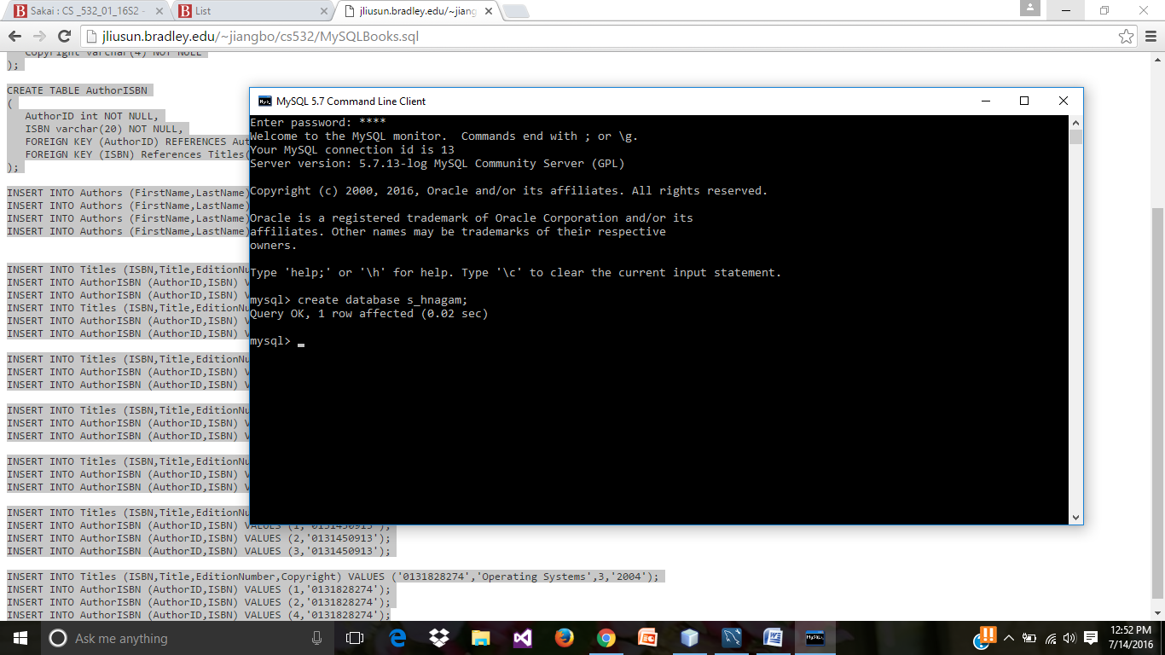

* Running the SQL script in the MySQL Command Line Client.

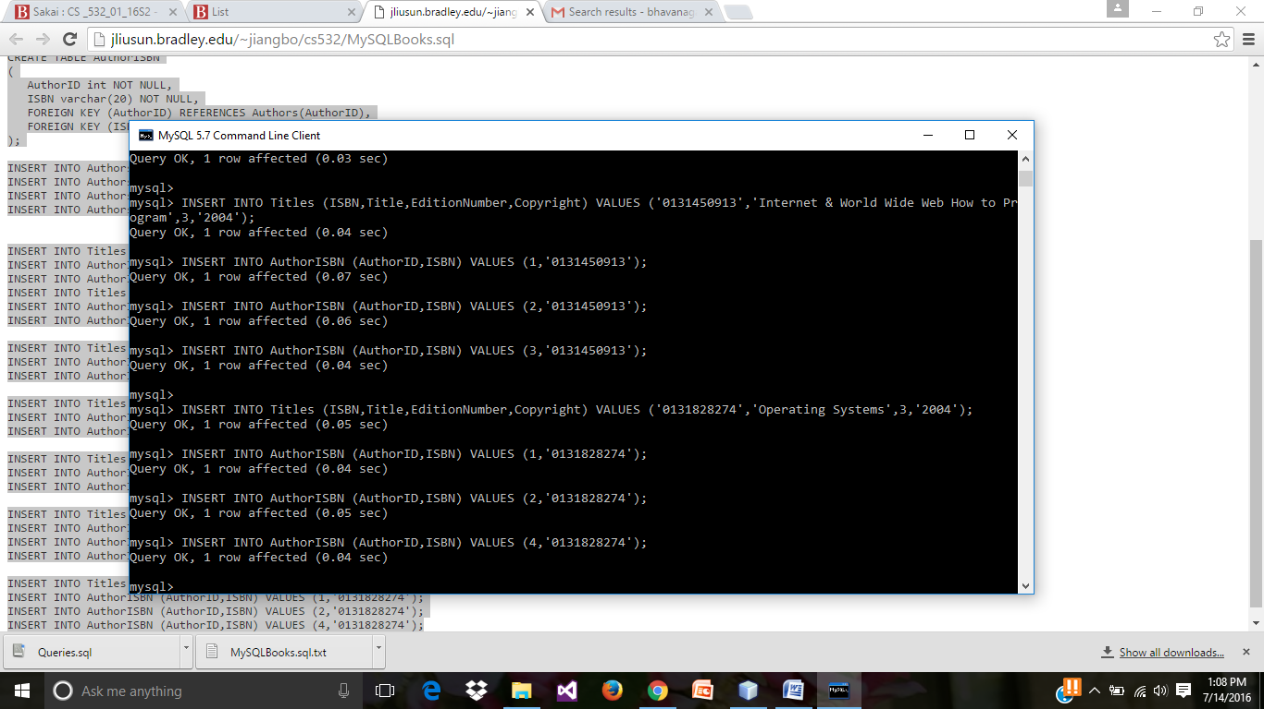

* Creating a new Java application in NetBeans IDE 8.1 (we need to select “Java” in Categories and “Java Application” in projects and click on “Next” button.)

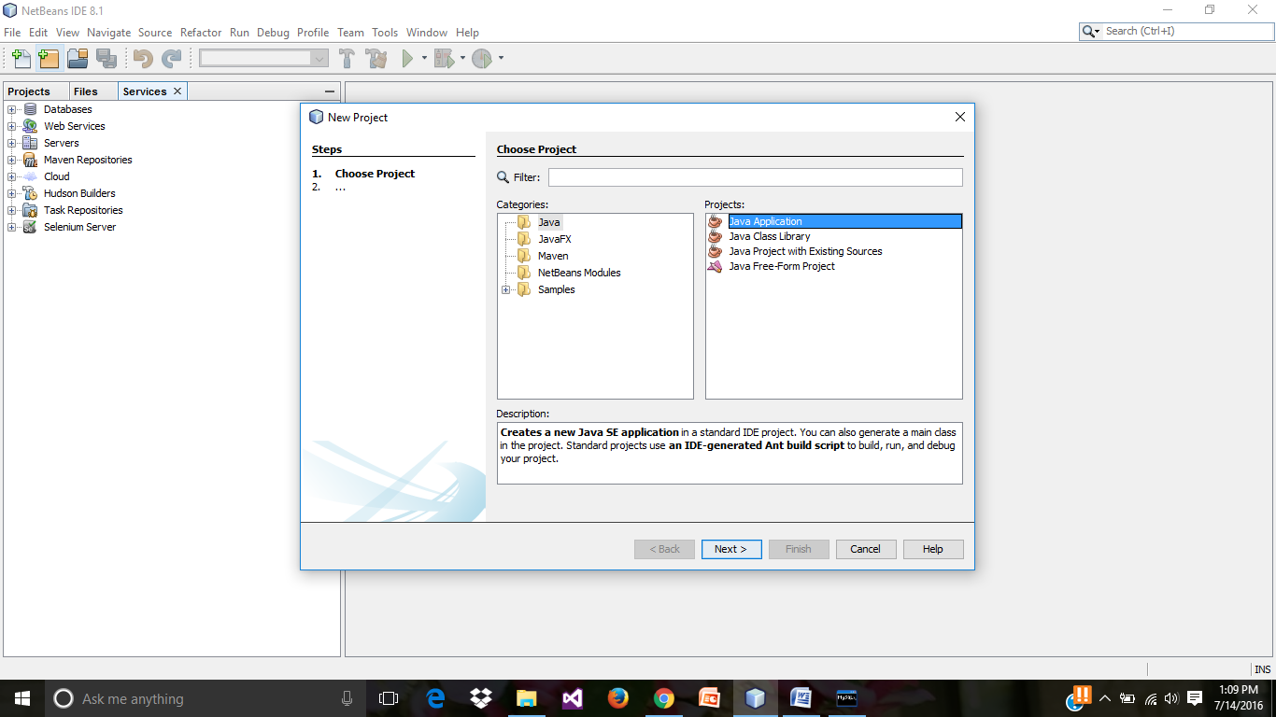

* Creating a new project “Java Application” and uncheck the “create main class” check box and click on “Finish” button.

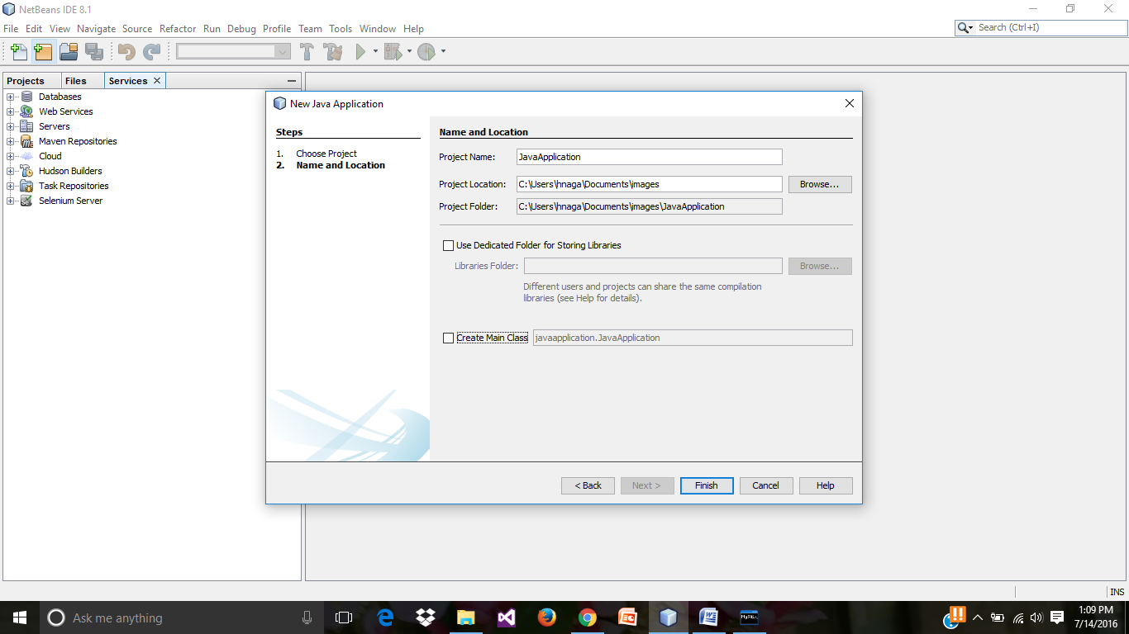

* New Project created.

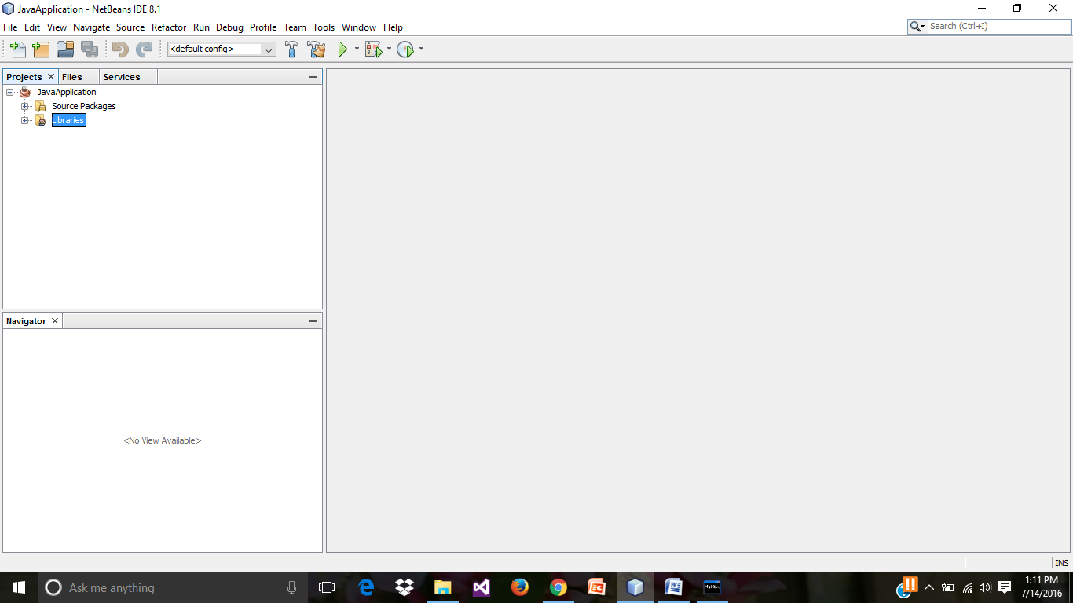

* Go to **Services**, click on **Drivers** and right click on **MySQL (connector/JDBC)** and select “**Connect Using…”**

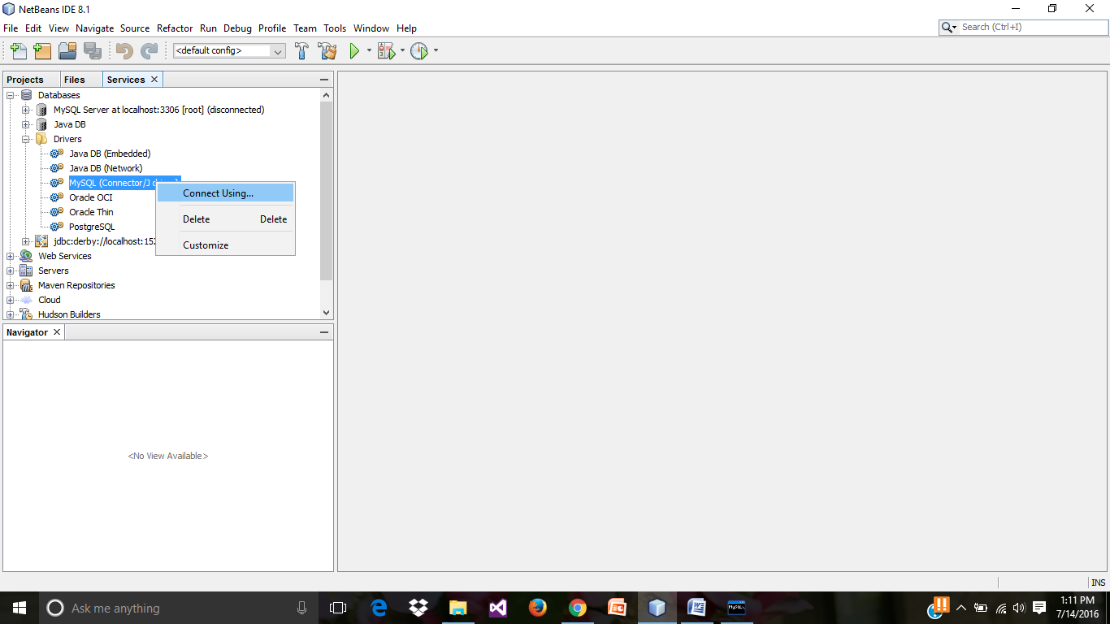

* In the New Connection Wizard, enter details of Database name, Port number, User Name and Password. Click on “Test Connection”(to test the connection) and click on “Next” button.

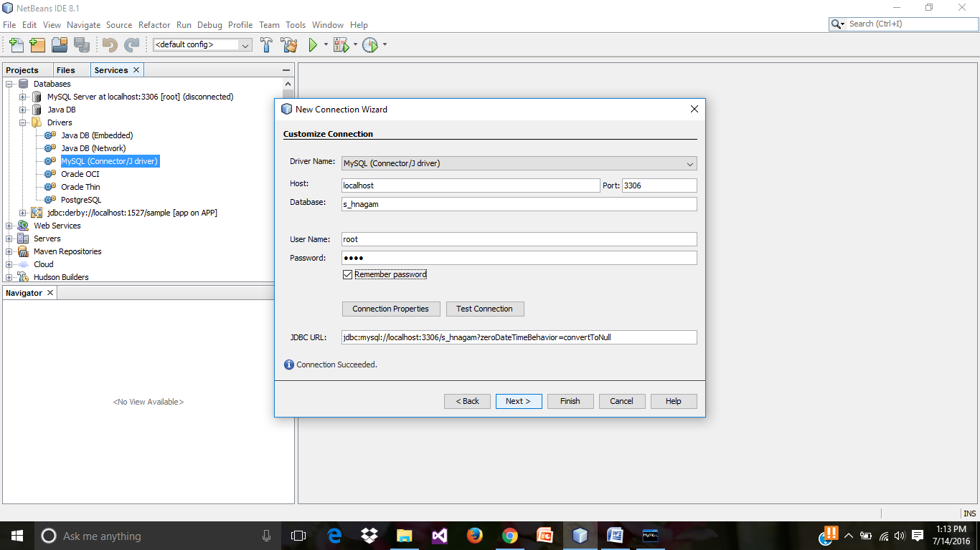

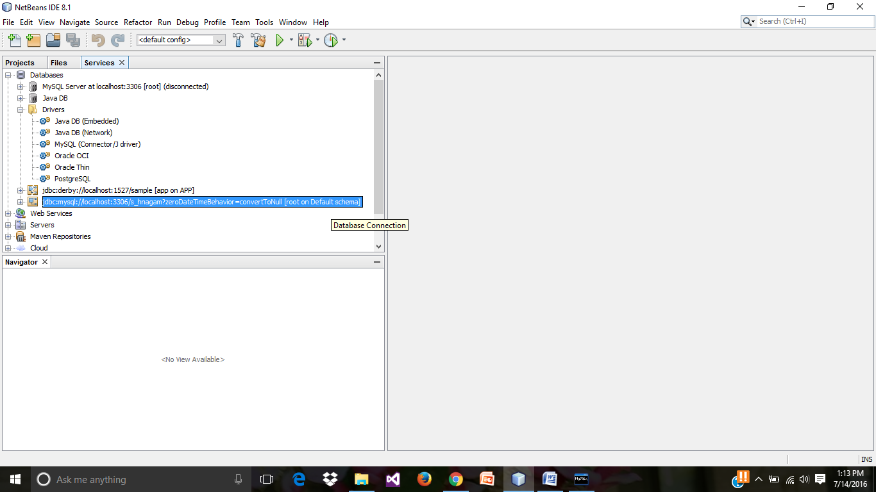

* Adding the “**mysql Java connecter. Jar**” file in the Libraries folder.

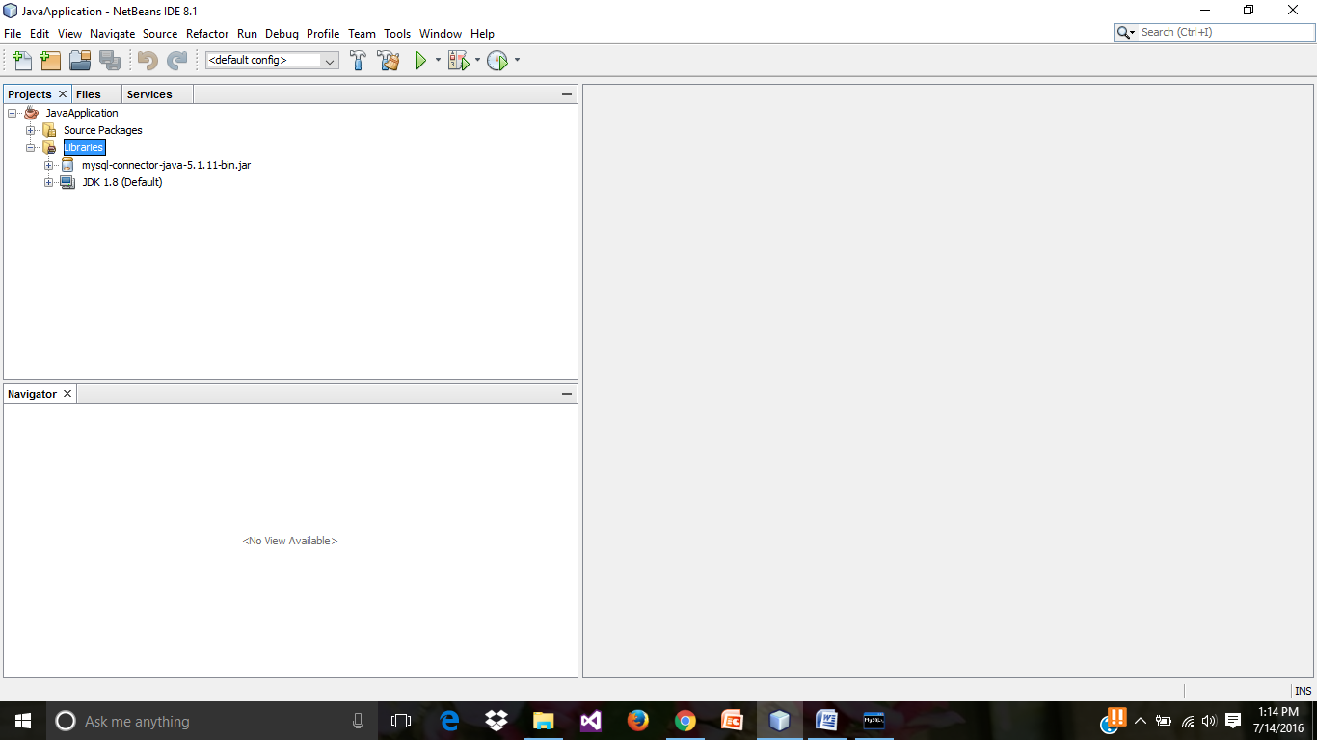

* Creating a “New Java Package”, **Main** and click on “Finish” button.

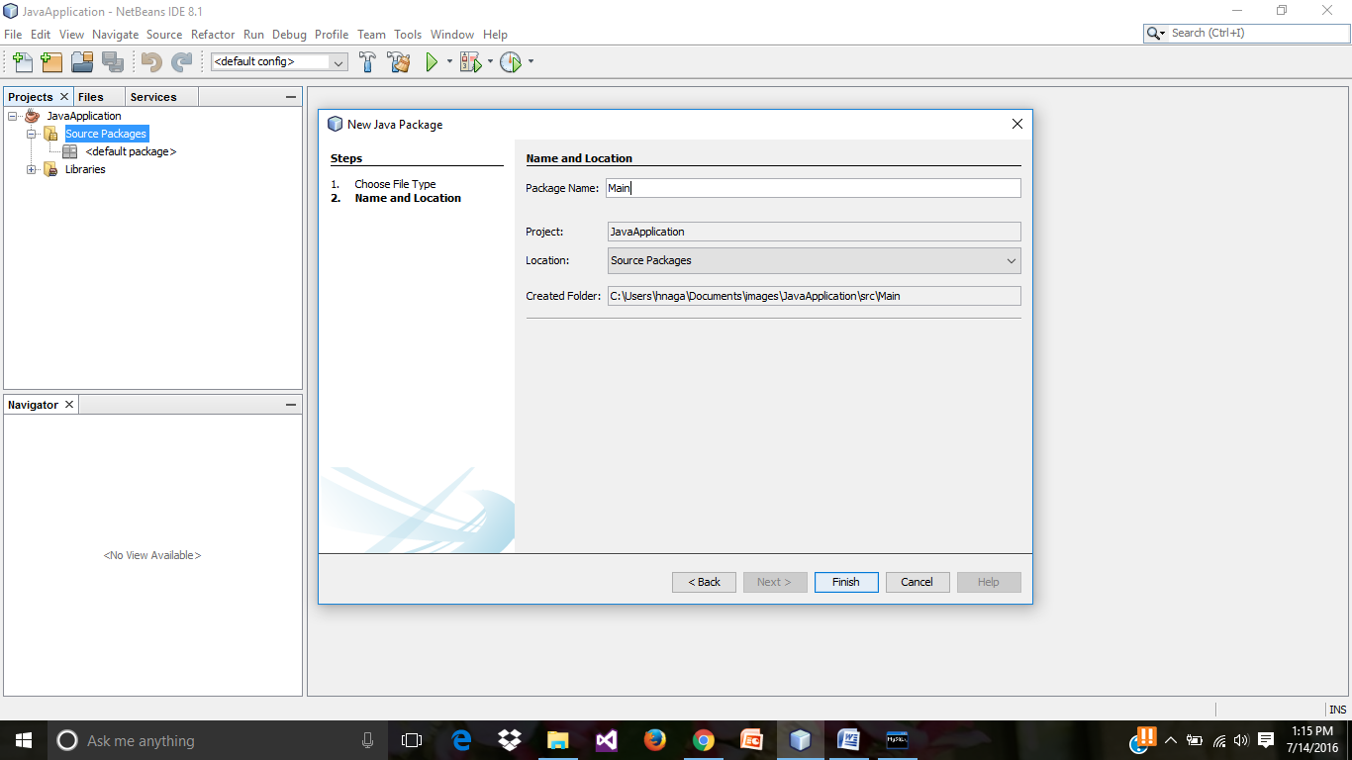

* Creating a **new JFrame Form** in the **Main** package.

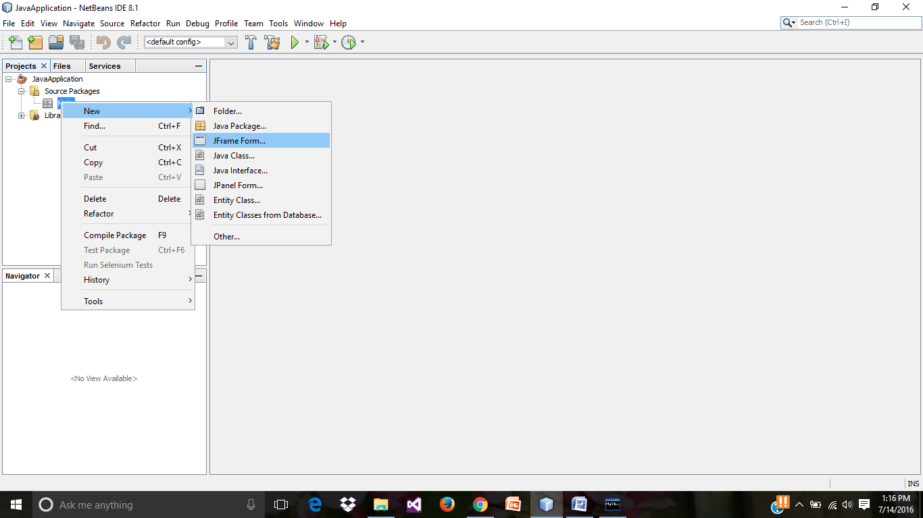

* Create a jFrame Form,with class name as “**MainFrame**”. Click on “Finish” button.

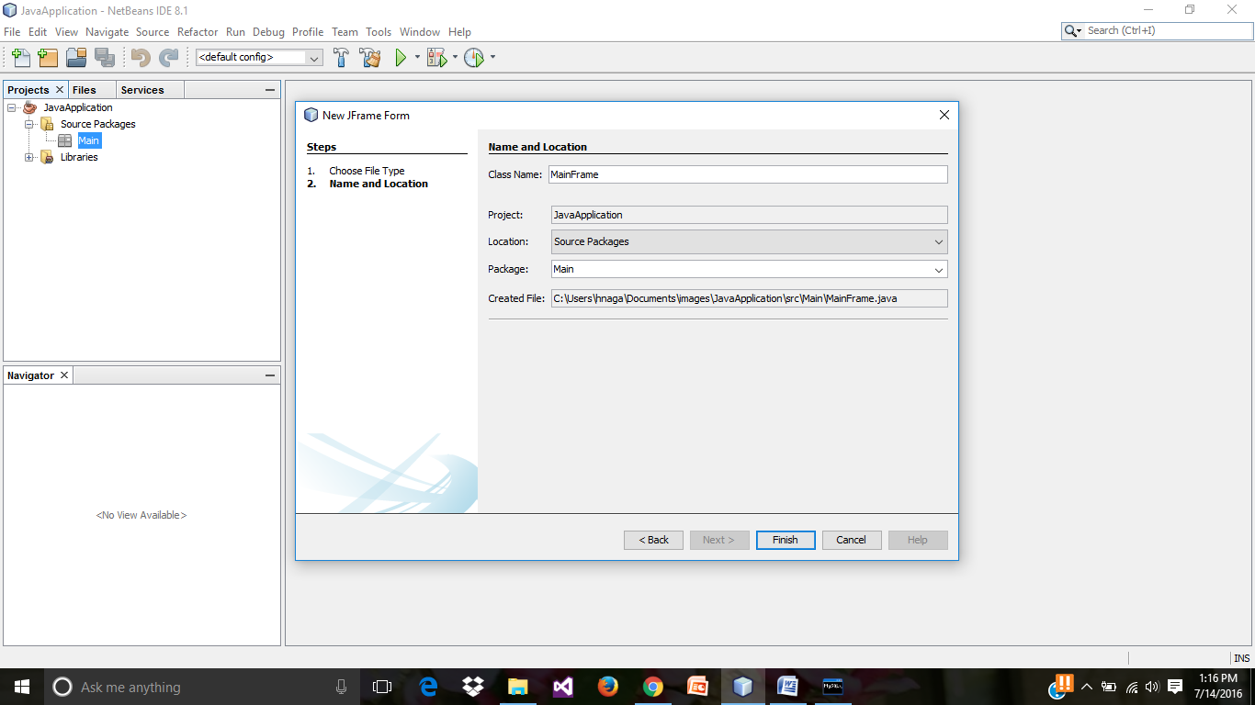

* Preview of MainFrame.java design.

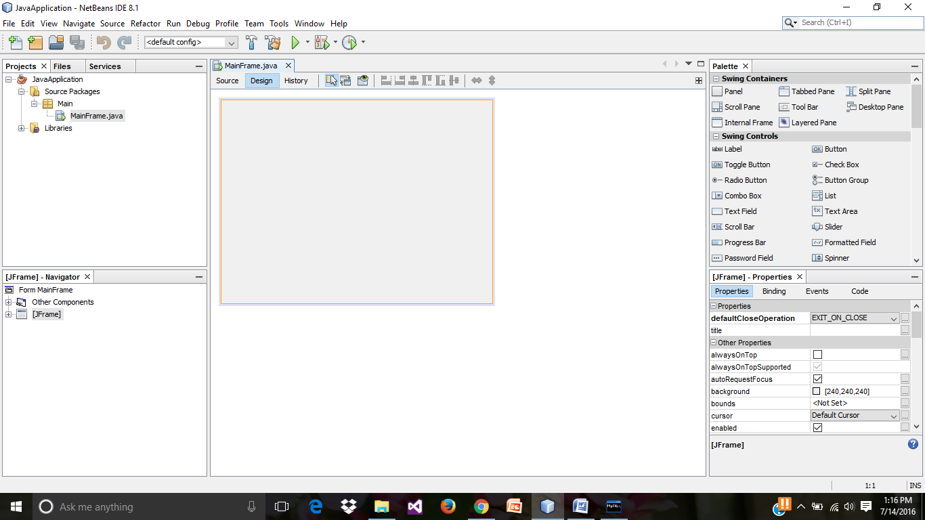

* Selecting the **Tabbed Pane** from the palette.

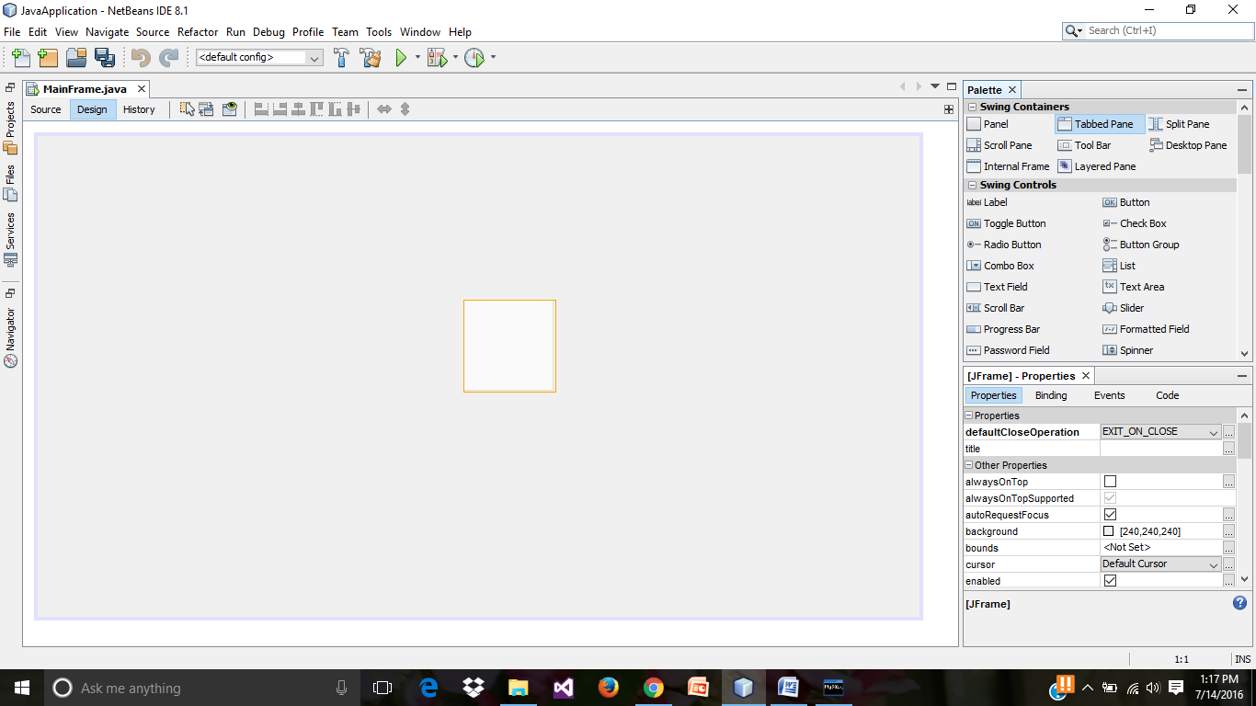

* Selecting the “**Panel**” in palette .

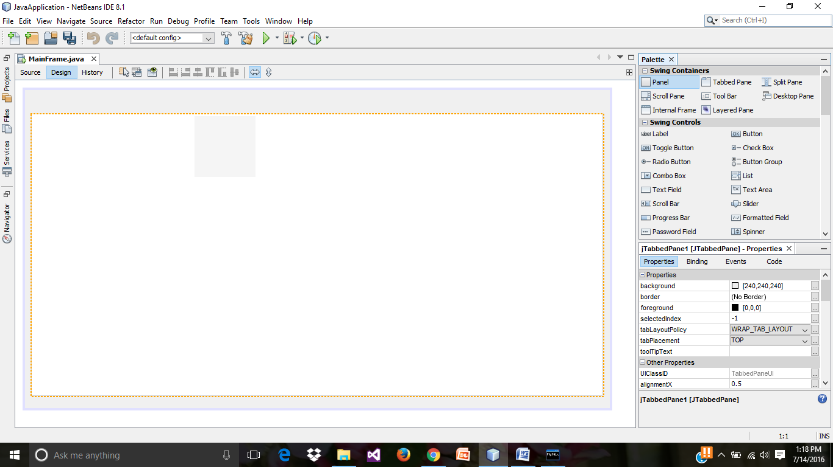

* “Tab1” is designed as shown below.

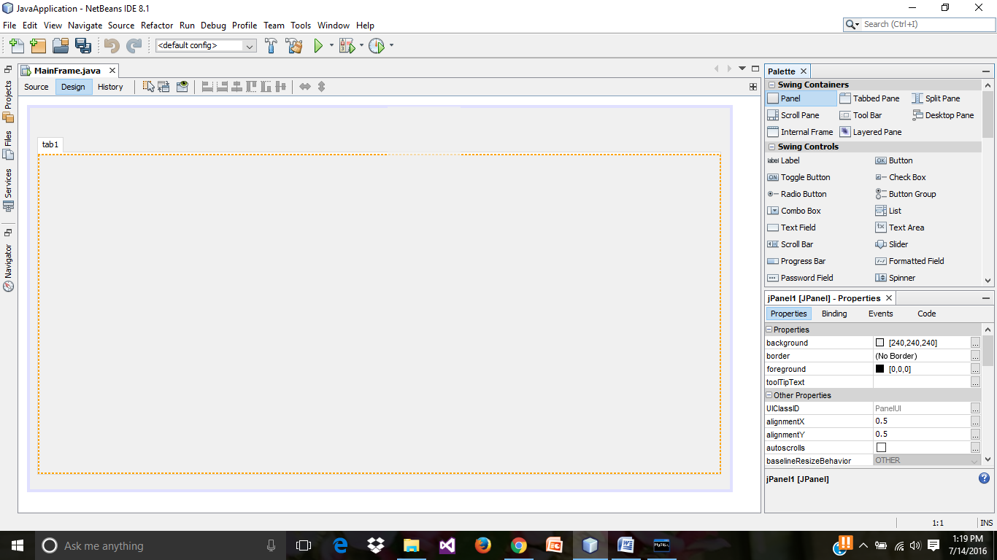

* To edit the text, right click on the tab1 and select “**Edit Text**”.

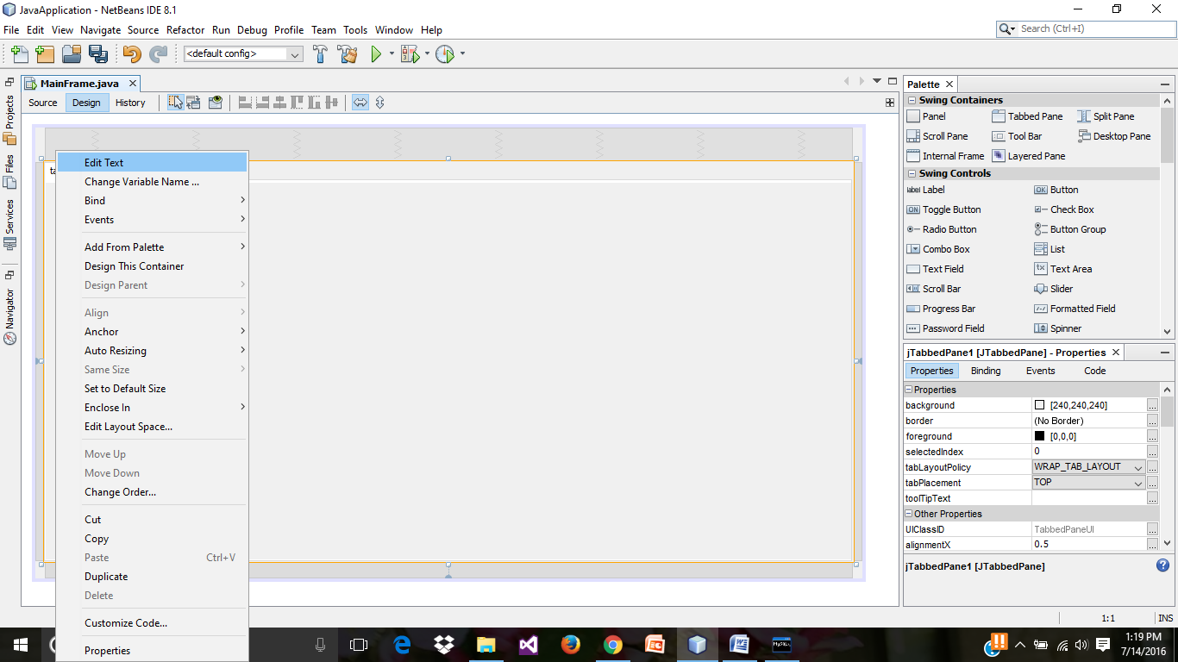

* Select one more Panel from Palette, to add another tab.

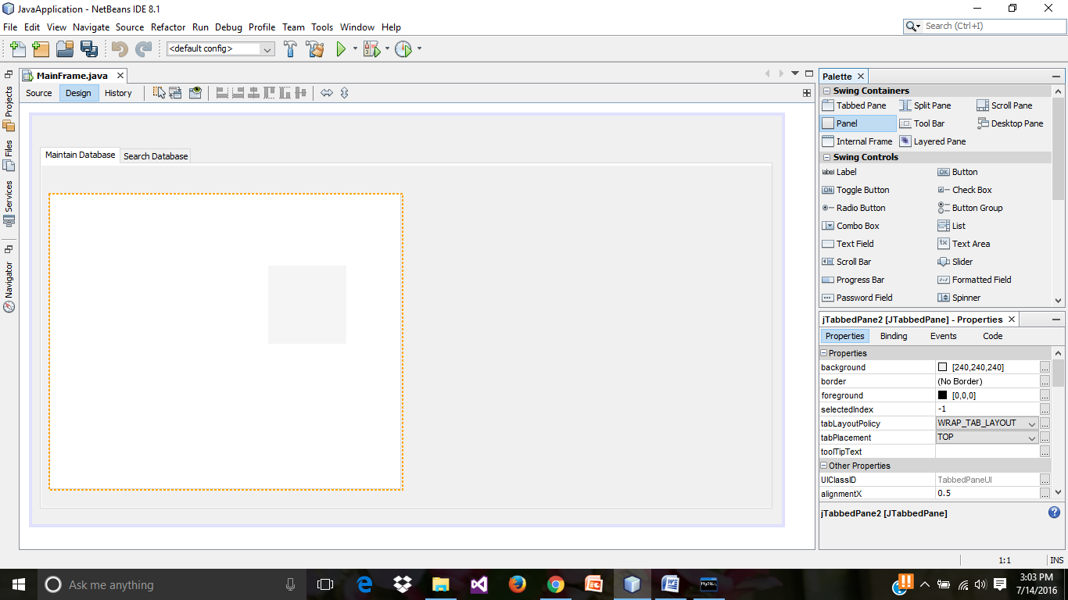

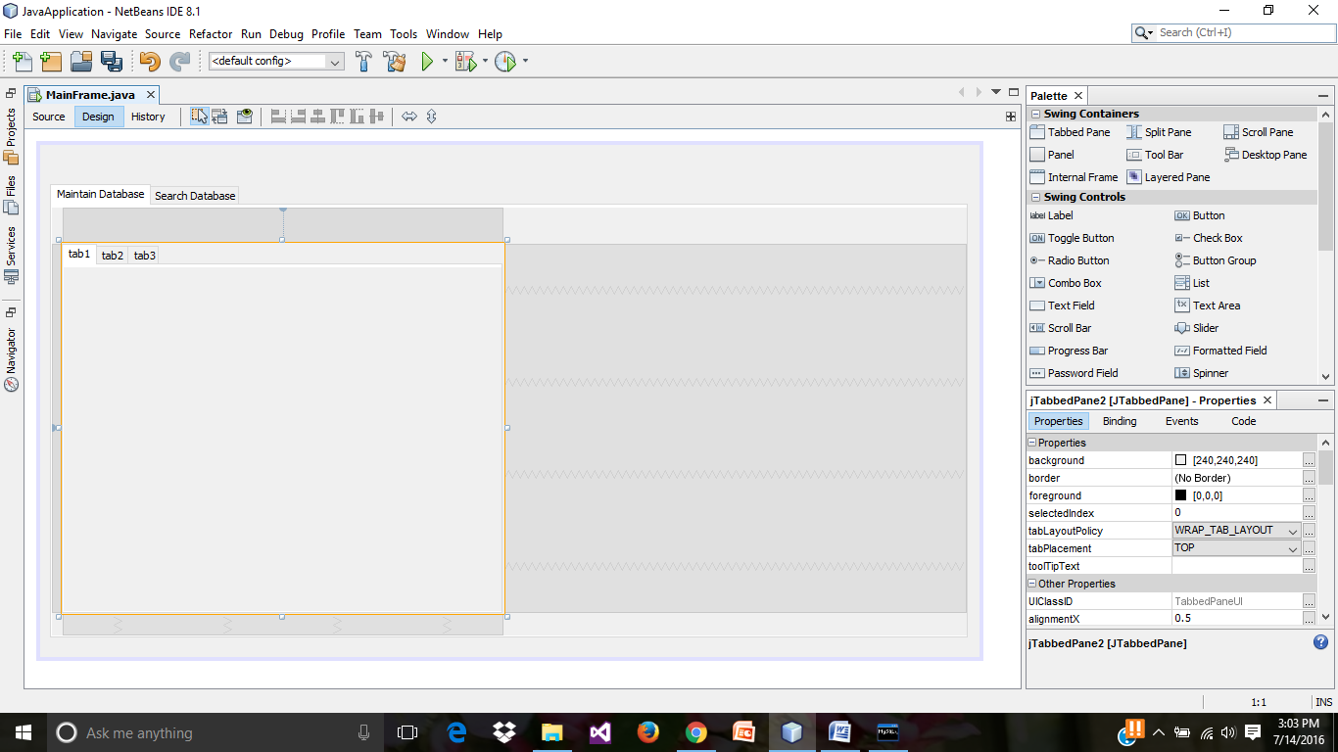

* Edit the text of tab1, tab2 and tab3 as **Insert**, **Update** and **Delete** respectively, with “Edit Text” option. Select “Label”. Name the “jLabel1” as “ISBN”

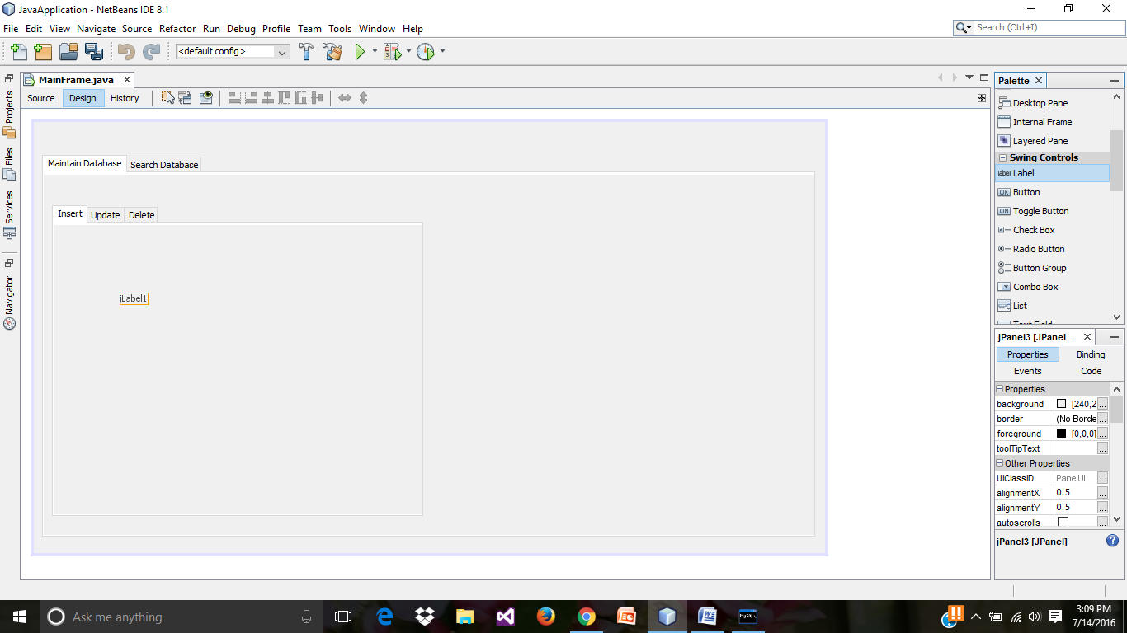

* Select “Text Field” from “Swing Controls”. Now right click on text field and select “Change Variable Name”.

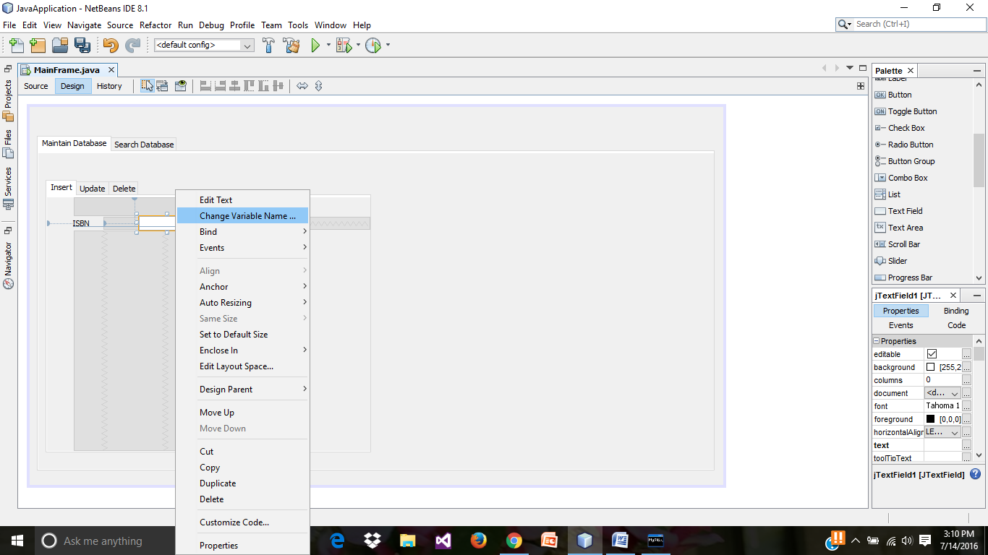

* Assign the variable name for the text field as “jTextField_Insert_ISBN” and click on “OK” button.

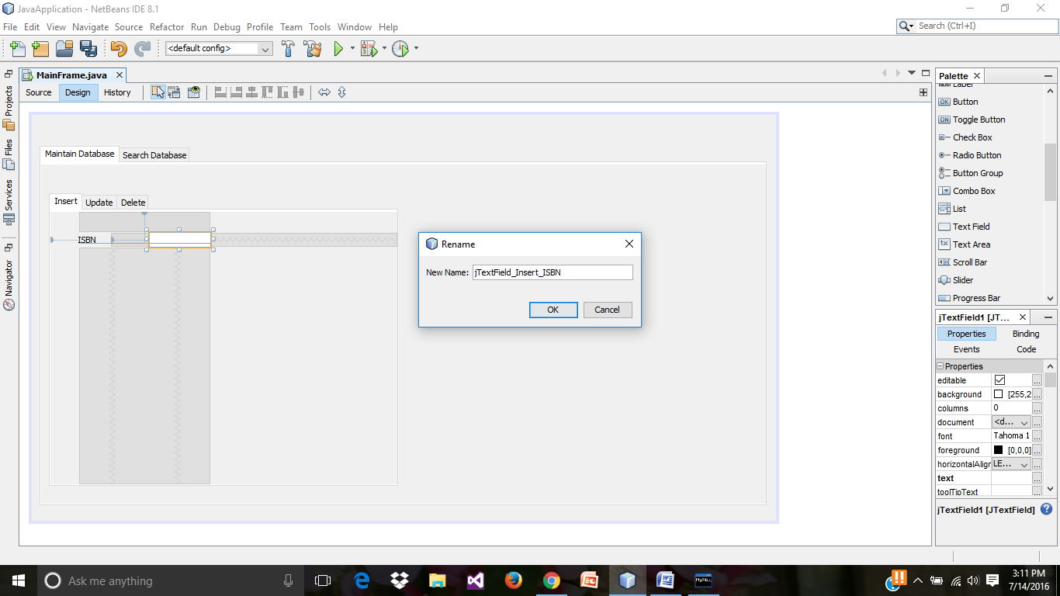

* Select the Labels and Text Fields from “Swing Controls” and name them as required. Also select **Text Area** as shown below.

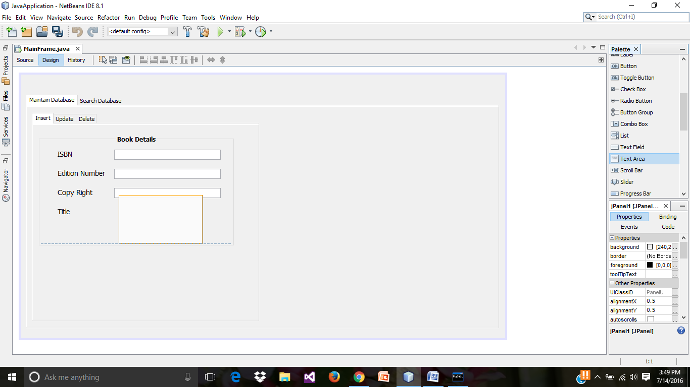

* Enclosing everything in a panel.

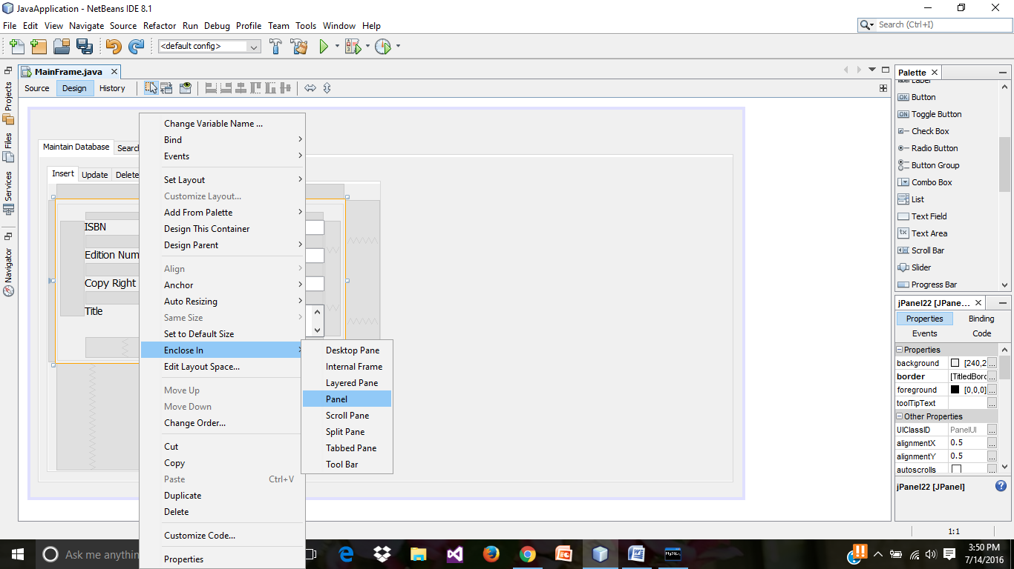

* To run the GUI. The Following window appears, as we have not created main class yet, click on “OK” button.

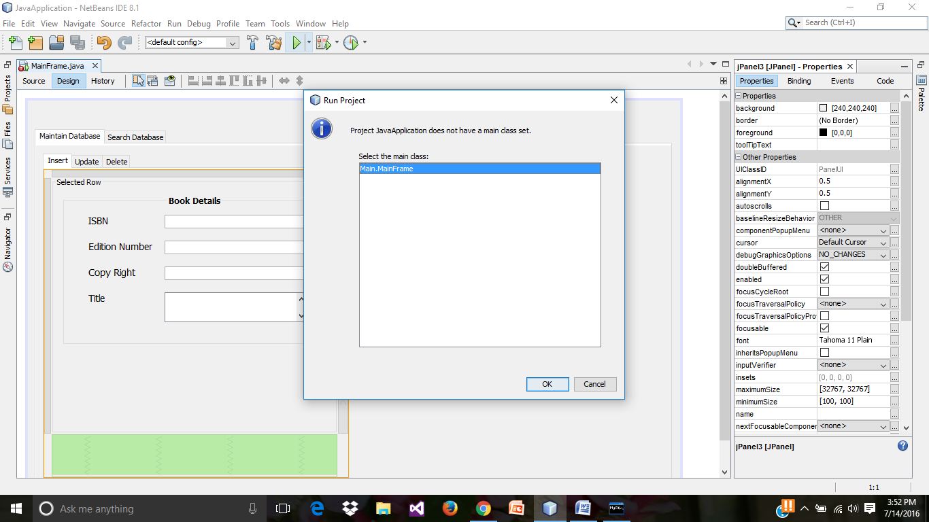

* Run result of the program (Java Application): GUI designed till now.

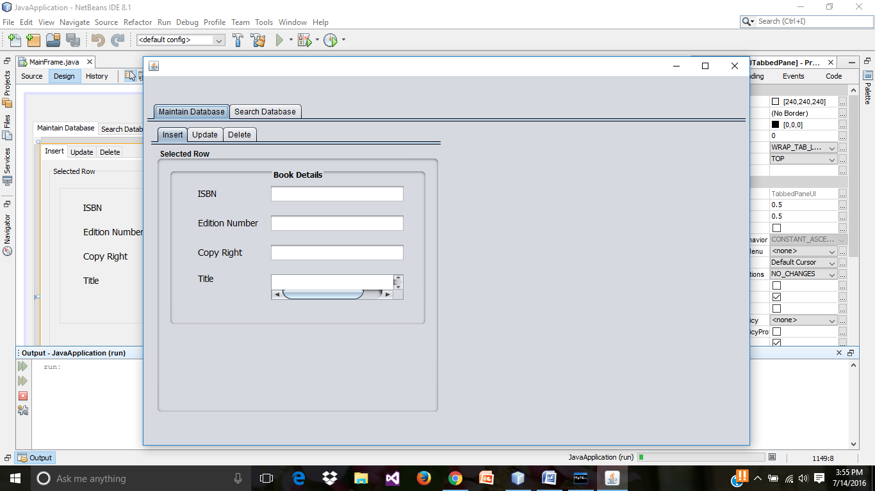

* Select the **jButton**.

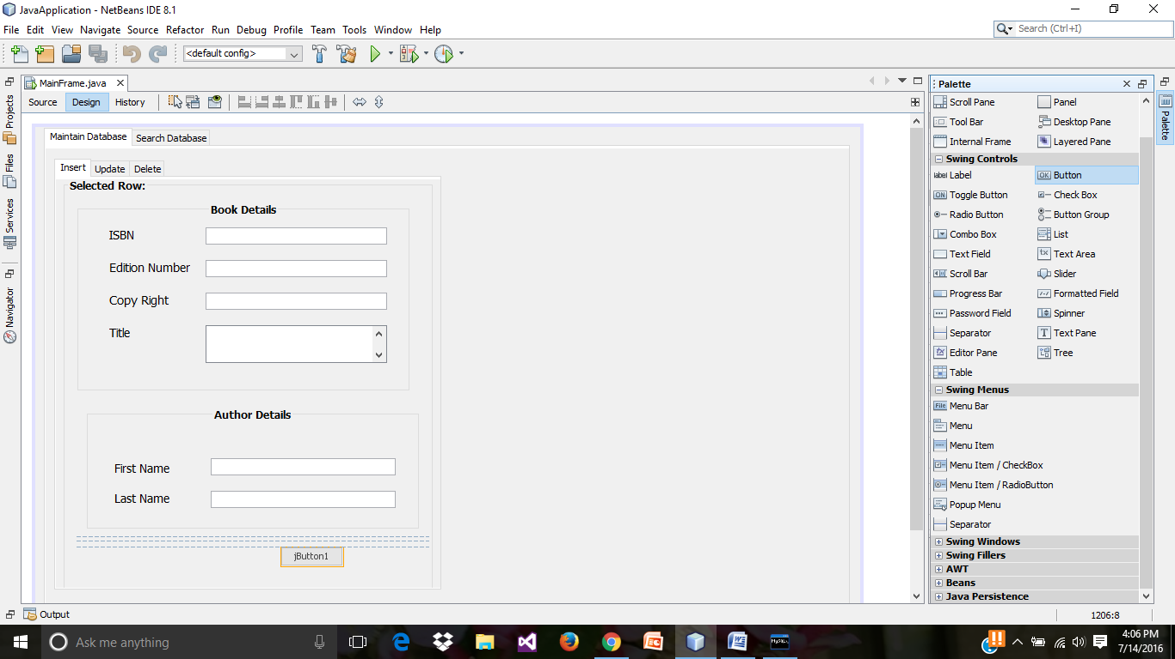

* Edit the jButton text.

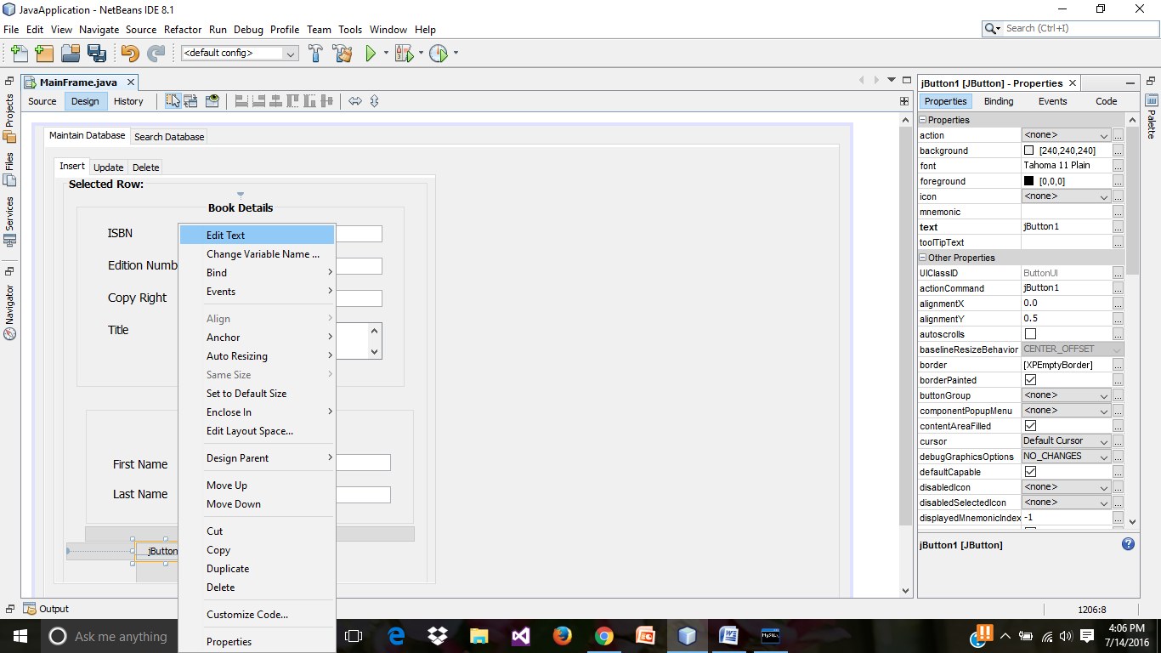

* Change the variable name for the “Insert” button.

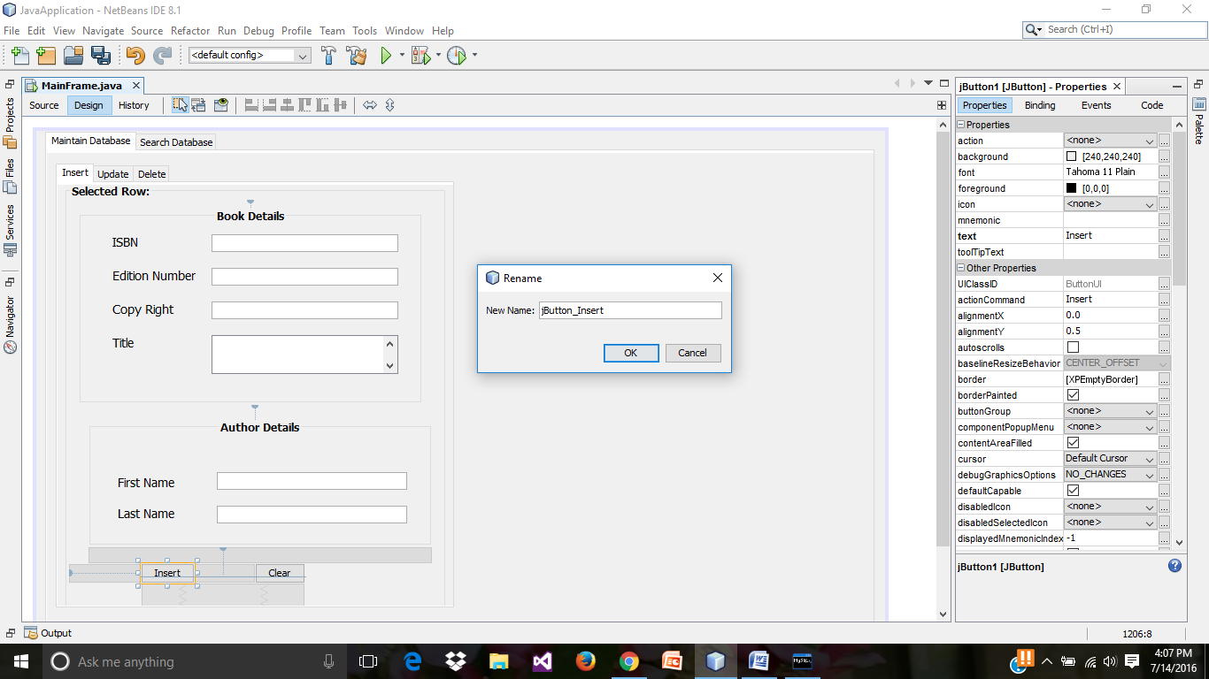

* Similarly, design the **Update** tab as shown above.

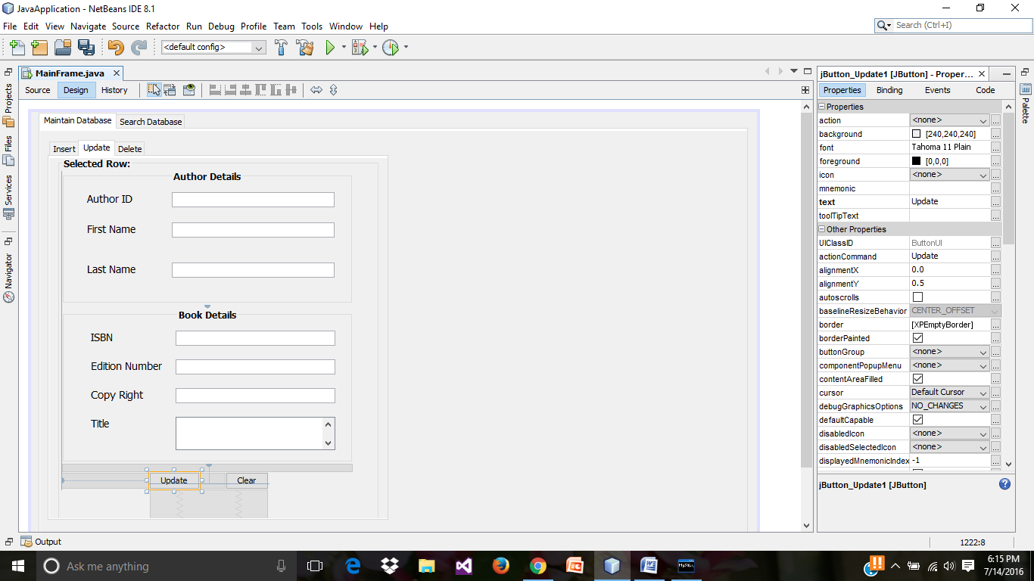

* Preview of the **Insert** tab, in run result.

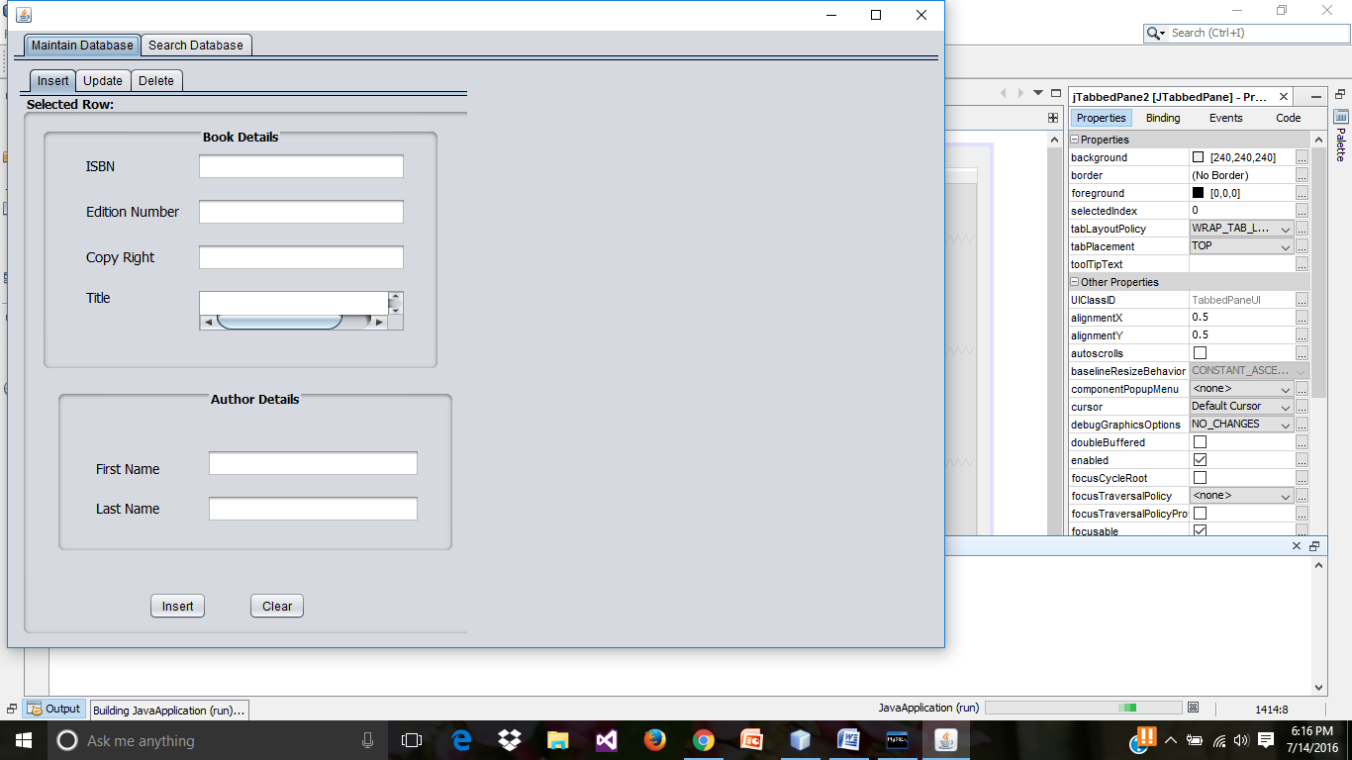

* Preview of the **Update** tab, in run result.

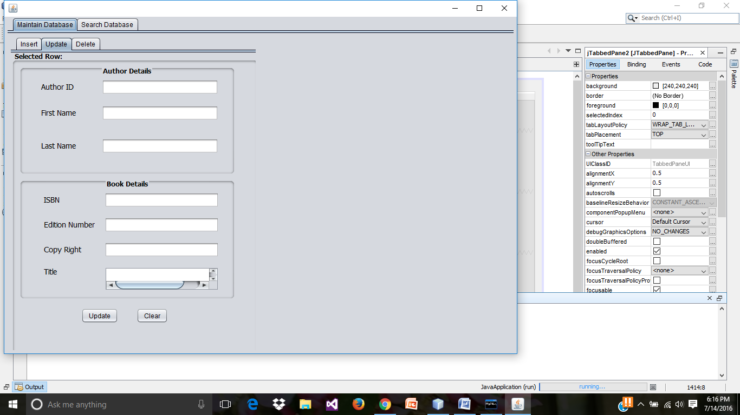

* Preview of the Delete Tab in the run result.

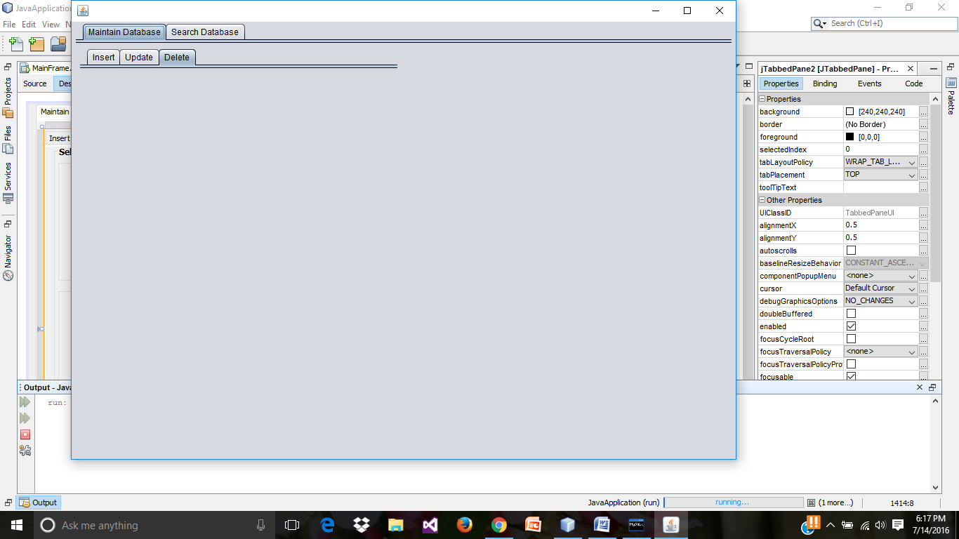

* Similarly, design the Delete tab and change the Delete button variable name.

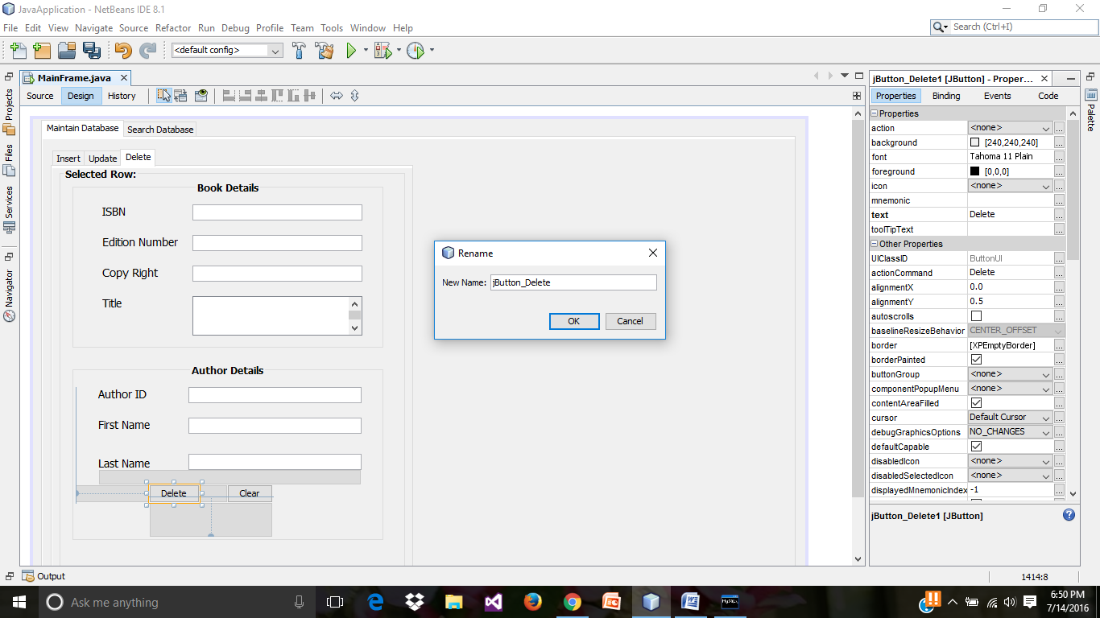

* Preview of Delete tab in run result.

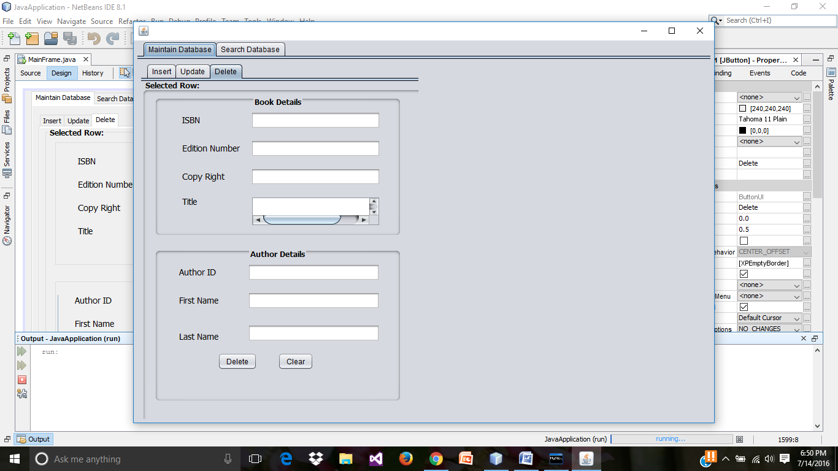

* Selecting a table from swing controls.

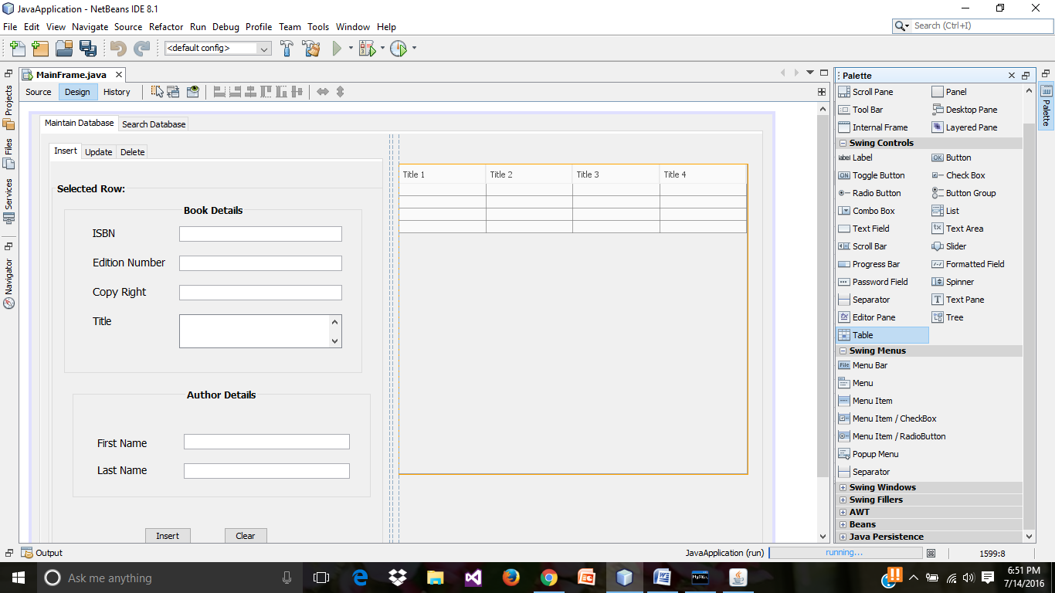

* Right click on the table and select “Table Contents…”

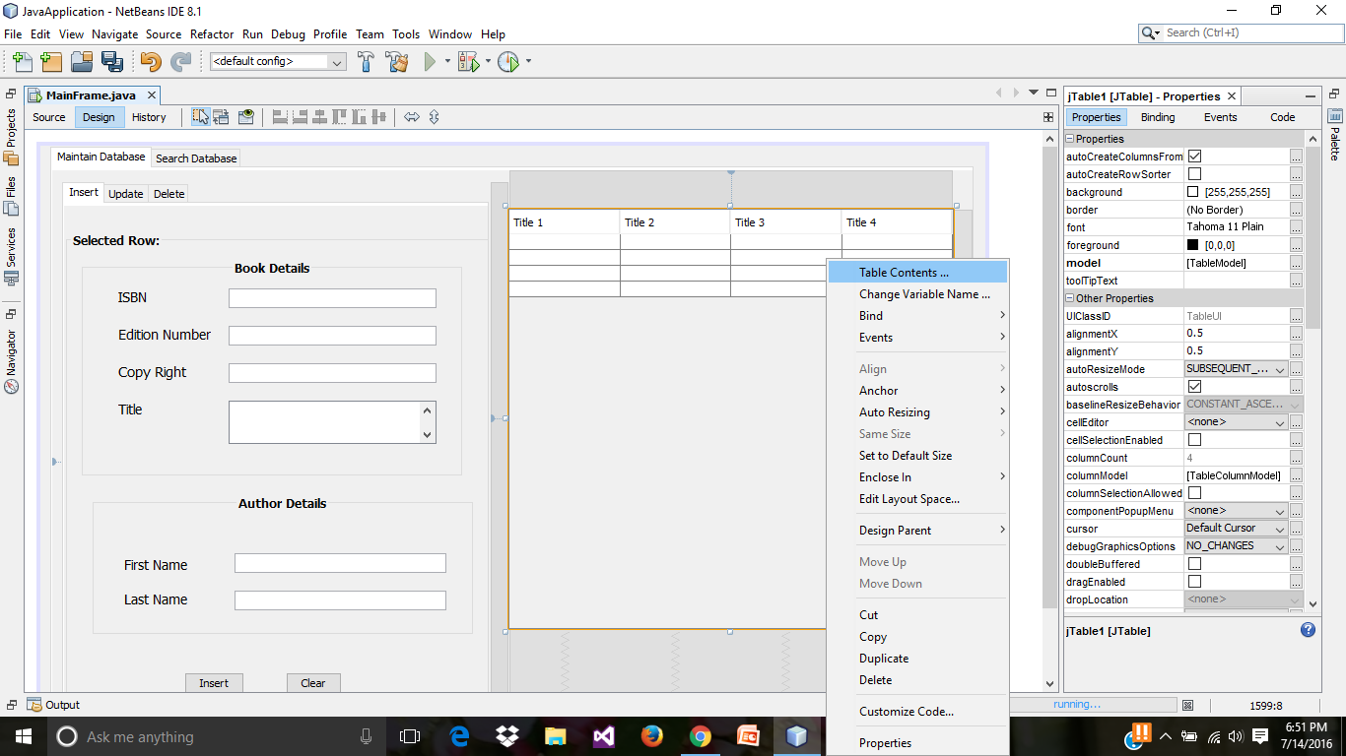

* In the Columns tab Edit the column names.

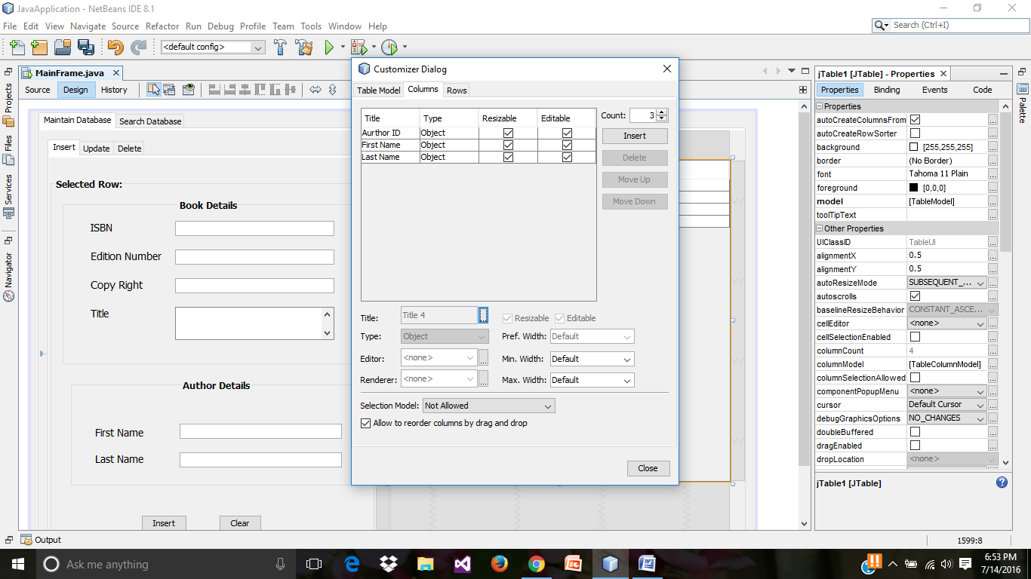

* Changing the variable name for table.

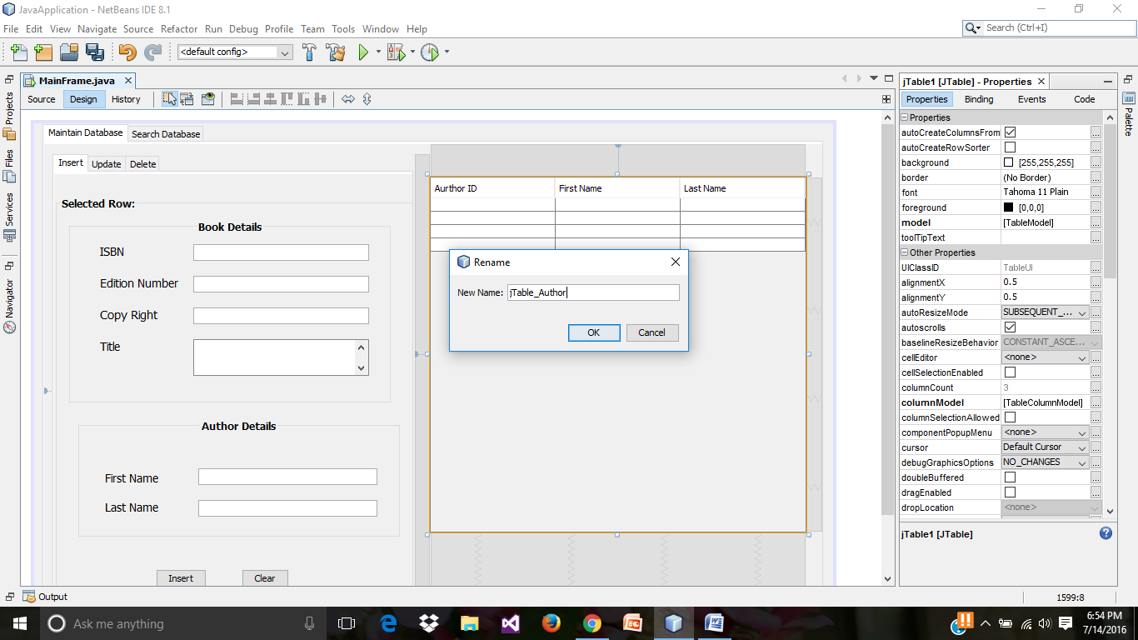

* Preview of run result till now.

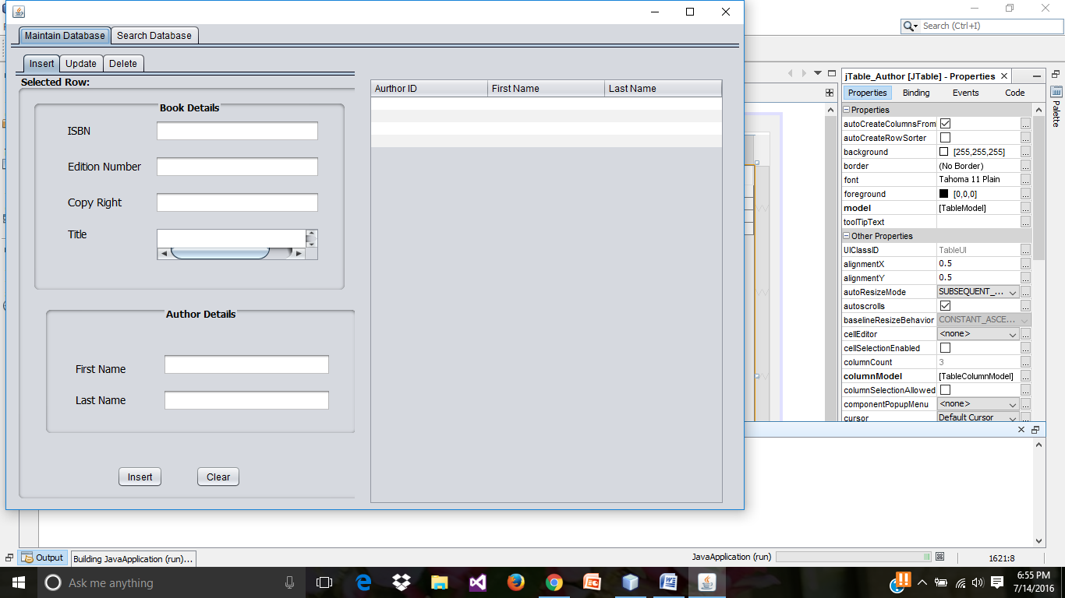

* Selecting **jlable** from the Palette.

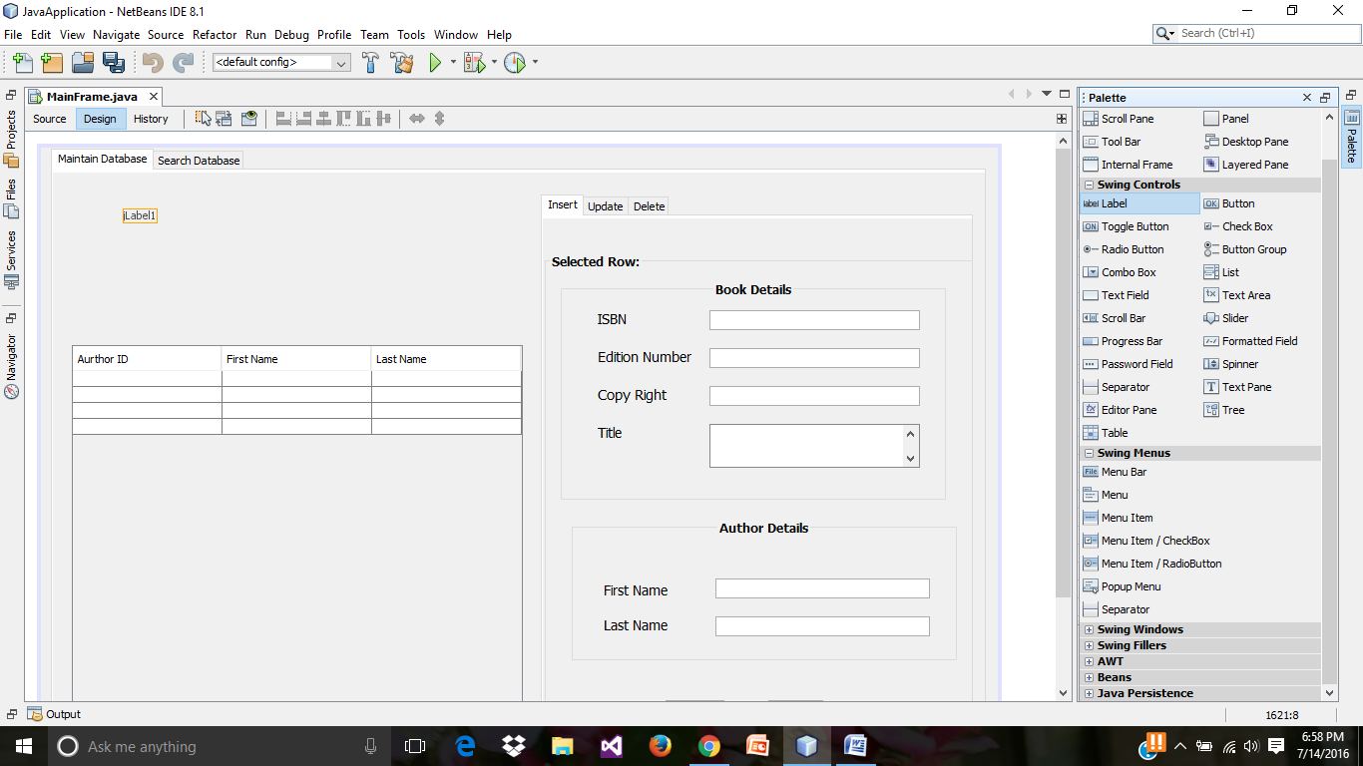

* Selecting a **Combo Box** from Palette.

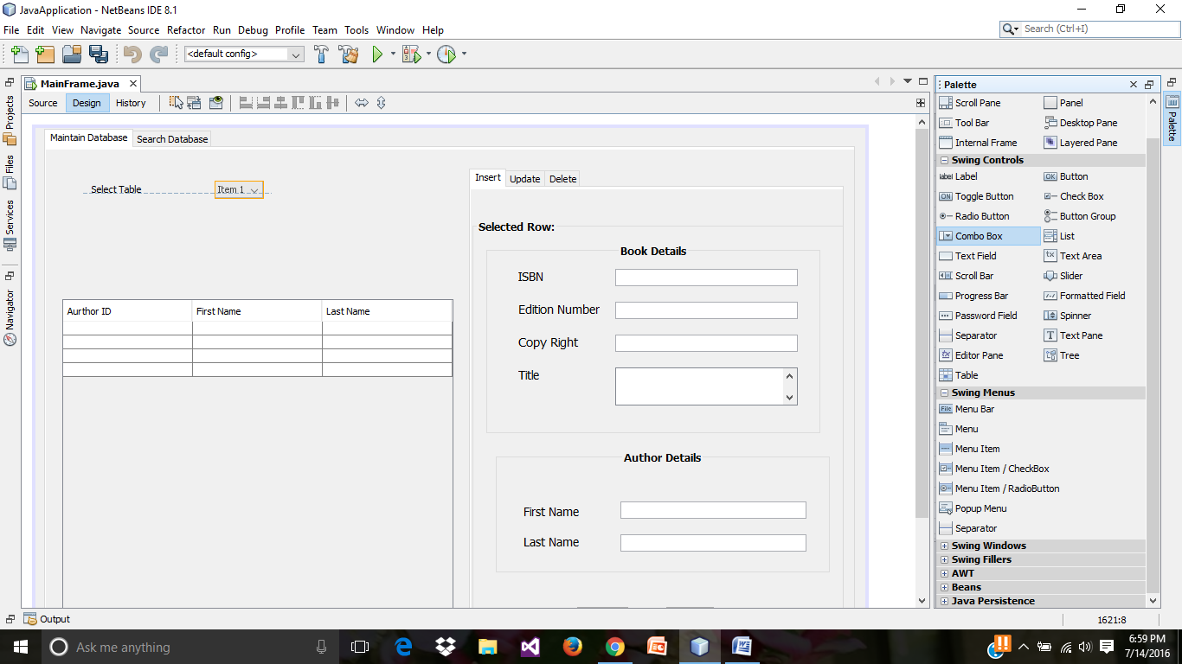

* On **Properties of combo box**, click on the **model** and change the item names in combo box.

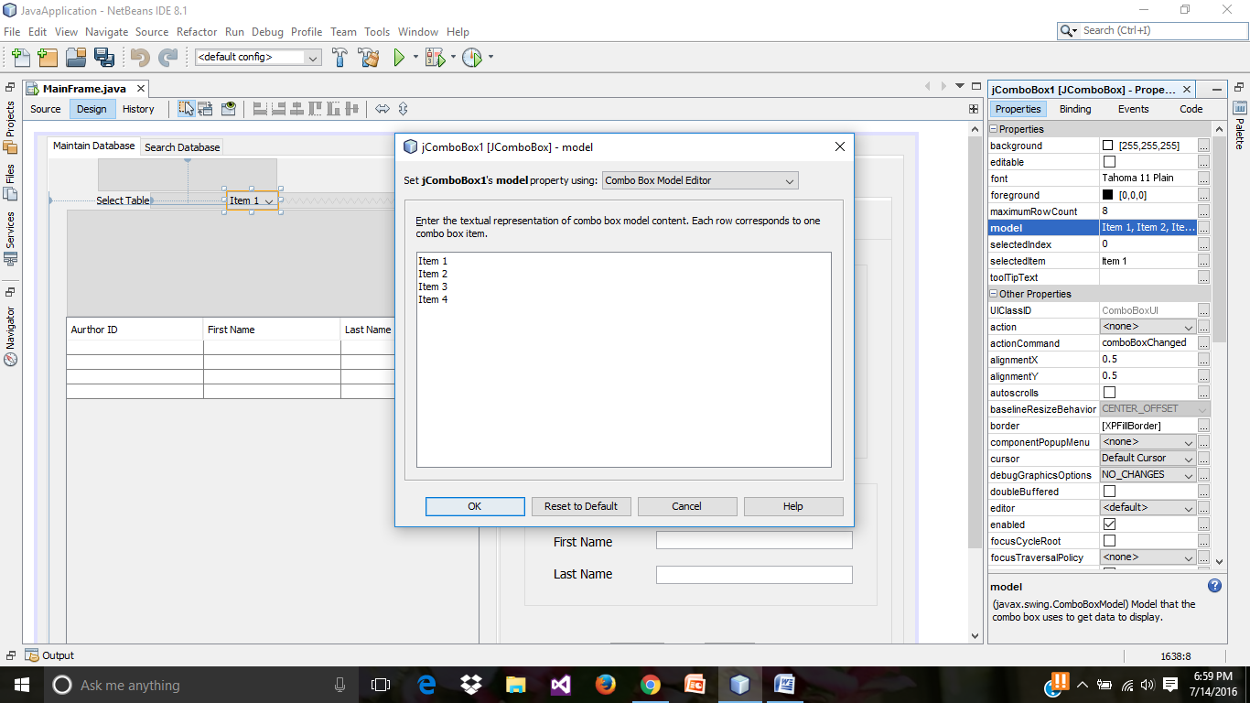

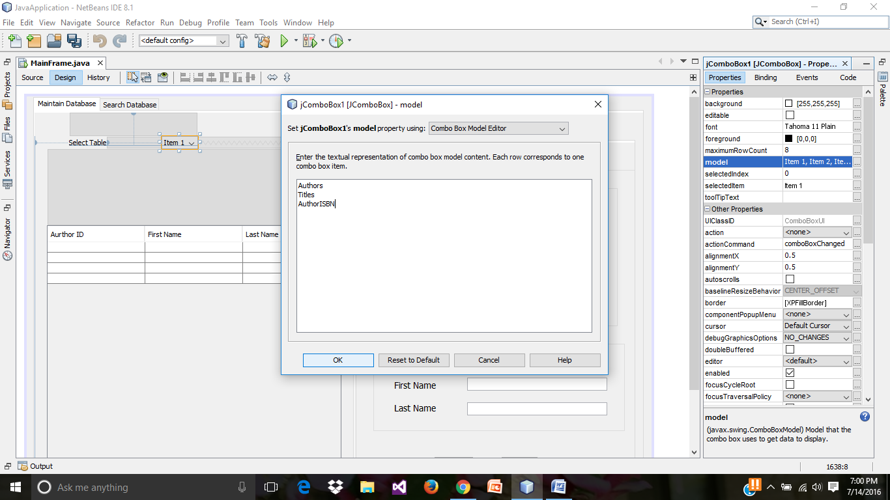

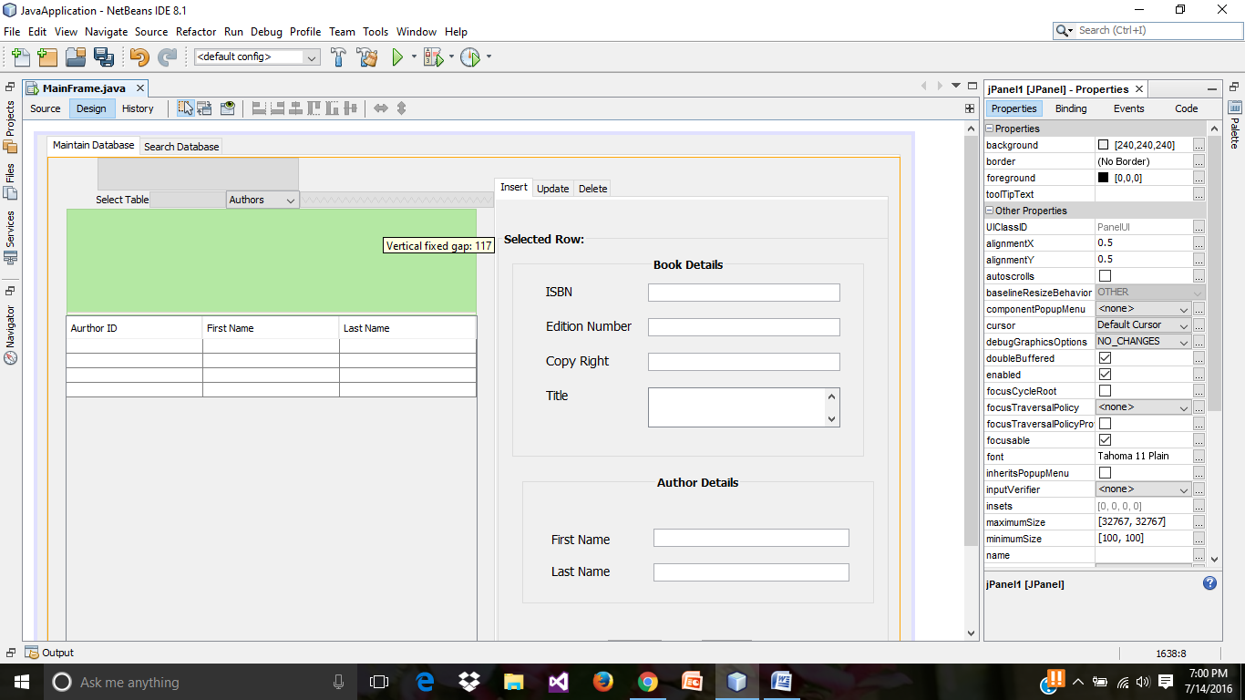

* Preview of run result till now.

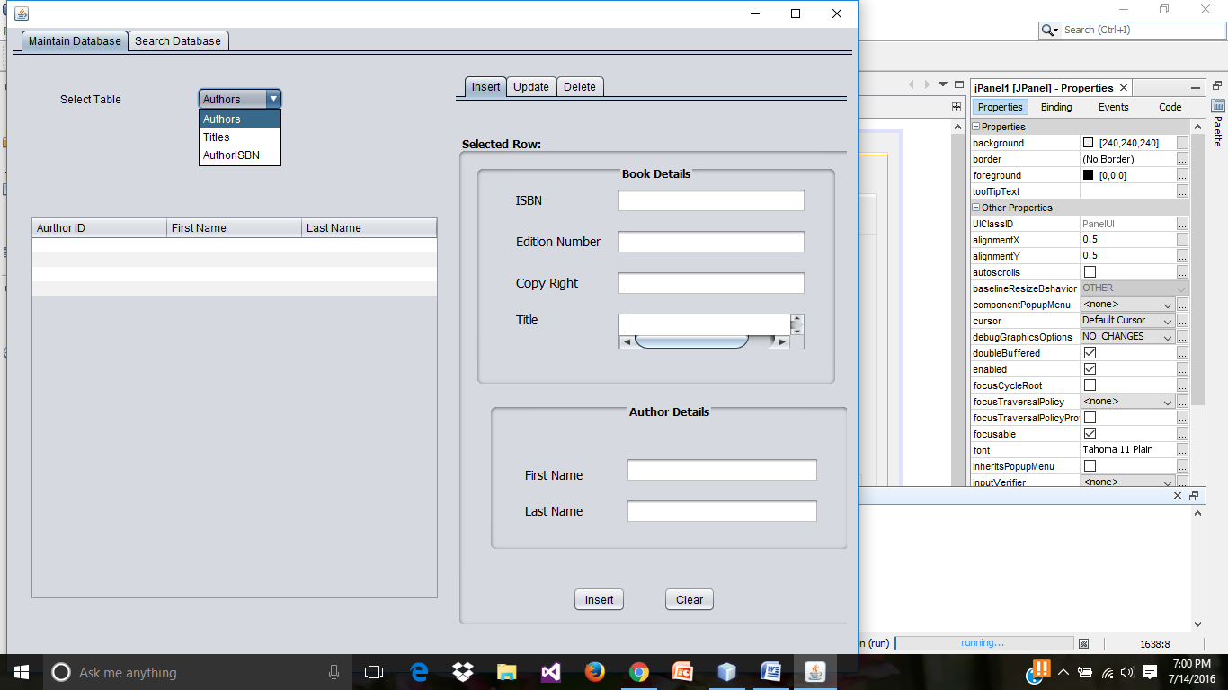

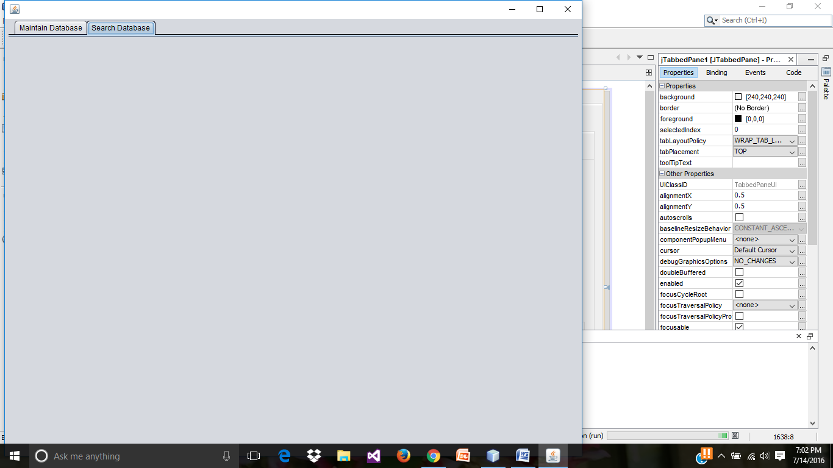

* Selecting a **Menu Bar** form Palette.

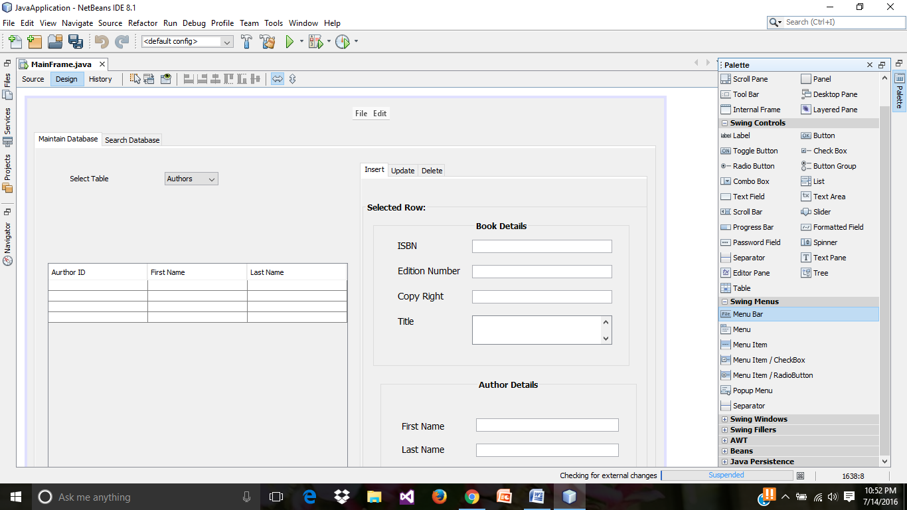

* Right click on the menu bar and add a **Menu Item/CheckBox.**

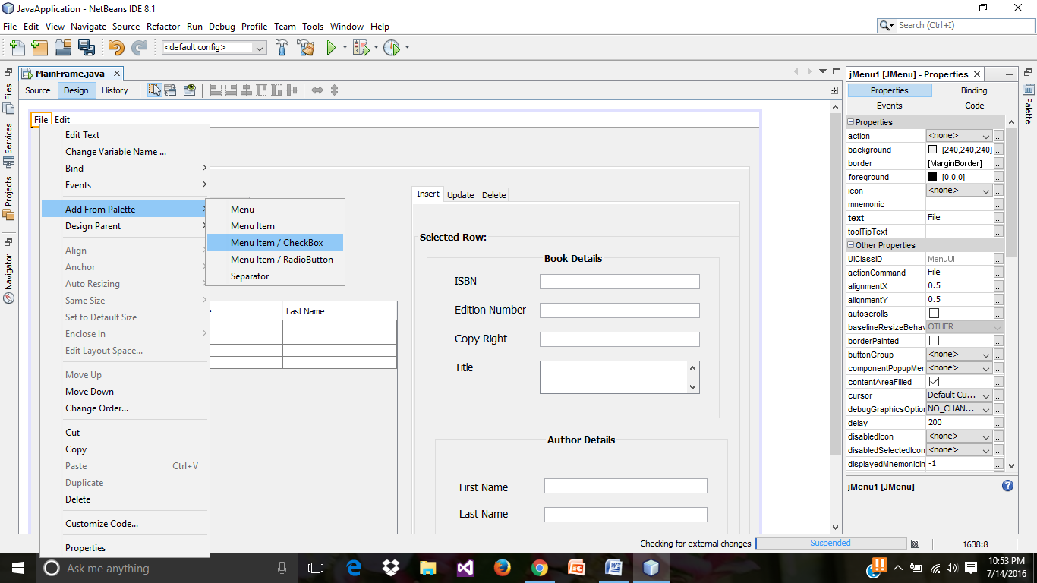

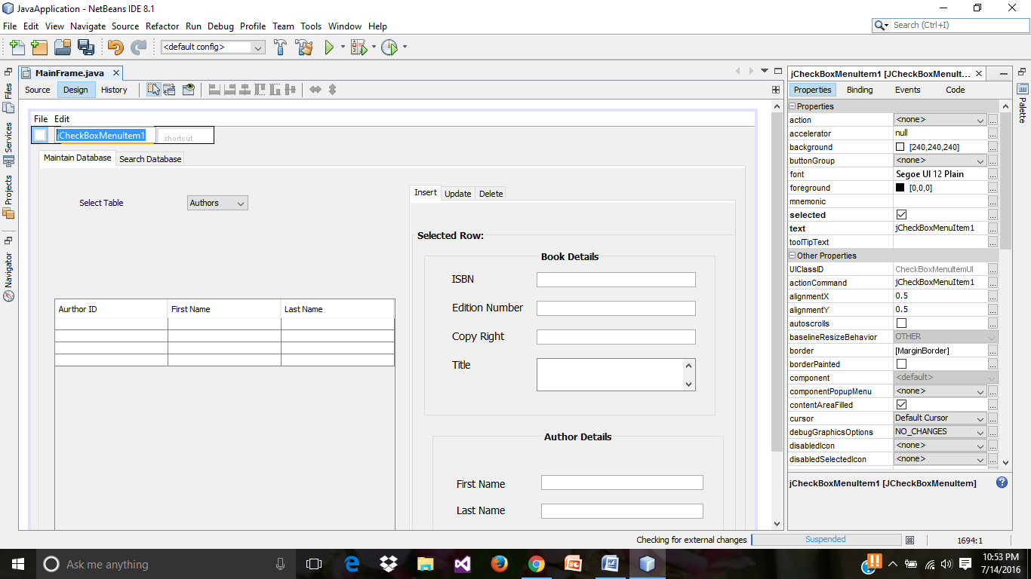

* Name the “jCheckBoxMenuItem” as Exit, and Click on **action Performed.**

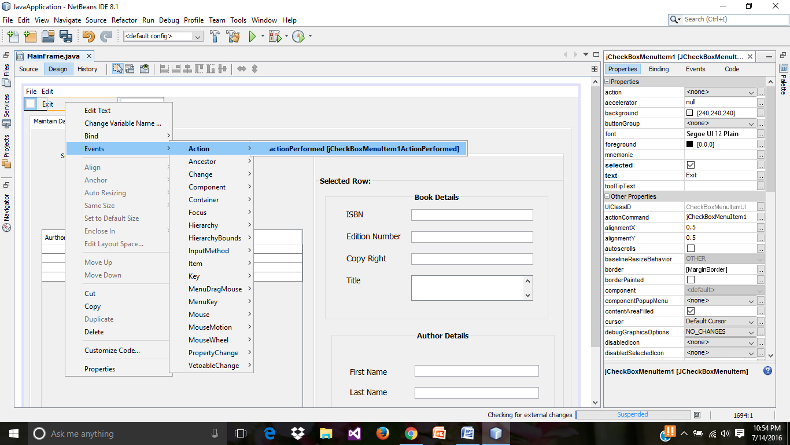

* In the source tab, enter the following code.

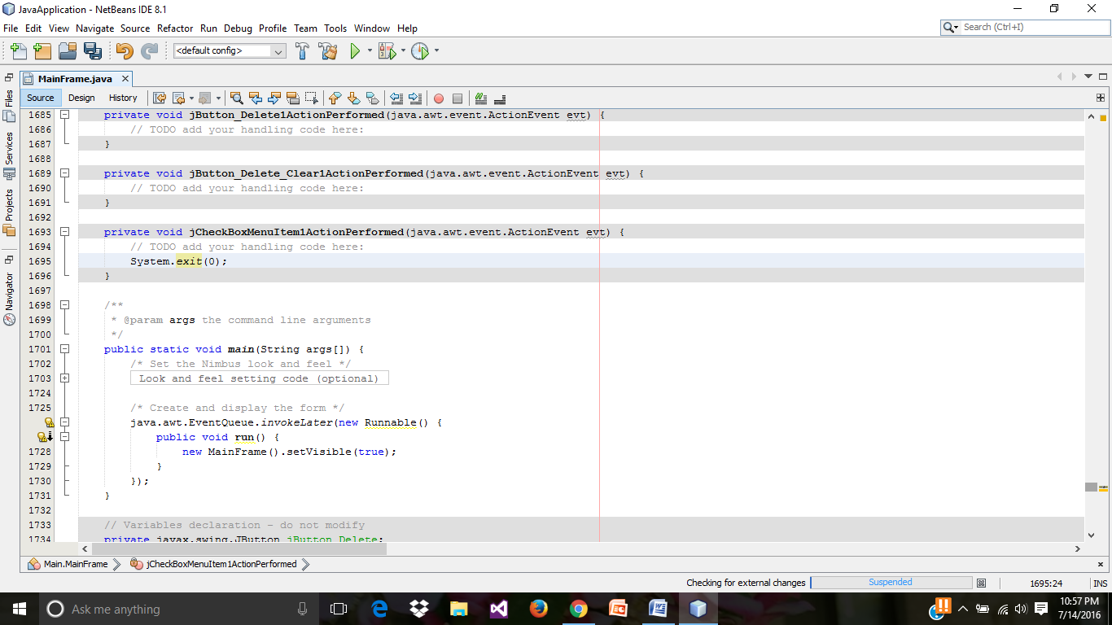

* Preview of **jCheckBox menu item** in run result, by clicking on Exit ,the run result will be terminated.

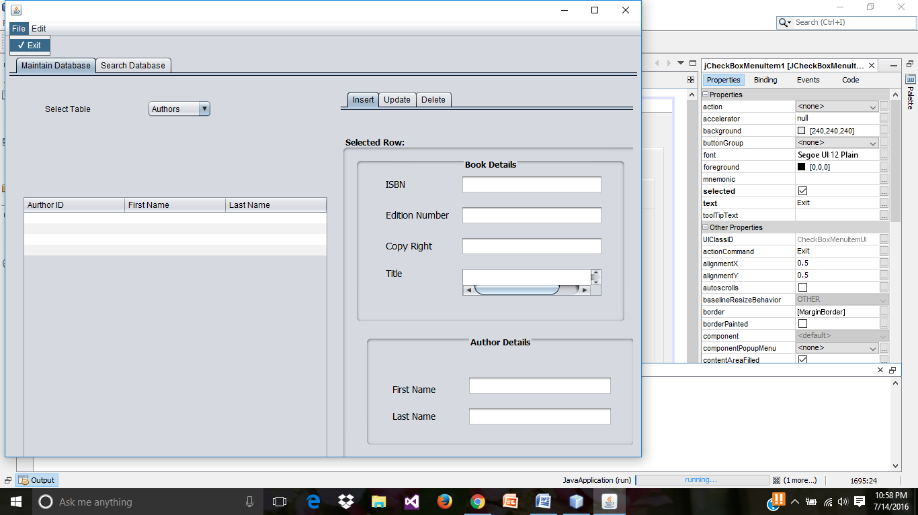

**JDBC Database Application Development**

* Create another java application.

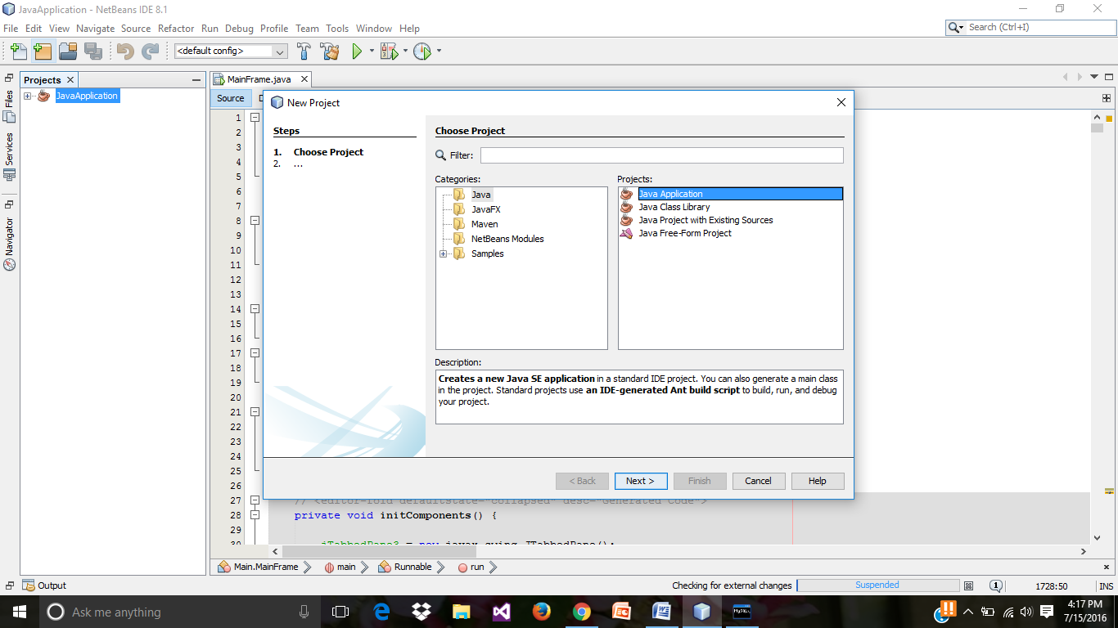

* Creating a new java application, **JavaJDBC** with a Main Class.

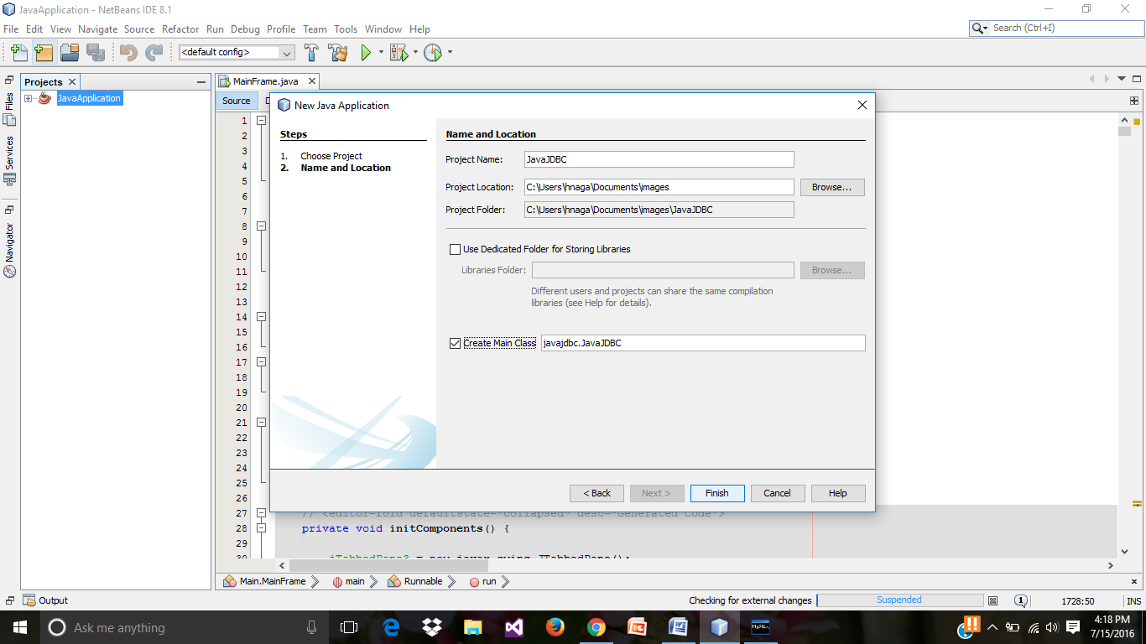

* Code for database connection.

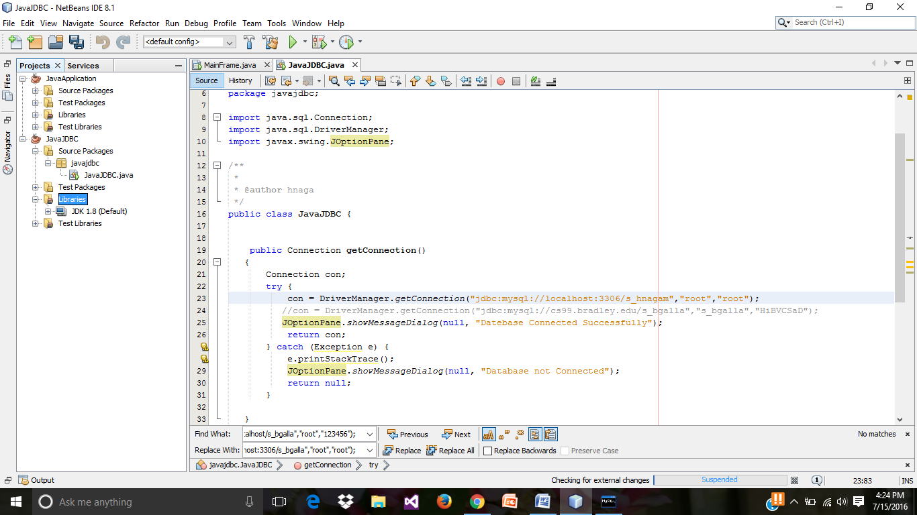

* Add the “**mysql java connector.jar**” file in the **libraries folder**.

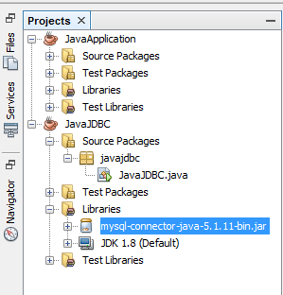

* Below is the source code for insert using the SQL prepared statements.

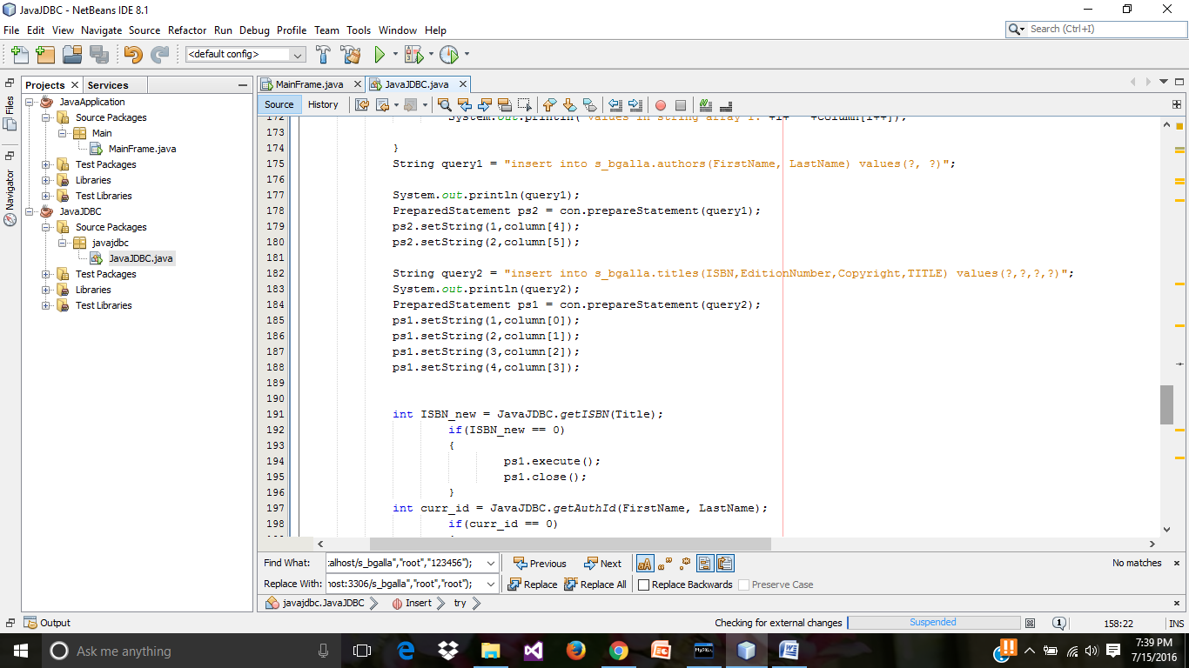

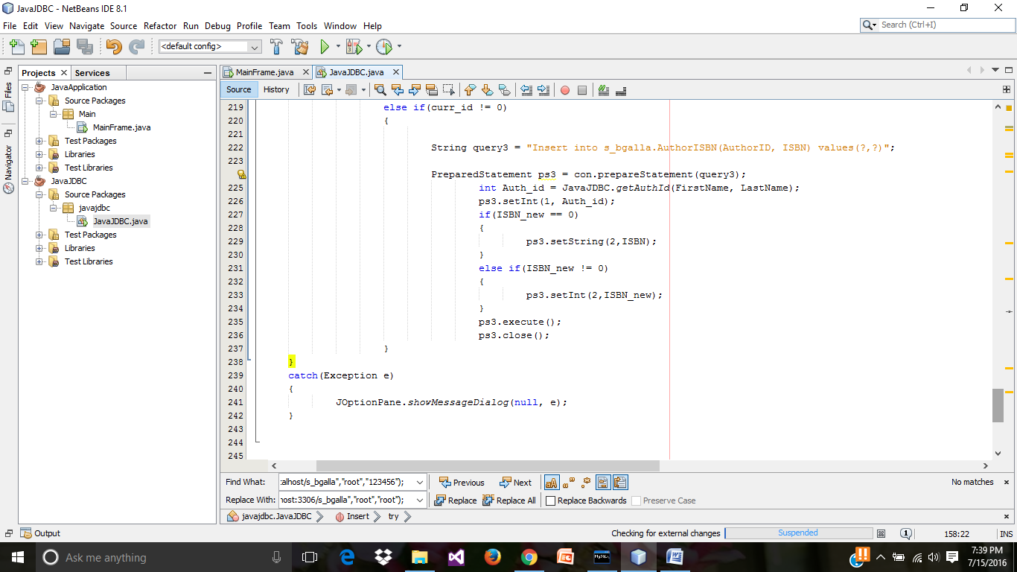

* In the **main class** of the **JavaJDBC.java** call the insert function by pass the insert values as shown below.

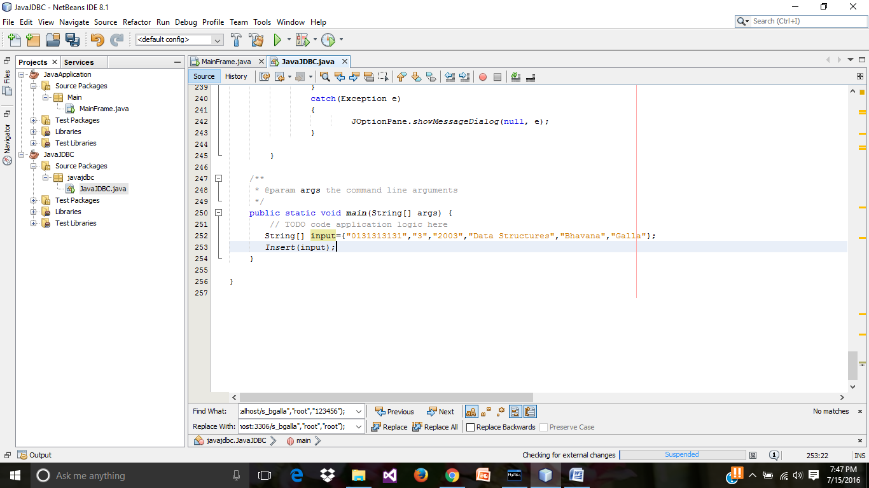

* Preview of run result.

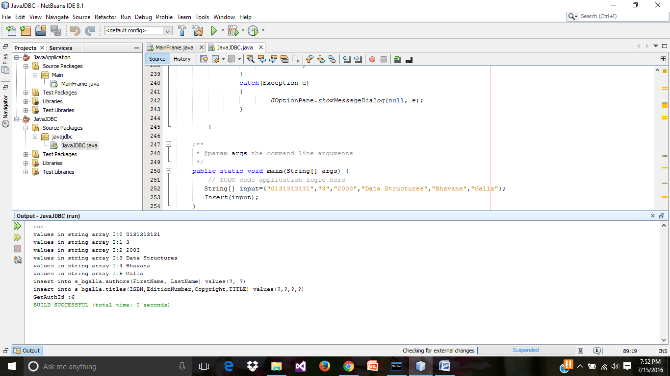

* Checking the inserted record in the local MySQL command line client.

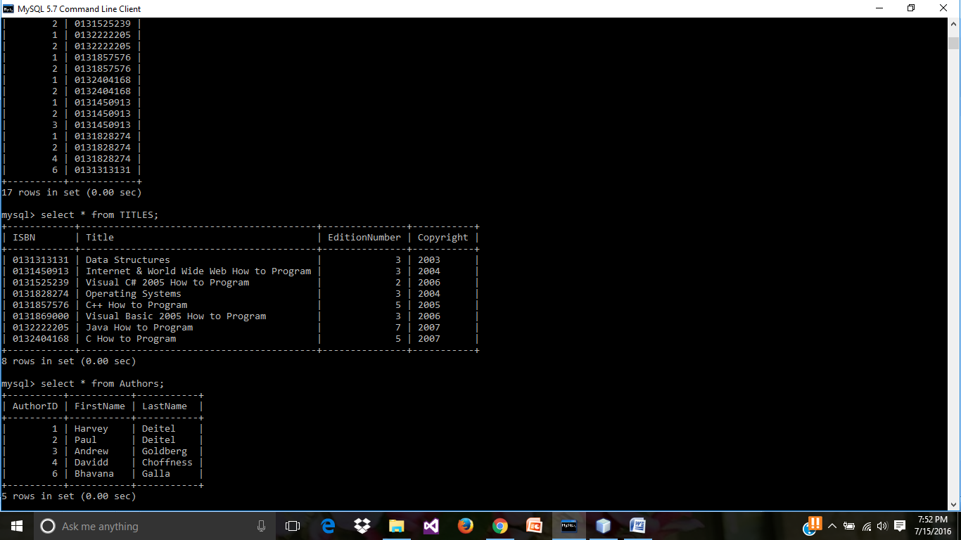

* Source code for Update using the SQL prepared statements.

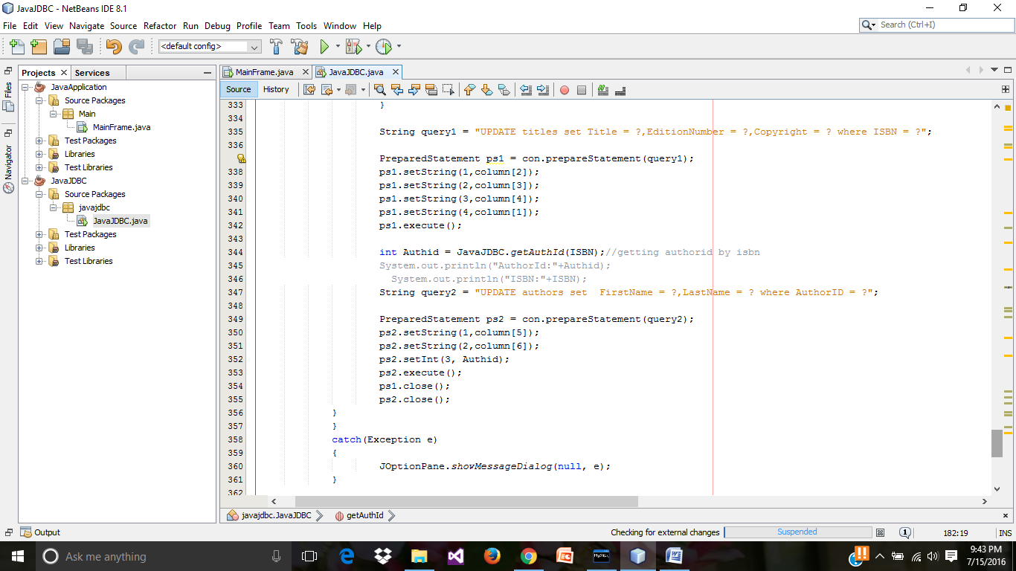

* Similarly, as shown above in the **main class of javaJDBC.java, call the update function** by passing the input parameters.

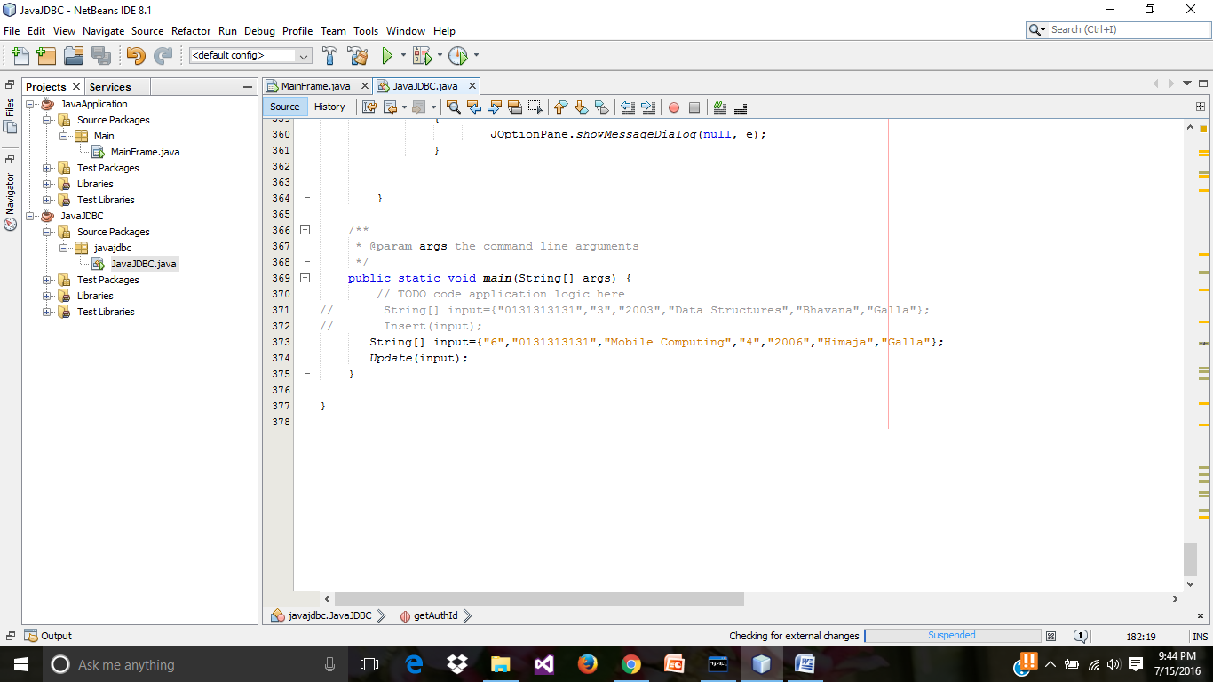

* Run results of updated record.

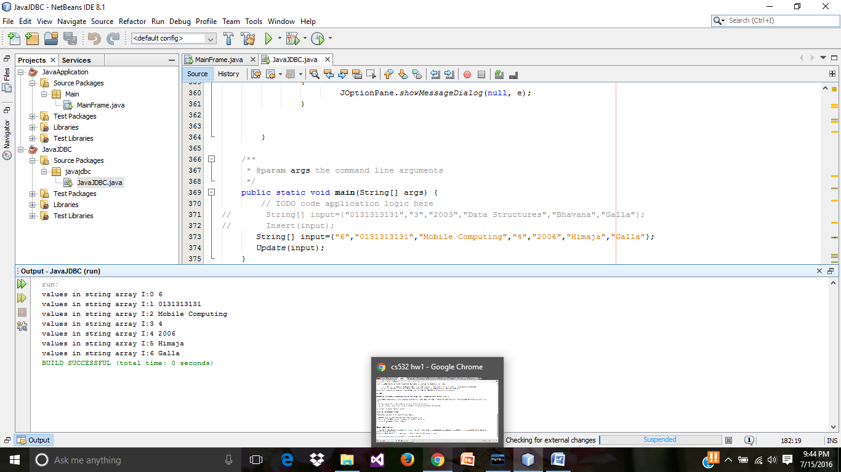

* Checking the updated record in the MySQL command line client.

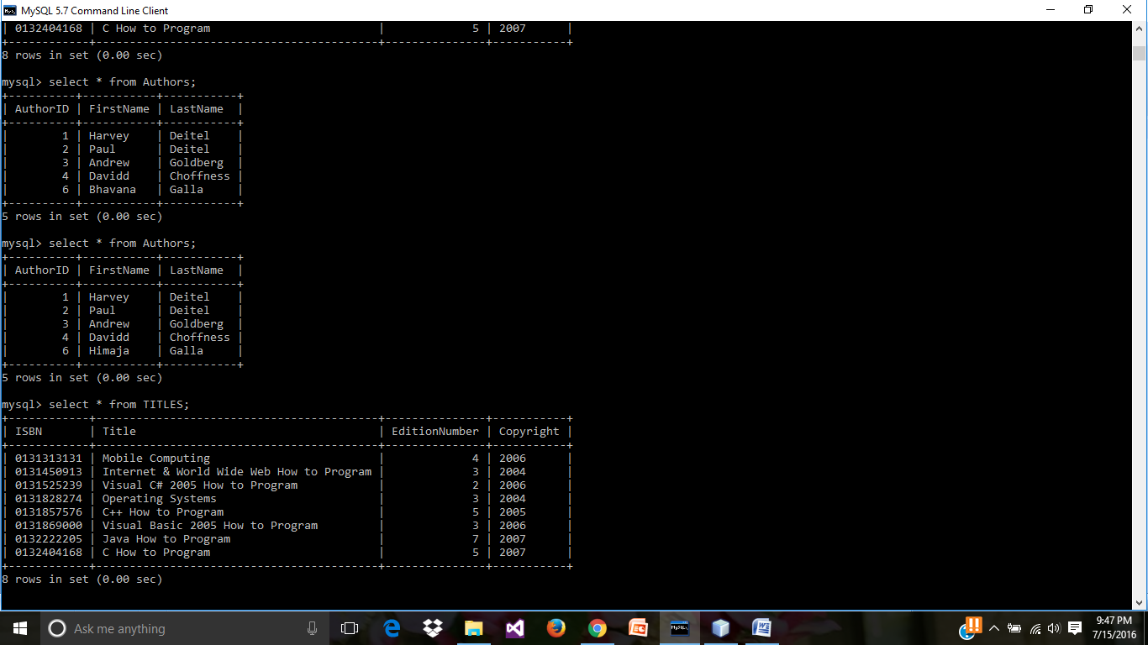

updated record values

Previous, record values

* Source code for delete using prepared statements.

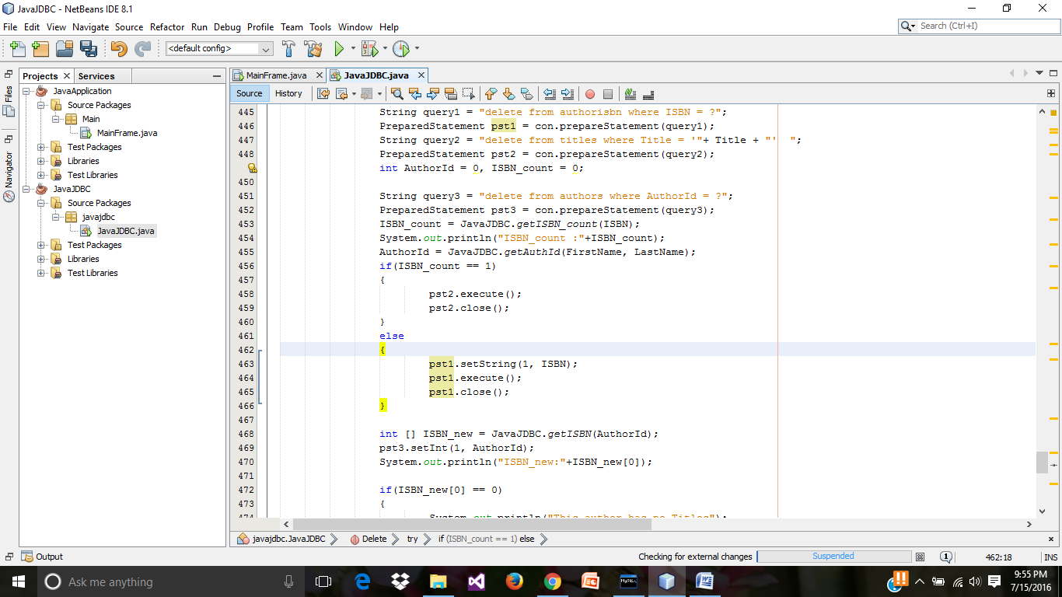

* Similarly, as shown above in the main class of javaJDBC.java, call the delete function by passing the input parameters.

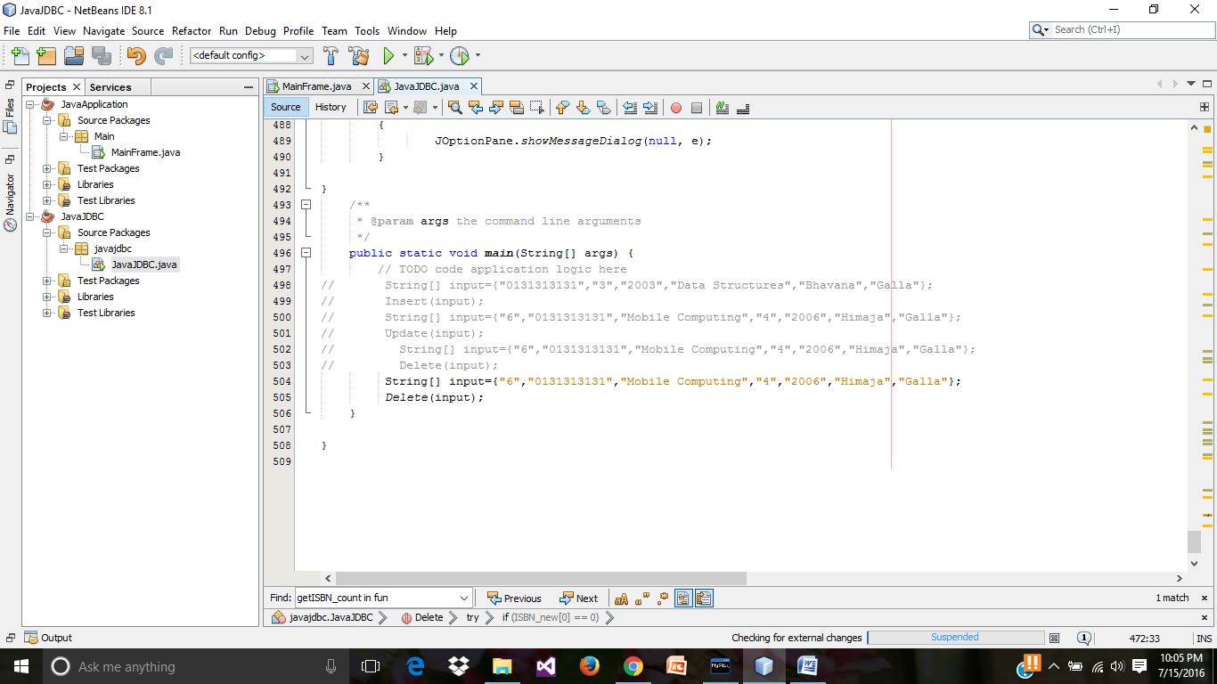

* Run result in delete action.

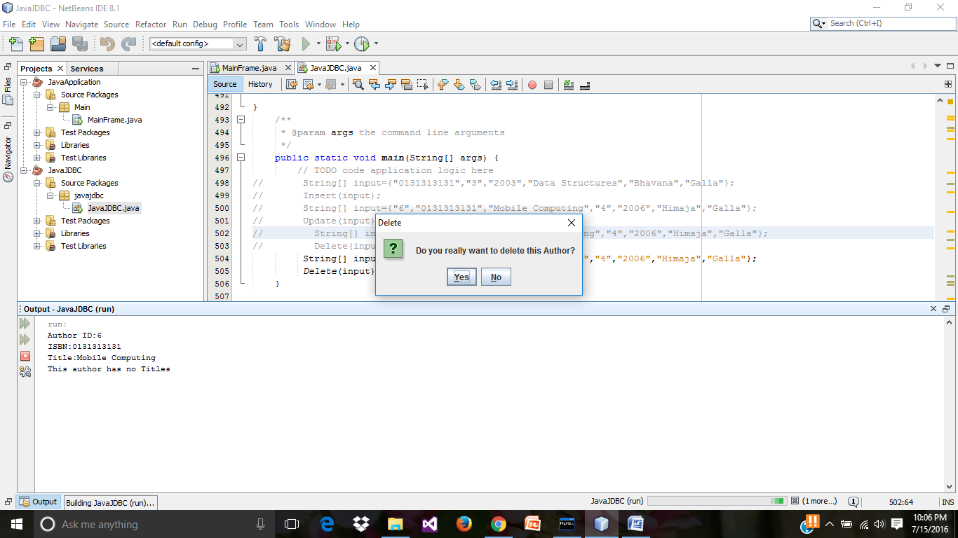

* Checking the deleted record in MySQL command line client.

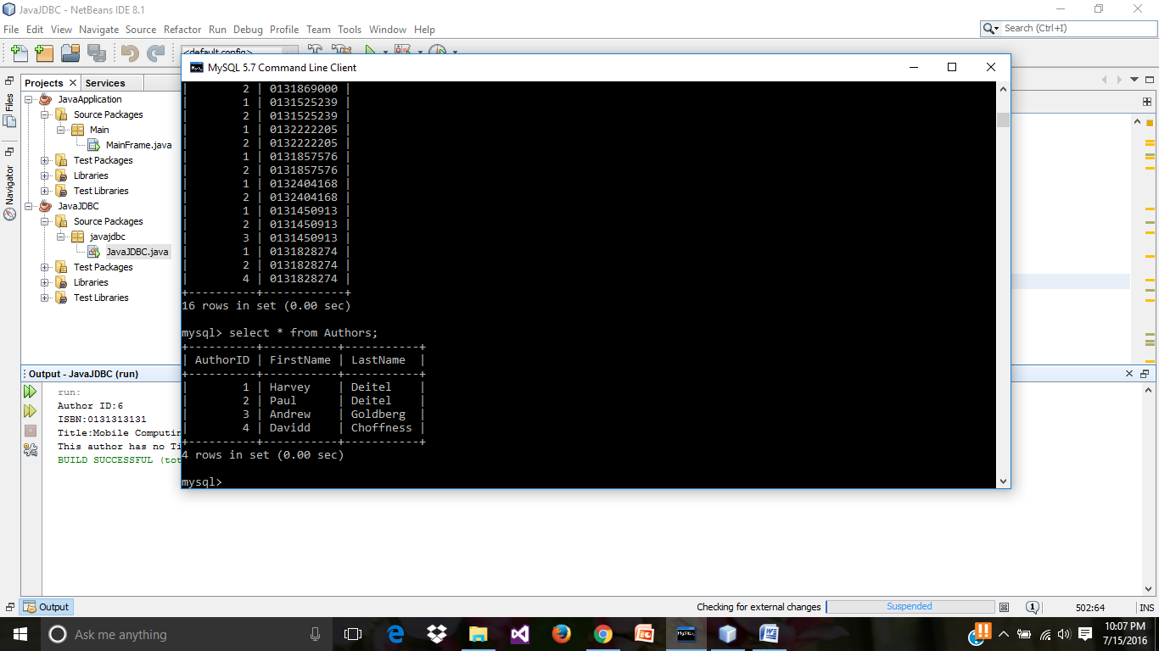

* + - For **Querying the search results in book database tables**, and
    - For **Combining the above GUI and JDBC**, (ie.,JavaApplication and JavaJDBC)
* create a **javaJDBC .java** connection in previous JavaAppication (GUI)

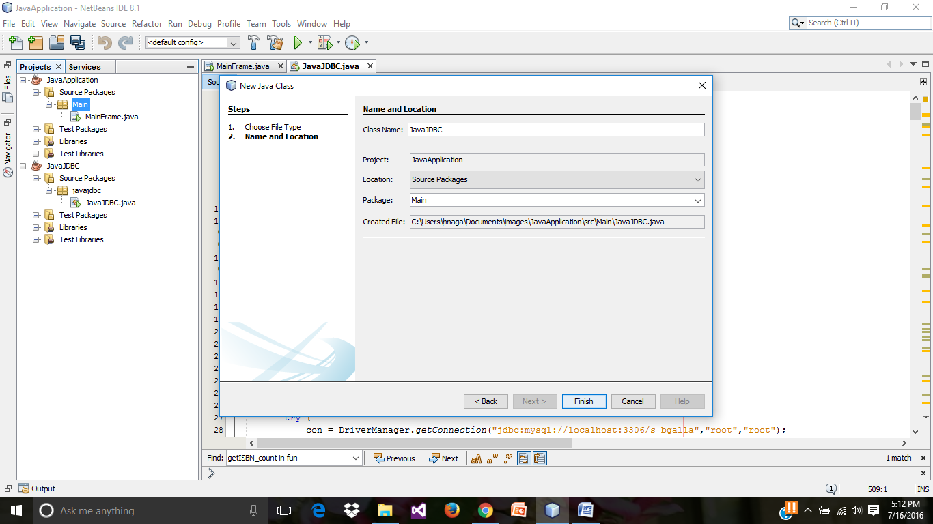

* Create another java class **Table_Fields** in Main Package.

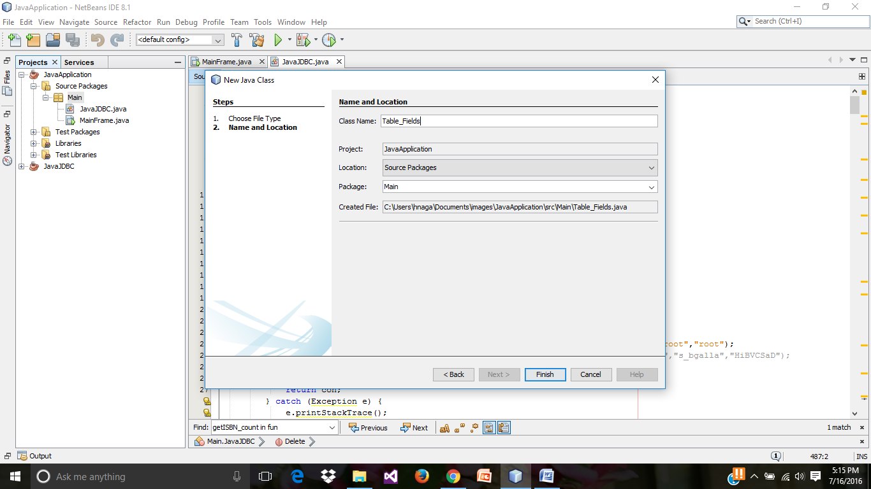

* Source code for **Tables_Fields.java** for passing the table column values to the **javaJDBC.java class for querying the database tables.**

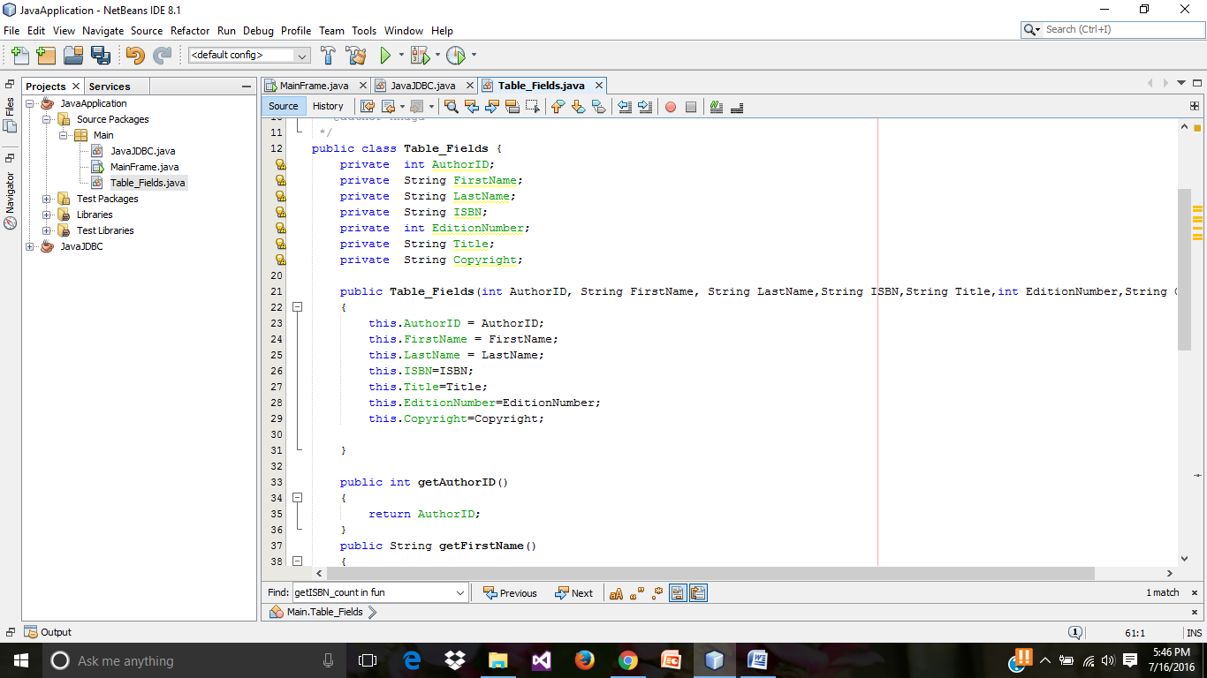

* Source code in **JavaJDBC.java** for querying database tables using the sql statements.

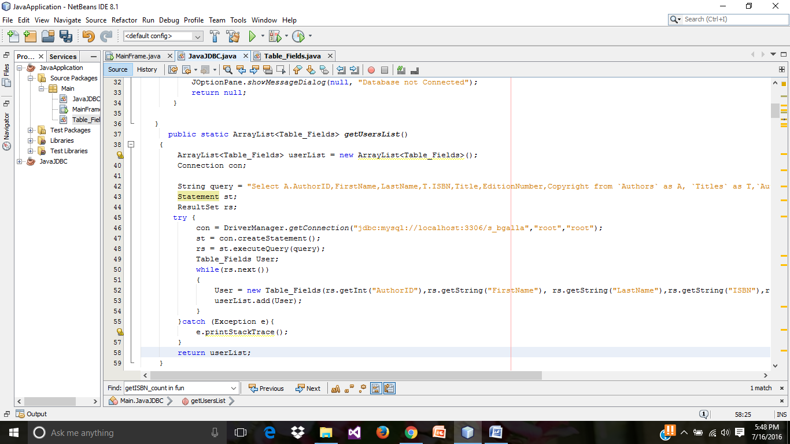

* In MainFrame.java (GUI) edit the table contents and set the 0 rows in rows tab.

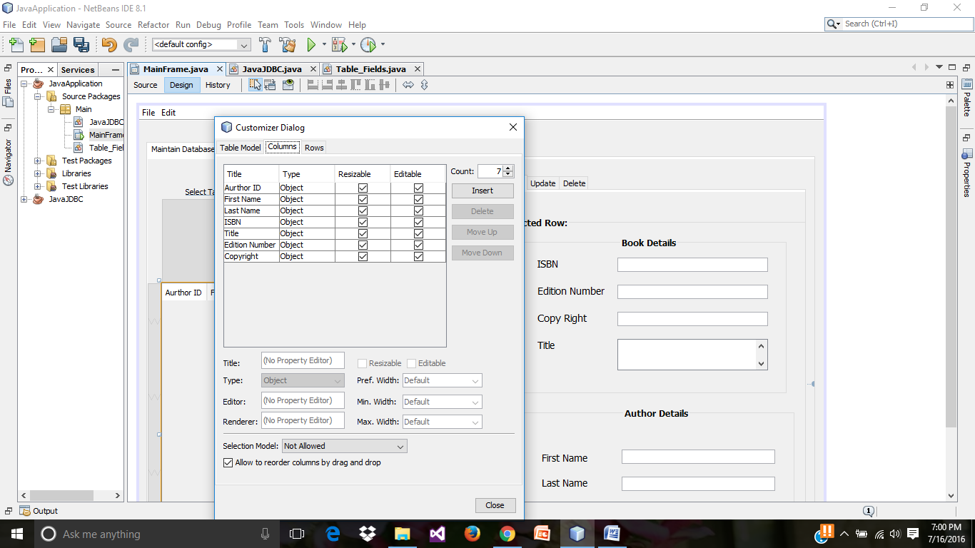

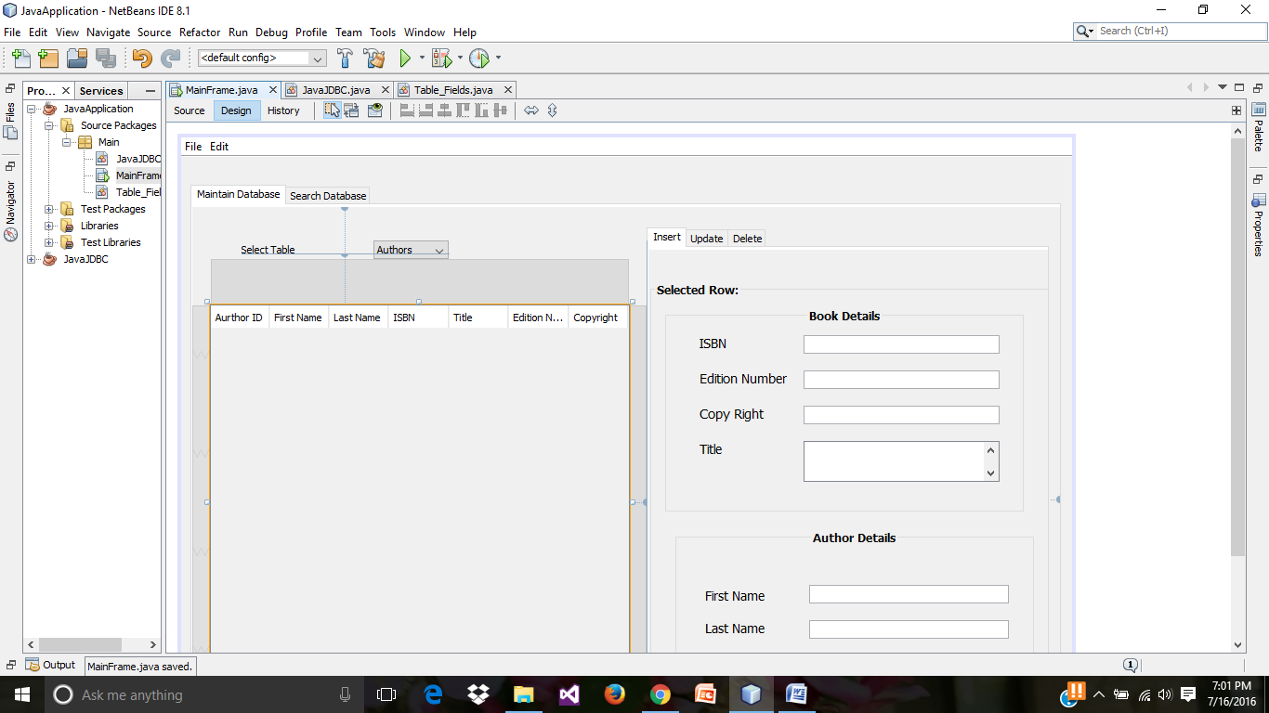

* Creating a **show_All_In_JTable()** function to display the table in the above GUI table (**jTable_ALL**) and call this function through the Main class.

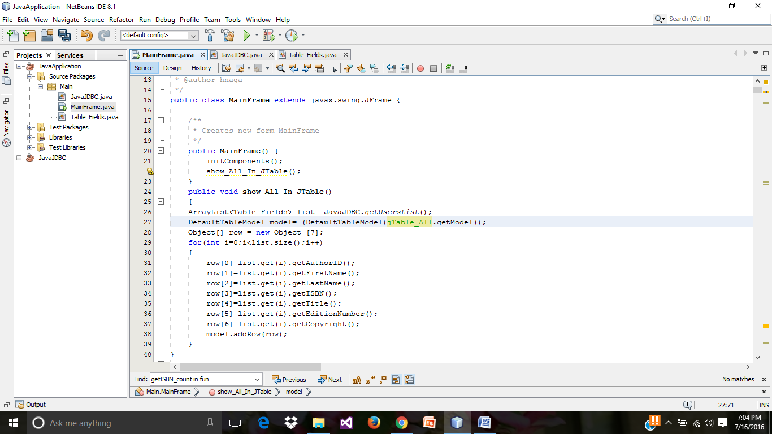

* Preview of run result till now.

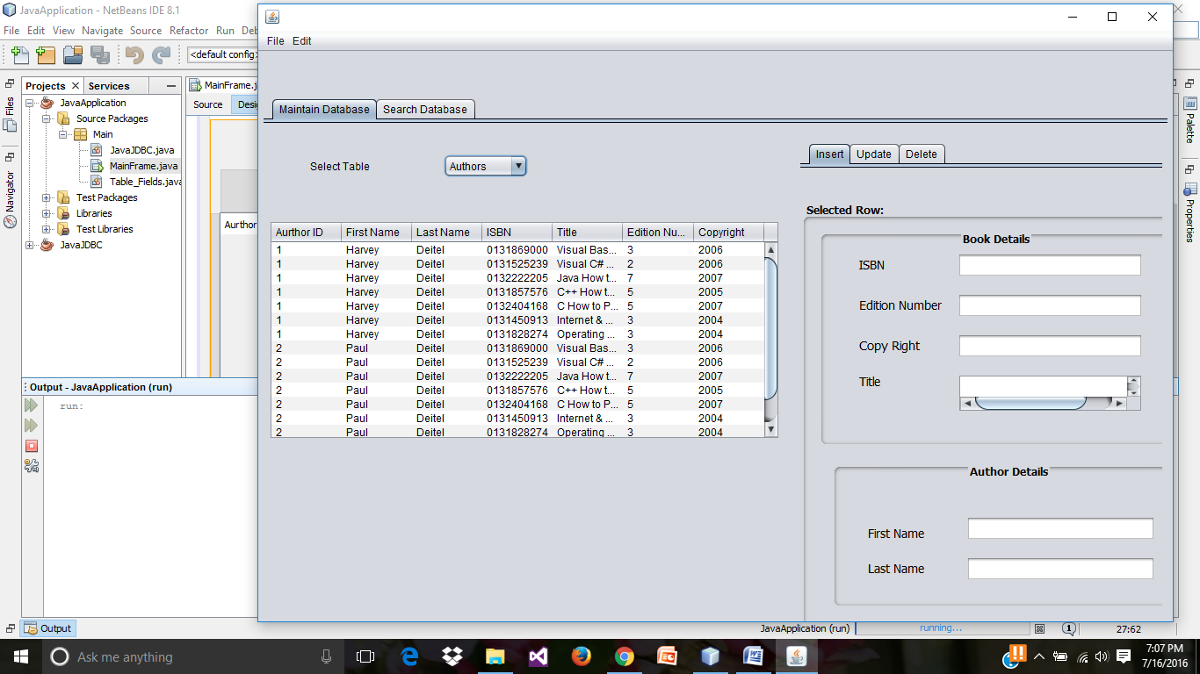

* Add another table from the palette.

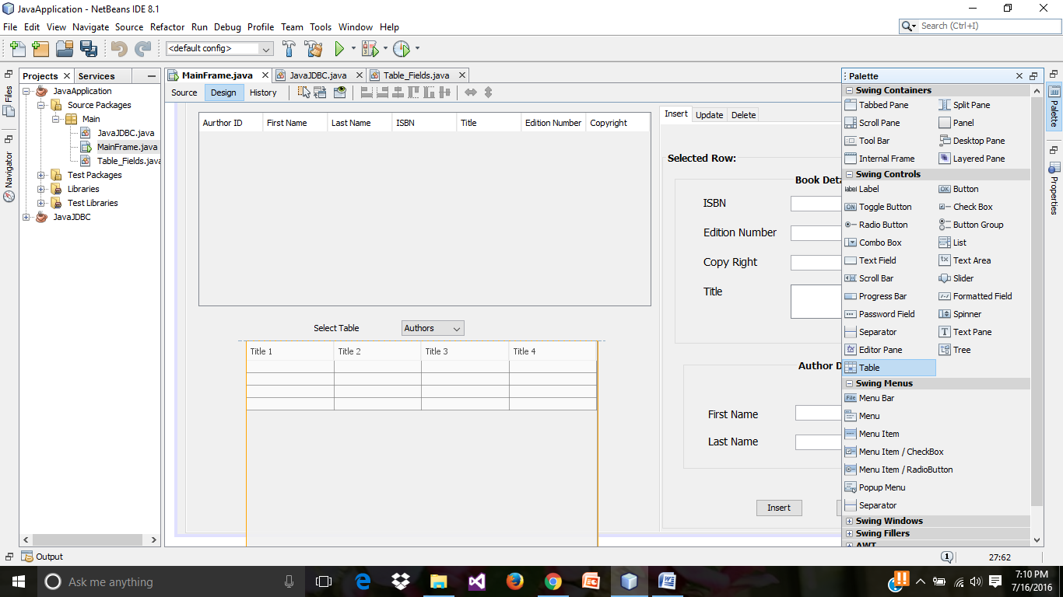

* Enclose the table in a panel.

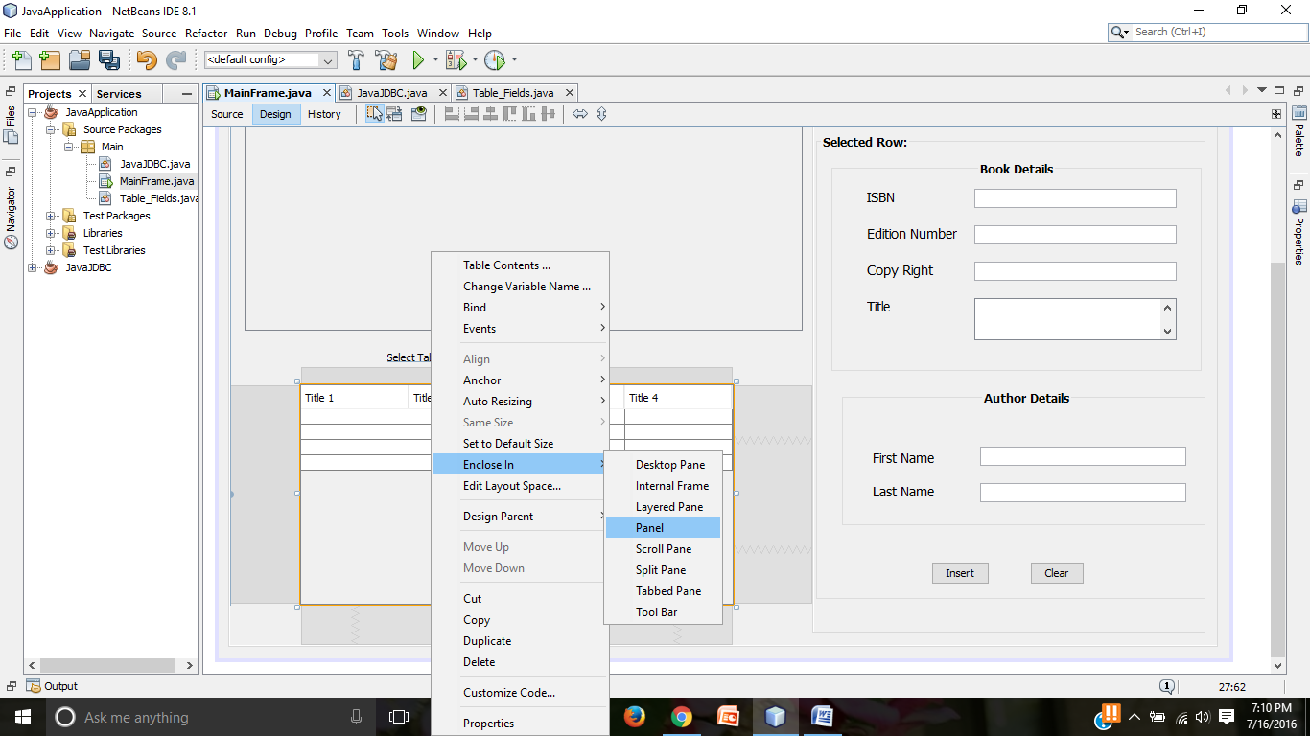

* Change the variable name of table to jTable.

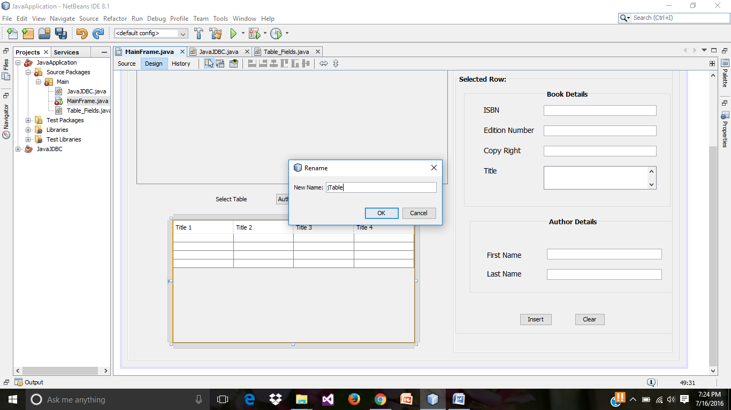

* Remove all the columns in the table and set the row value to 0.

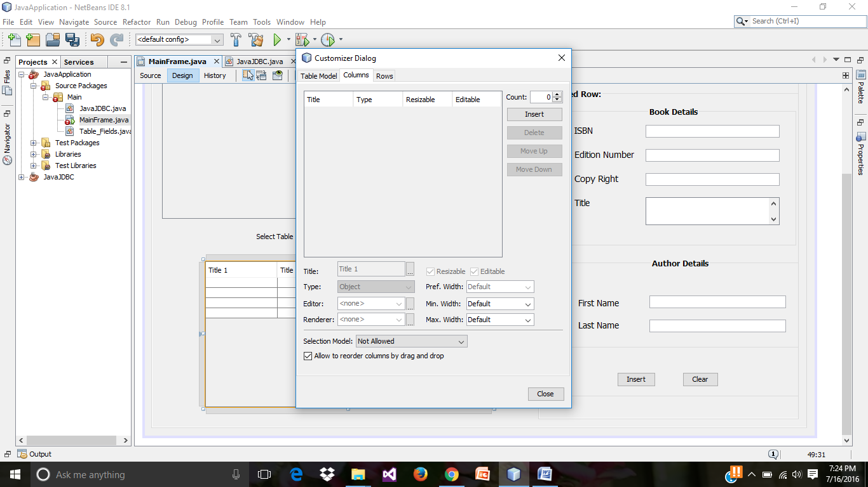

* Source code in **MainFrame.java** is binding the **jcombobox** and the above table (**JTable**).

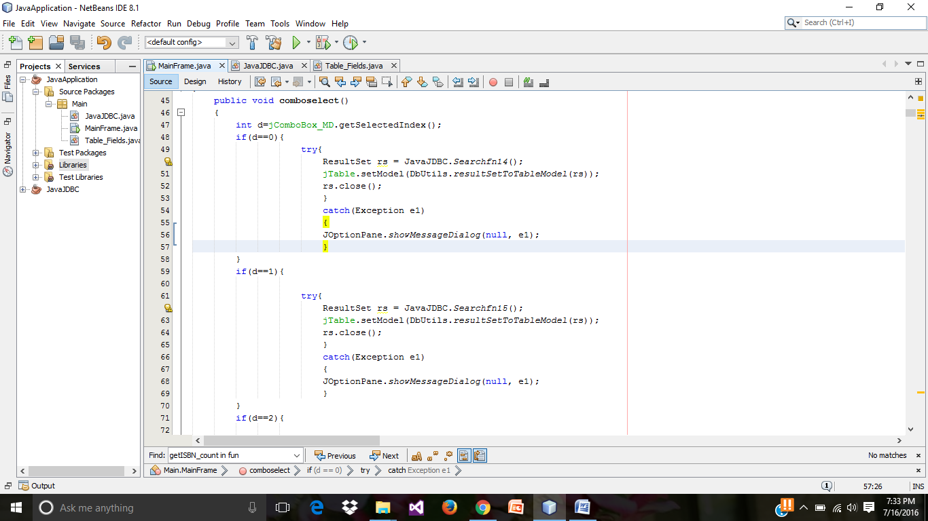

* Call the above function in the **jCombobox** event action.

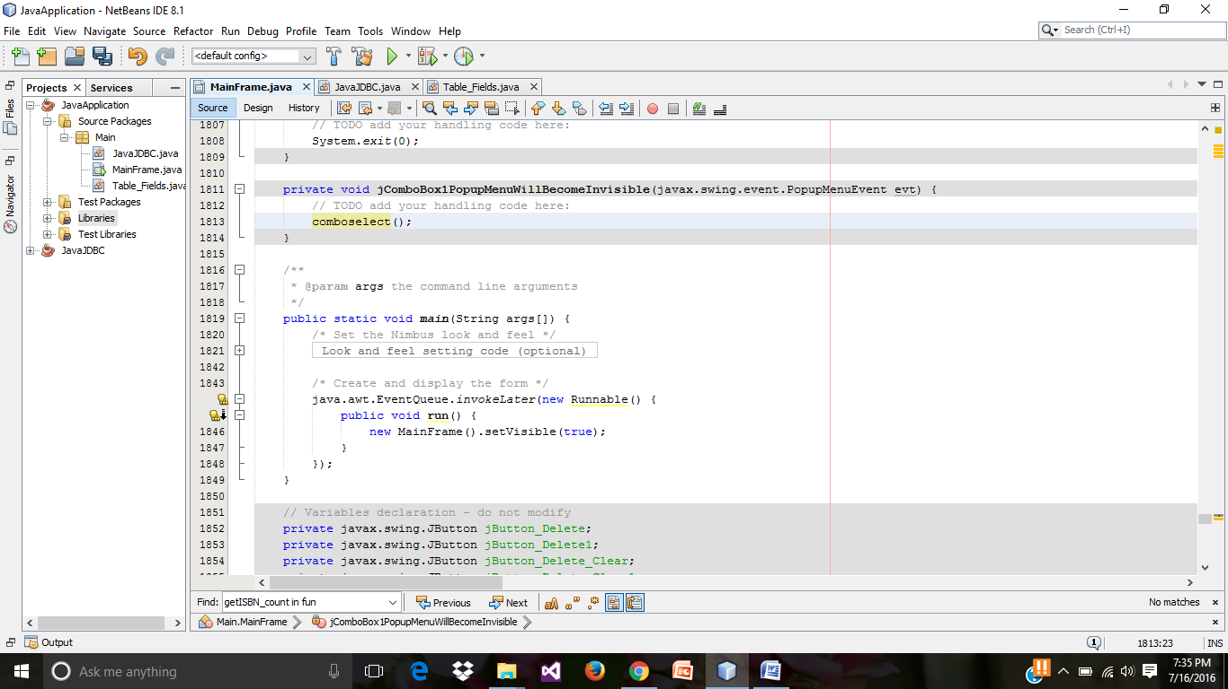

* Preview of run result till now.

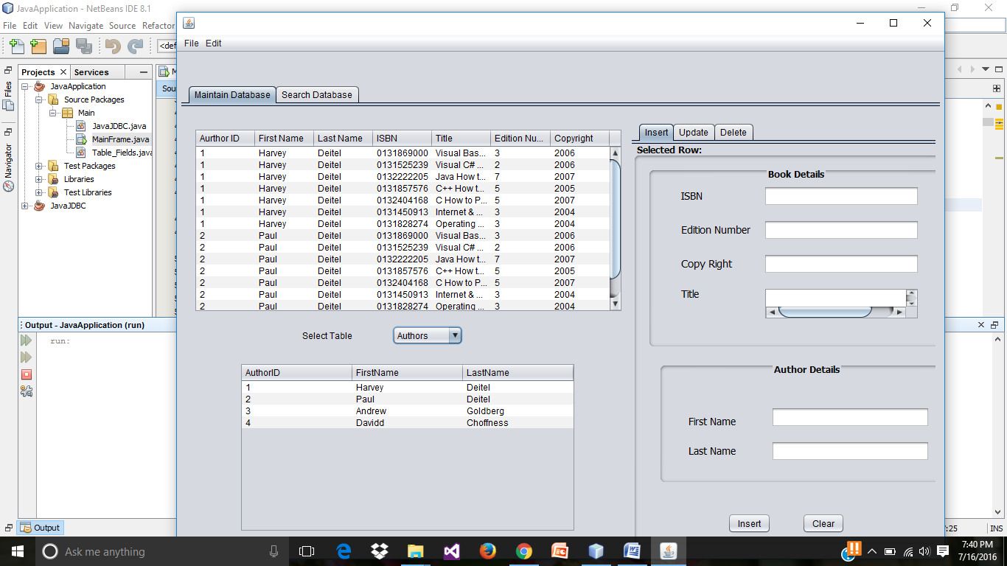

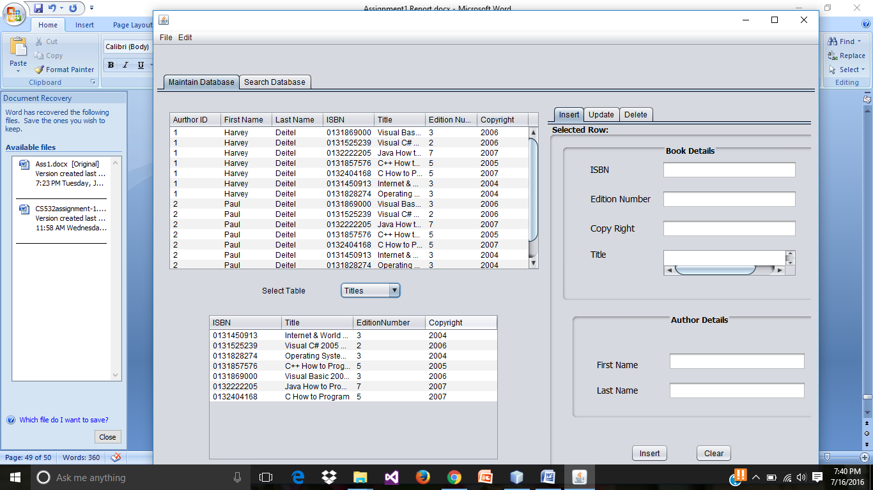

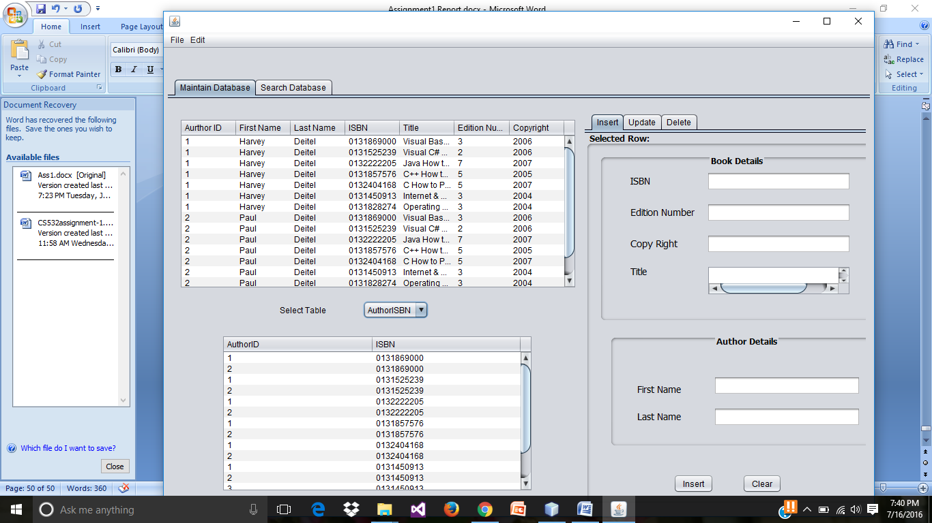

**For dynamically getting the data from database table, to the input fields**.

* Create the mouse click event on the table as shown below.

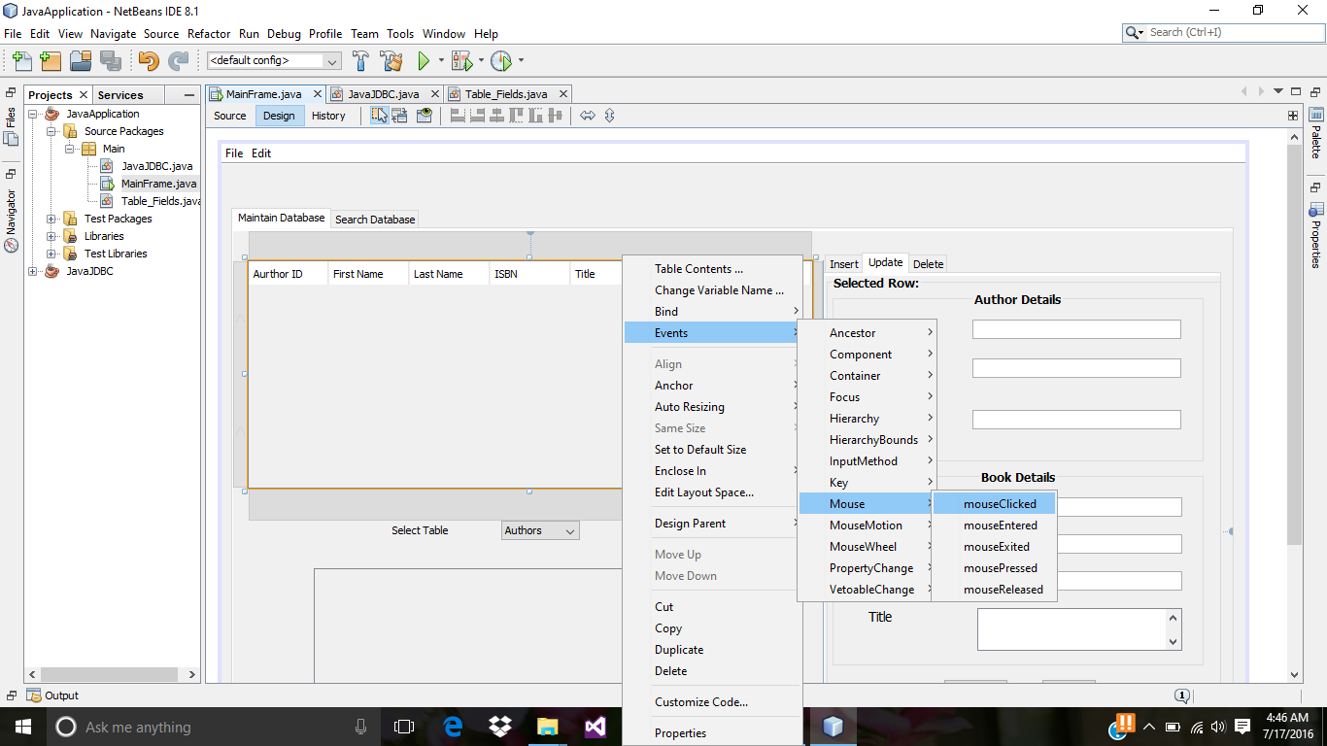

* Source code for getting the selected table row data in the input fields.

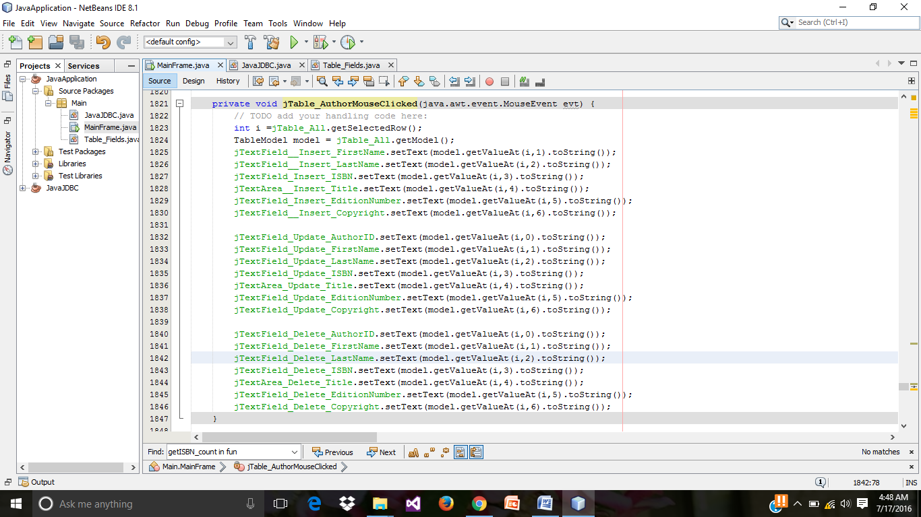

* Preview of run results displaying the selected row data in the table, to the input fields of update tab.

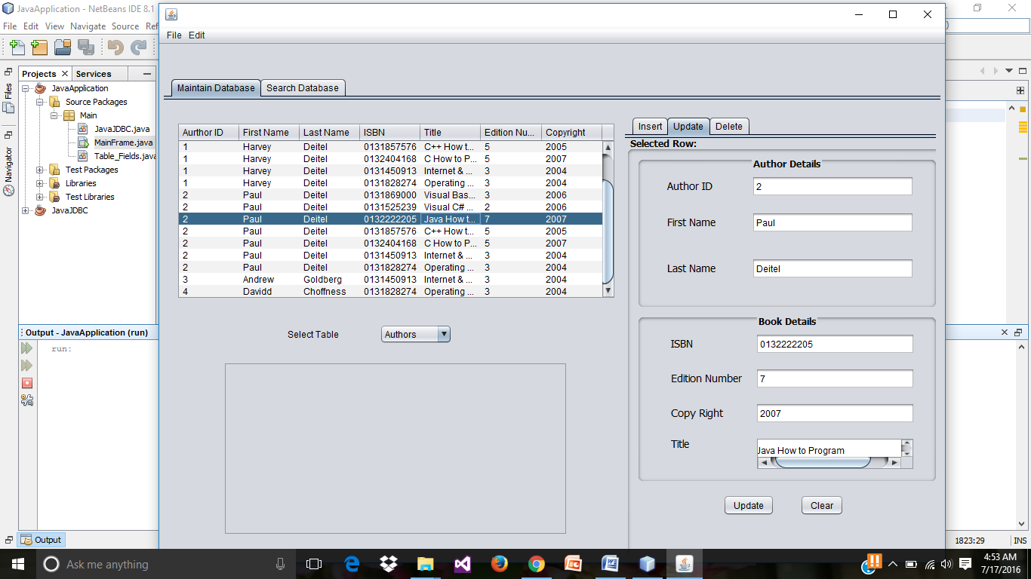

* Preview of run results displaying the selected row data in the table, to the input fields of delete tab.

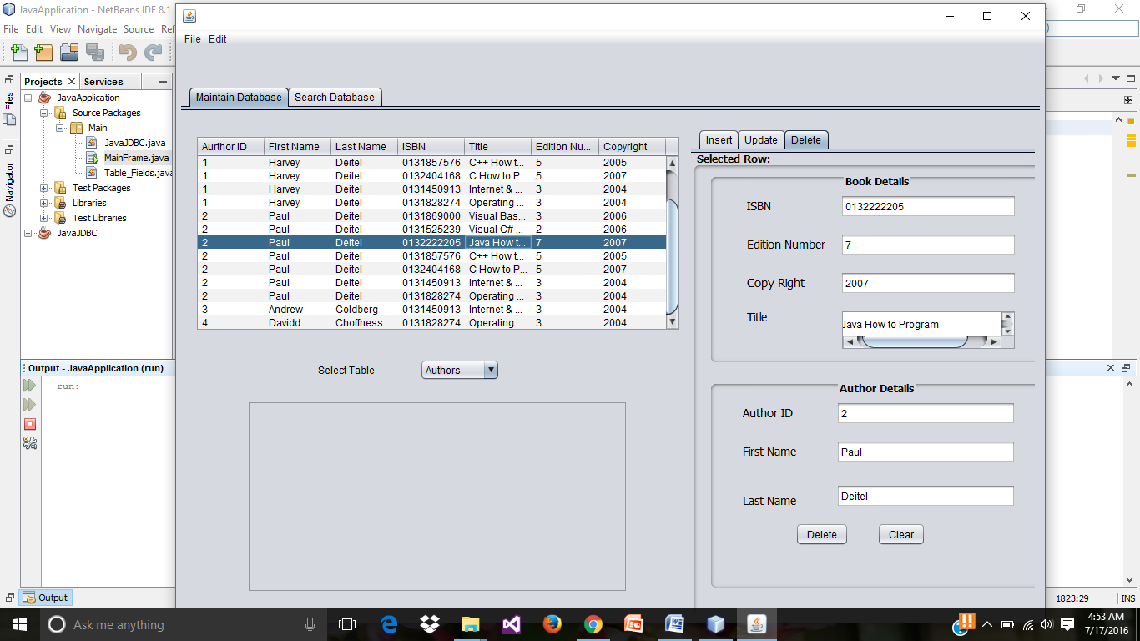

* Creating the **actionPerformed** for insert button.

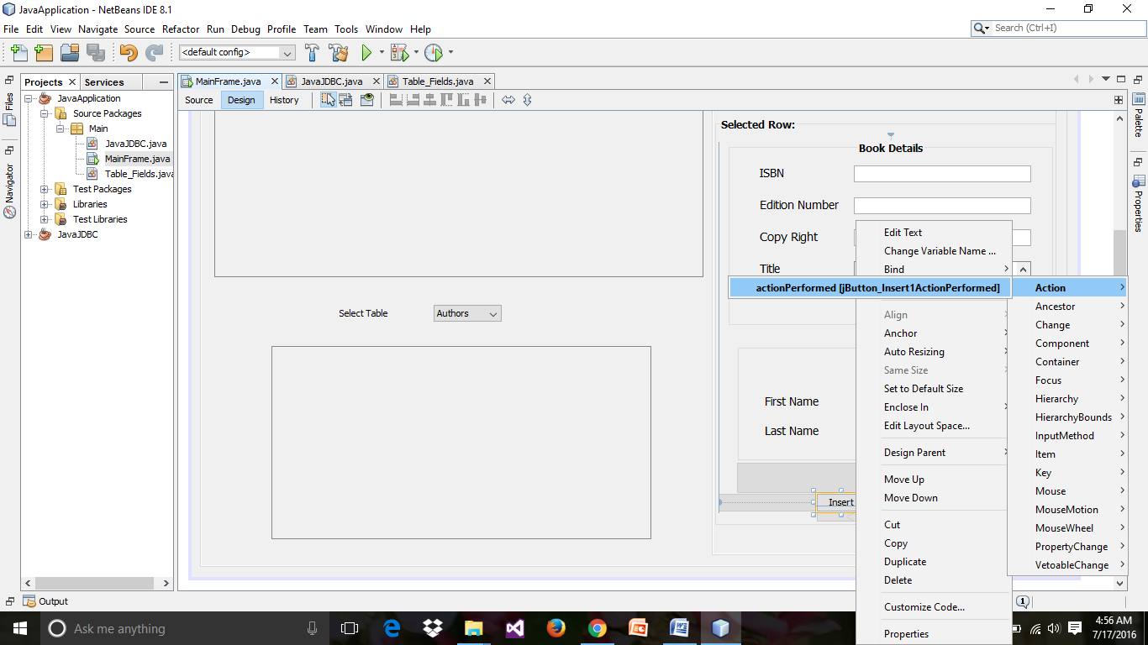

* Rewrite the **JavaJDBC.java code** in **JavaJDBC application** to the JavaJDBC.java class in **JavaApplication (gui)** .

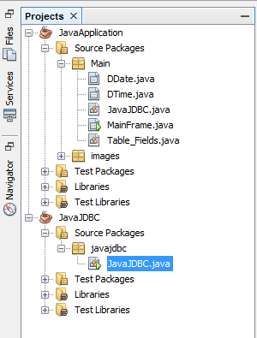

* Source code for Insert button and update button on action performed.

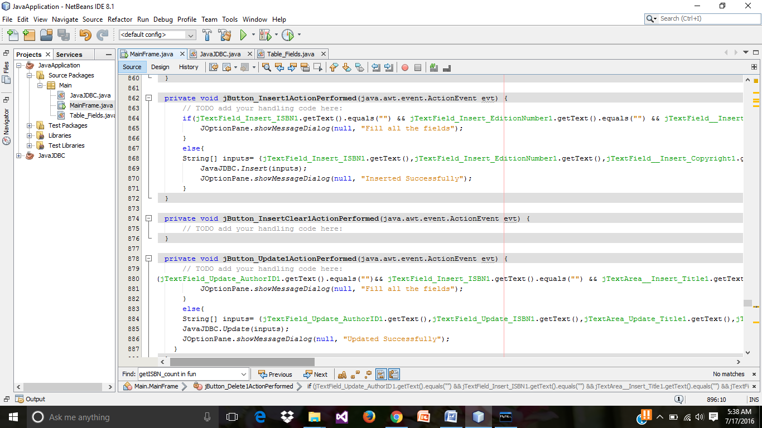

* Source code for update button and delete button on the action performed.

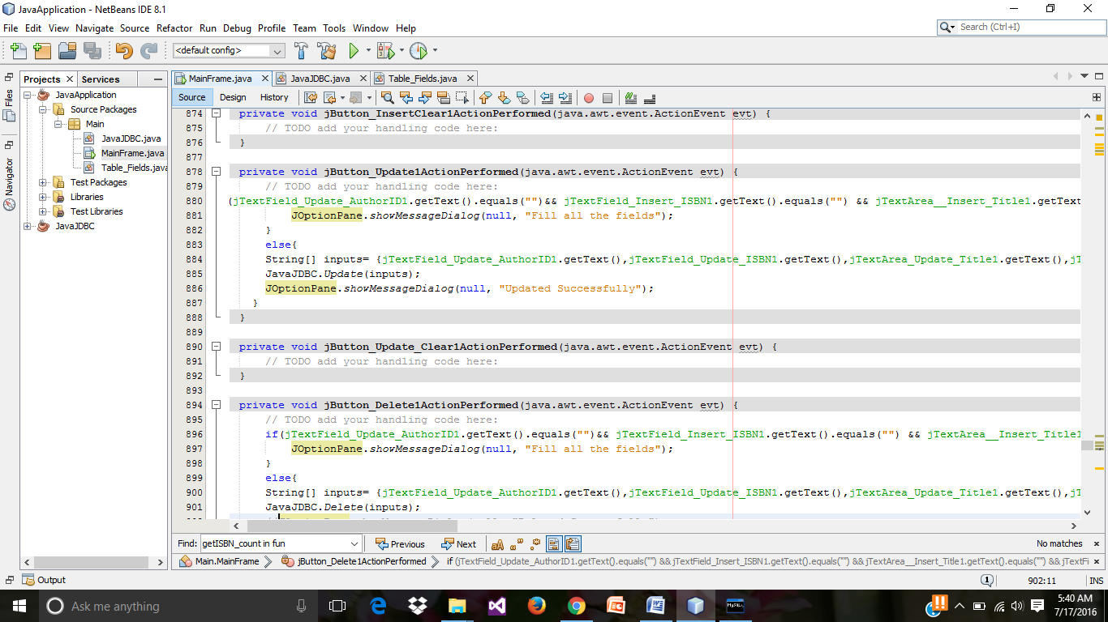

* Preview of run results on **inserting new data**.

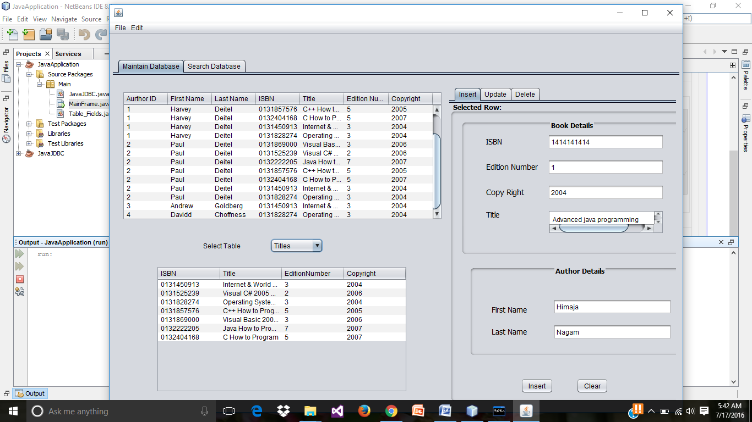

* Preview of run results on click on Insert Button.

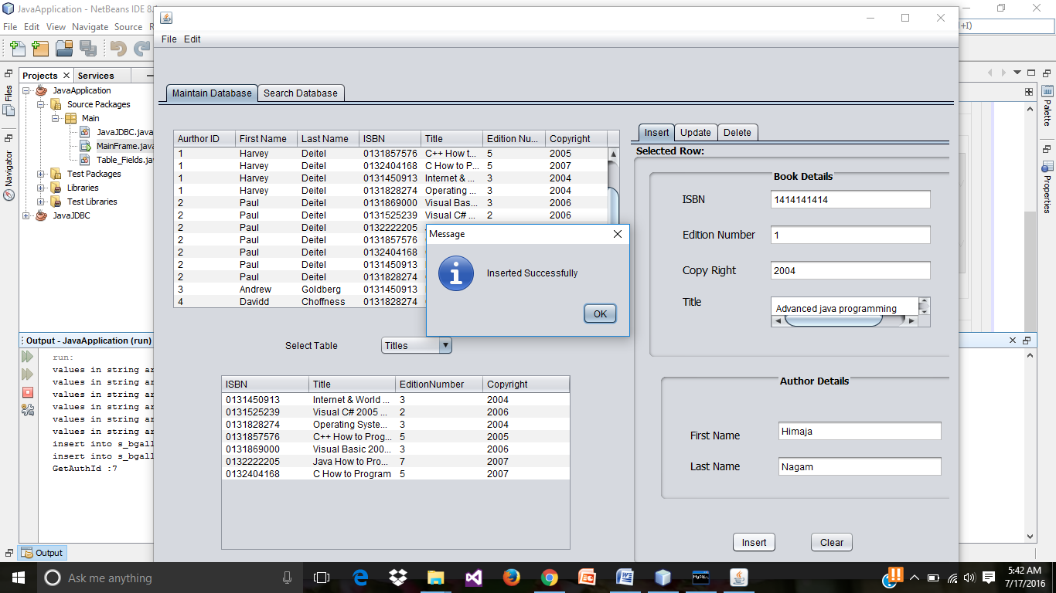

* Add a JButton and rename its variable name.

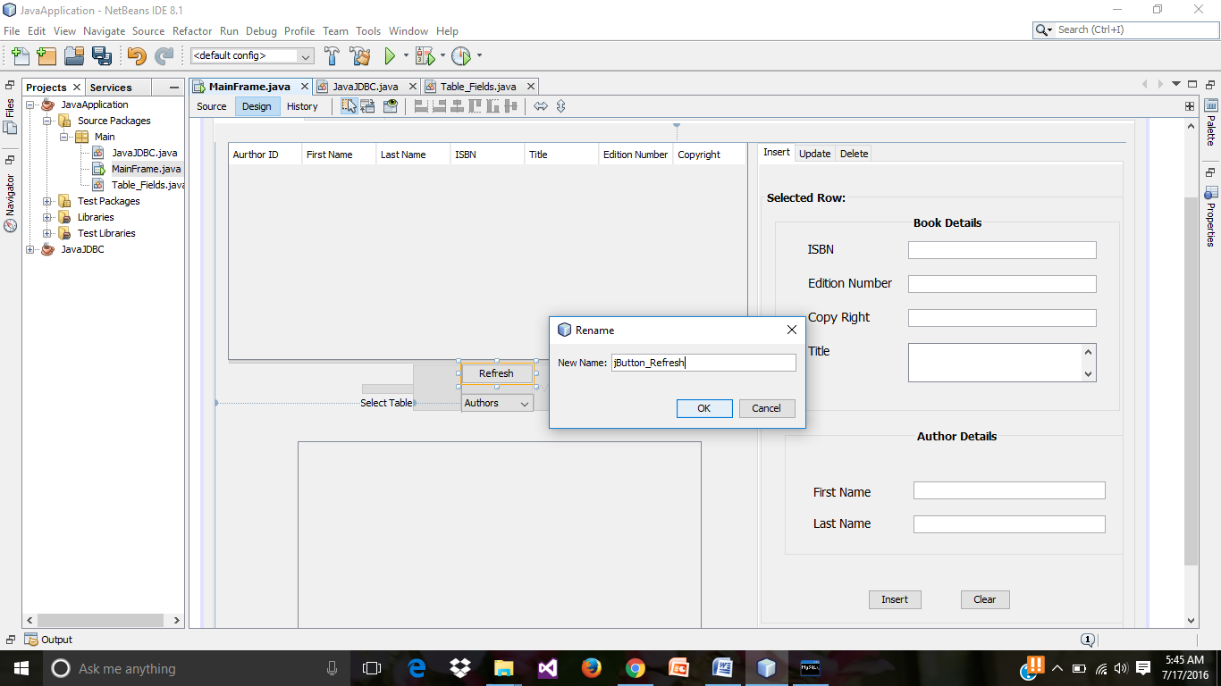

* Soure code for above refresh button, on the action performed.

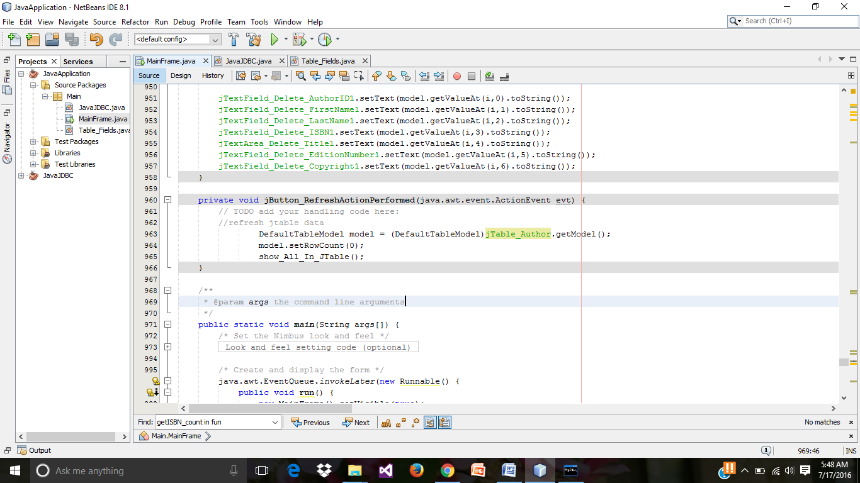

* In below run results, we can see the recently inserted record in the table.

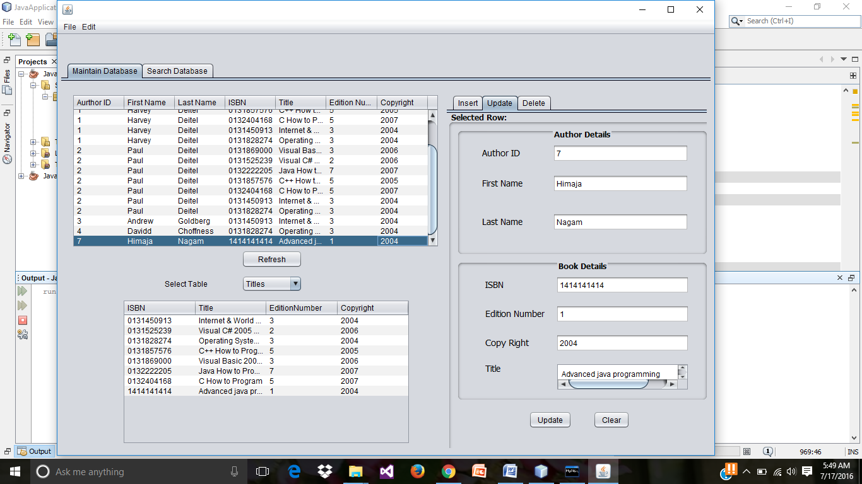

* In run results update the recently inserted data.

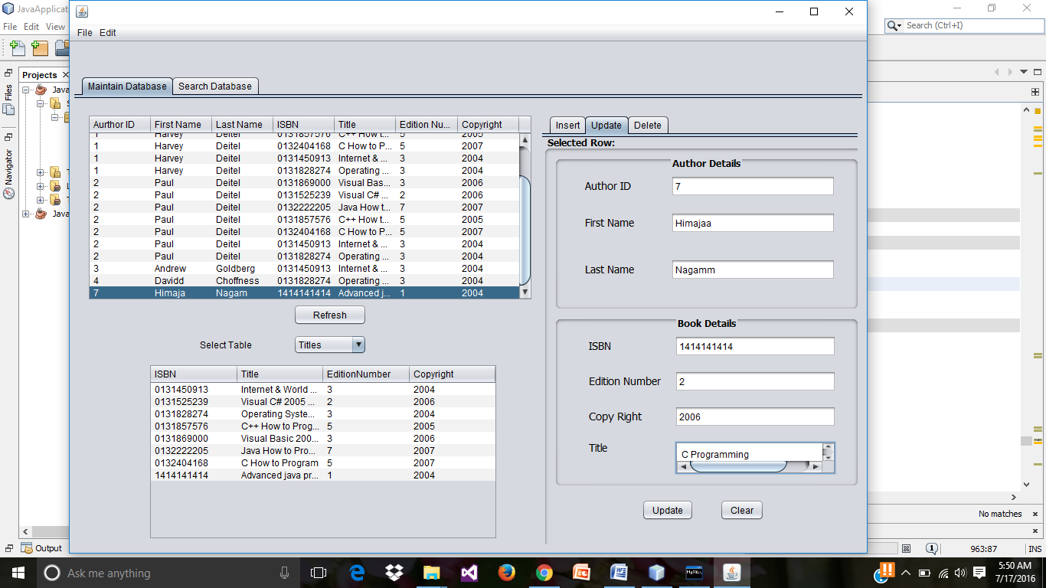

* Preview of run results on click on update button.

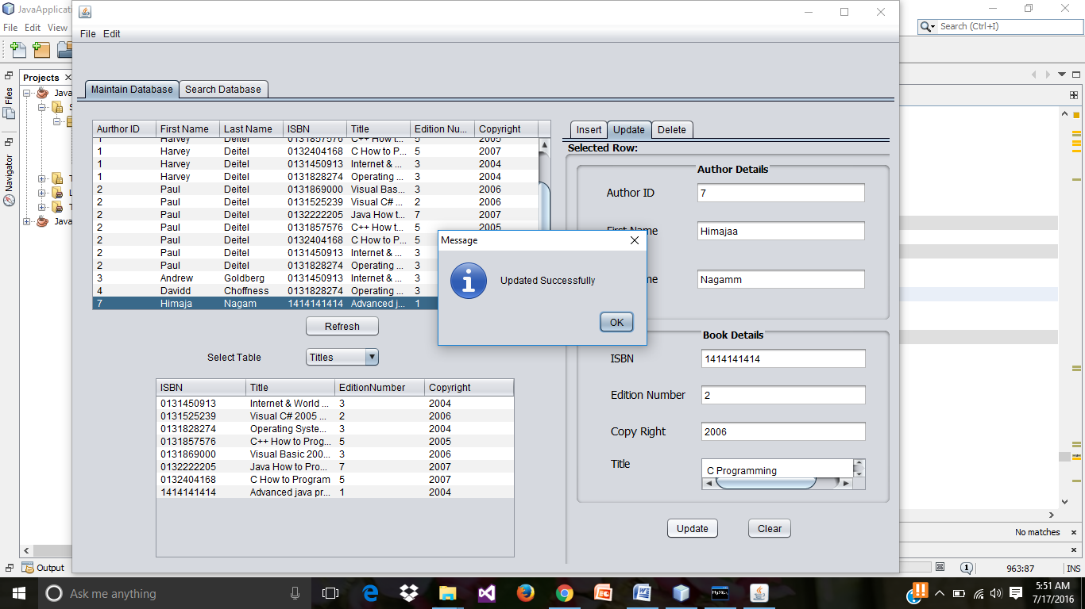

* On click on the refresh button, we can see the updated record.

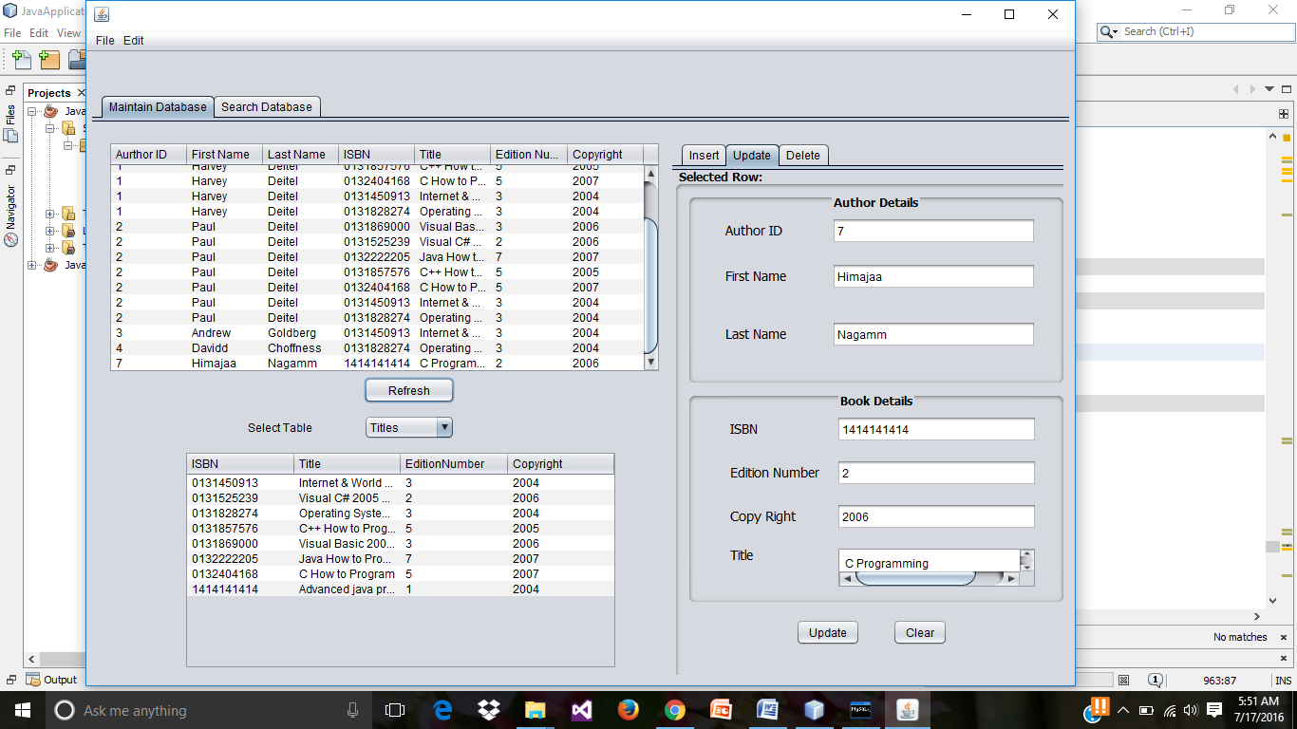

* Preview of run results for deleting the record.

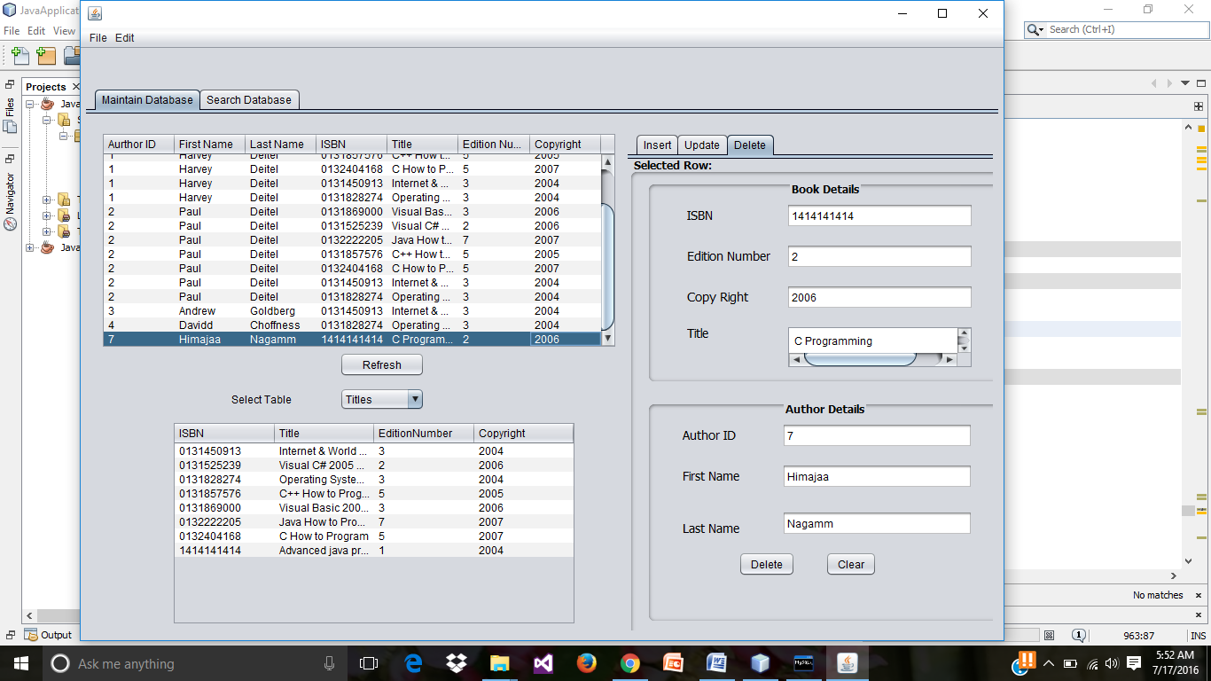

* Preview of run results on click on delete button.

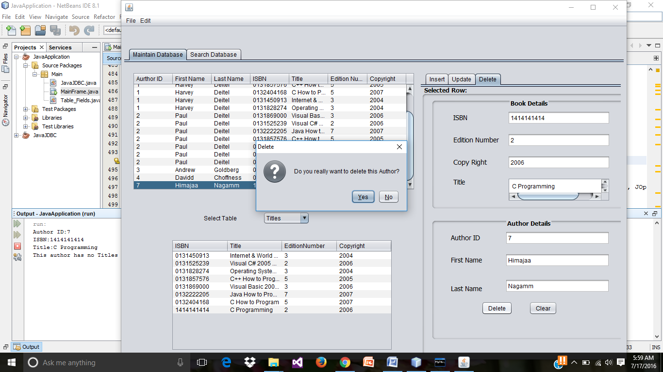

* Preview of run results on click on refresh button, we can see that the record is deleted form the database.

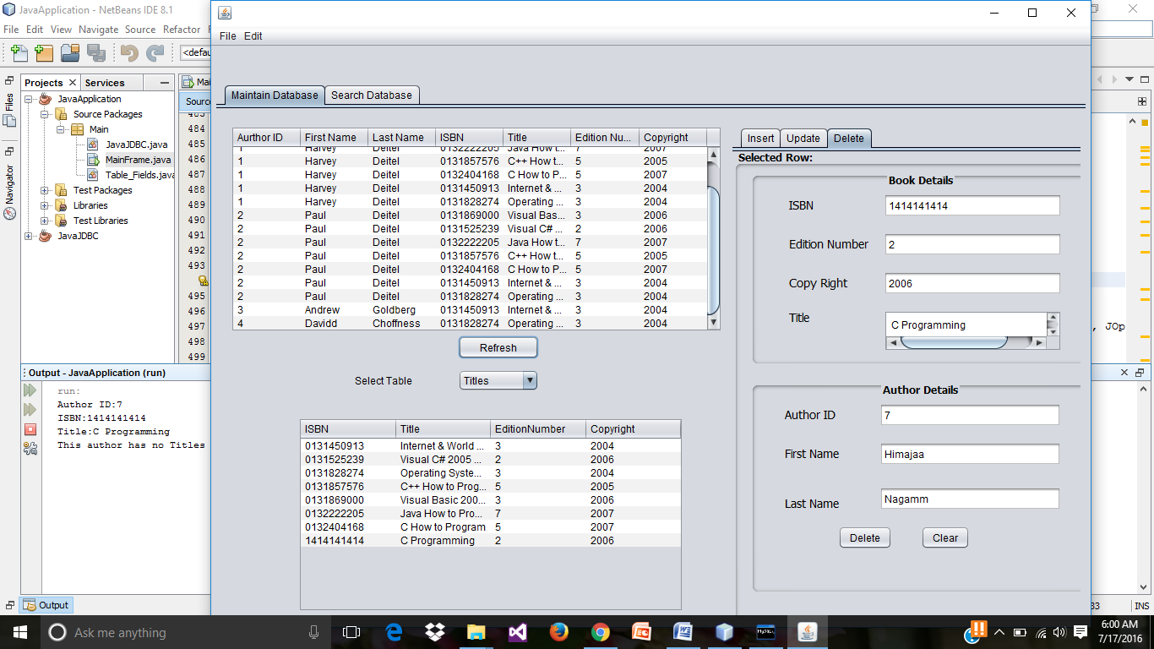

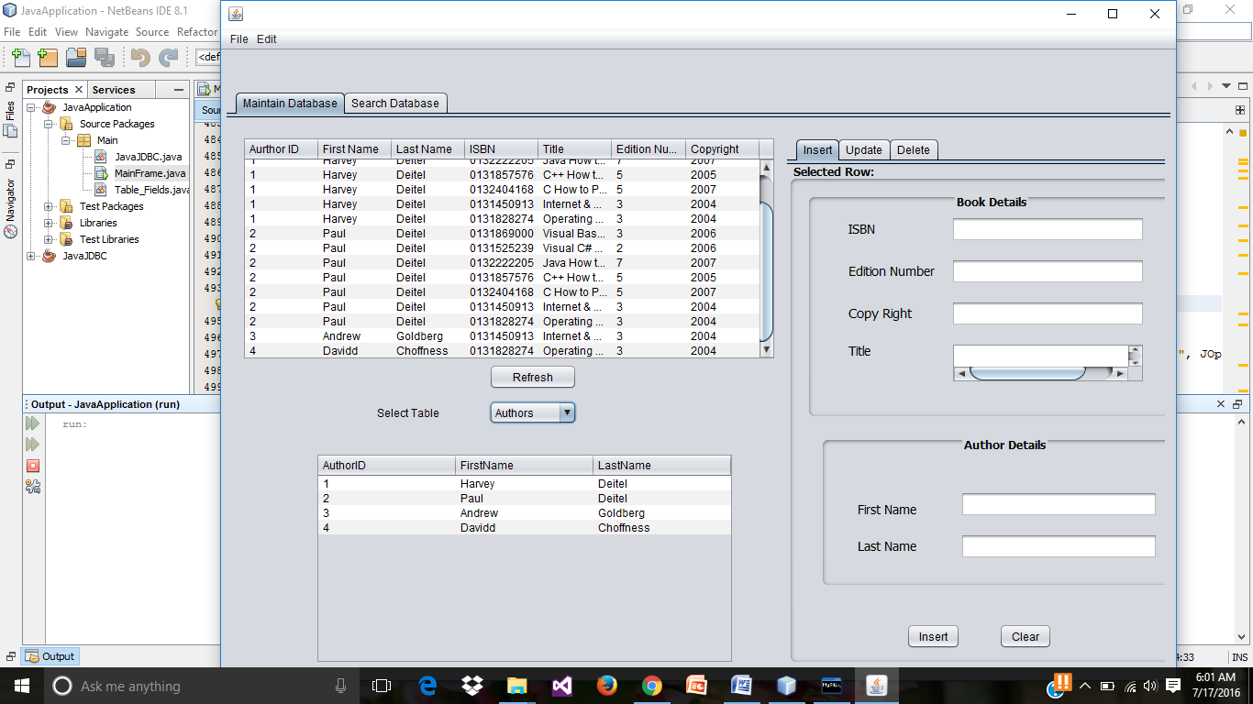

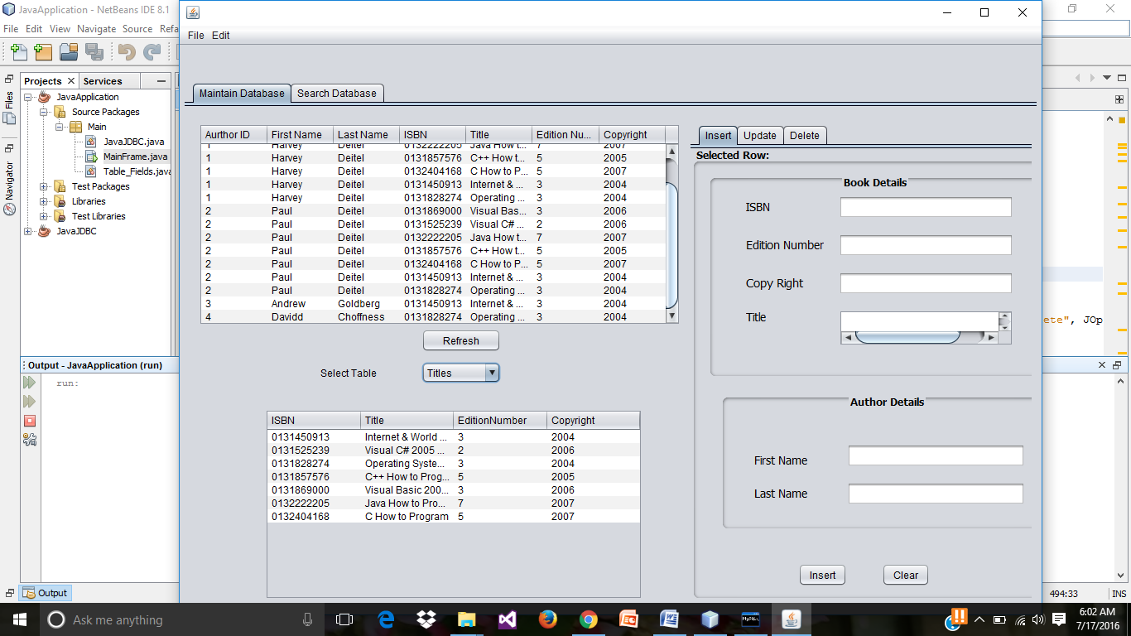

* Action performed for **clear button.**

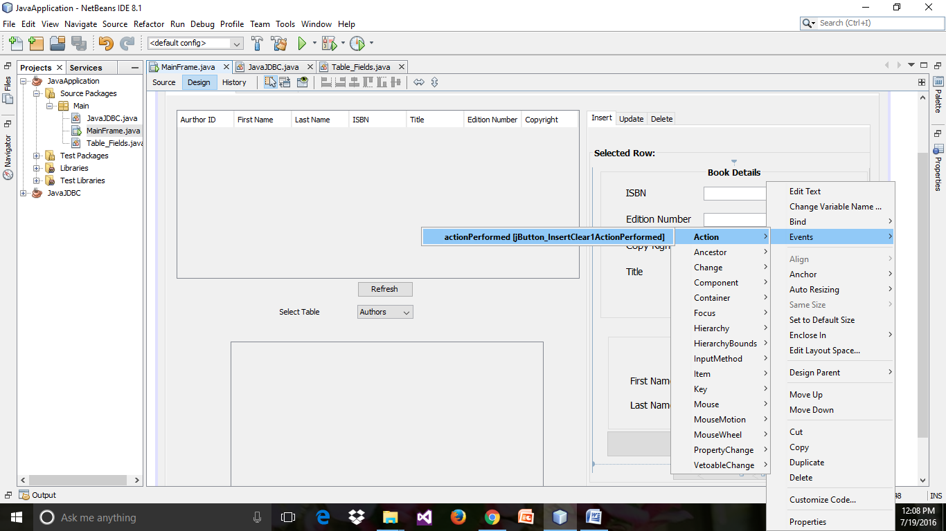

* Source code for clear button, setting all the input field values to empty.

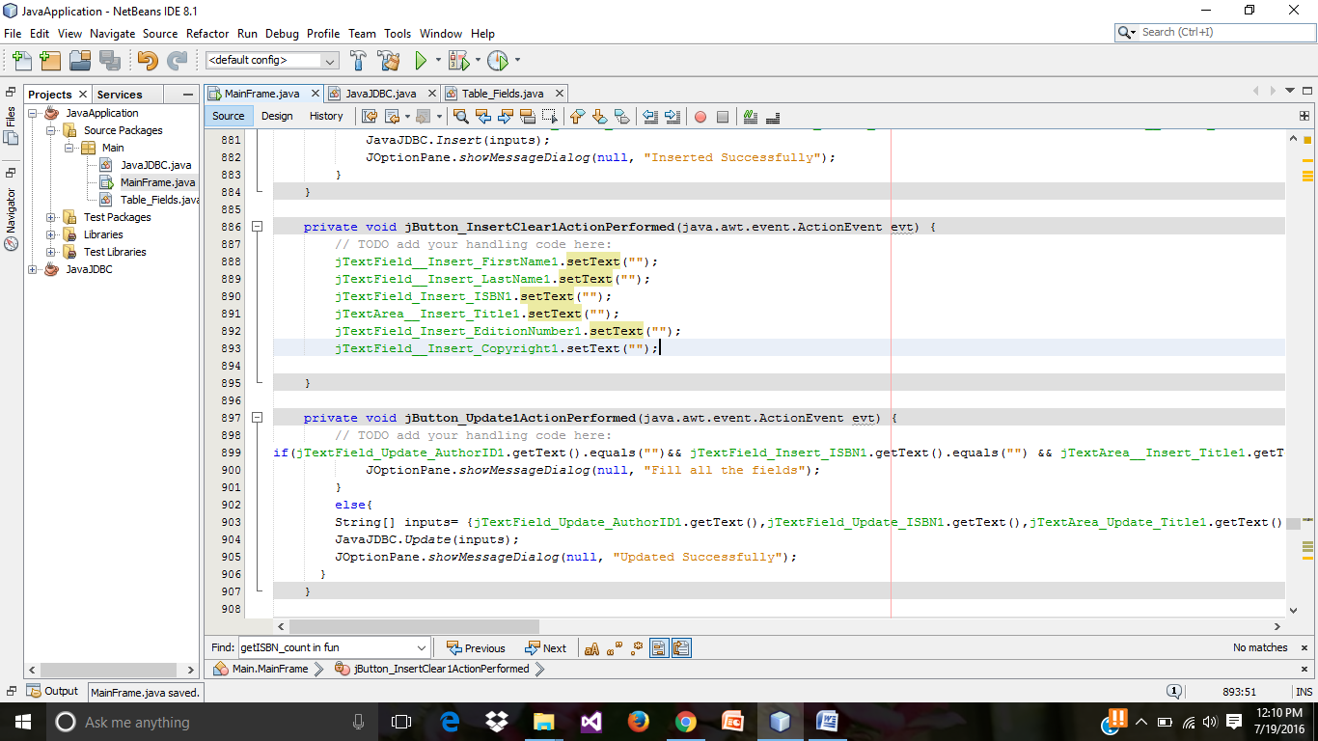

* Adding a **jmenu** item. (Right click on the menu bar and click on add menu).

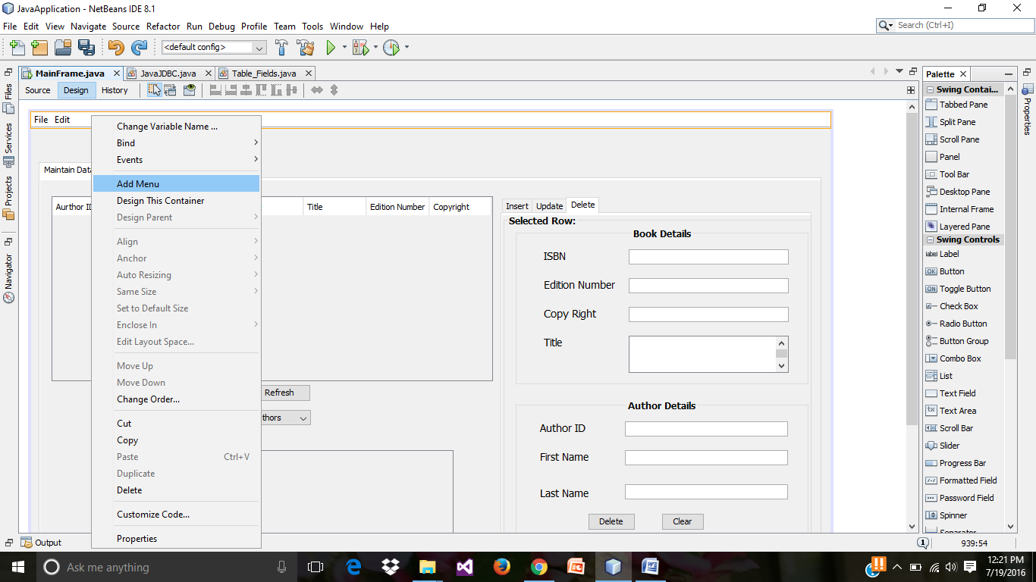

* Adding **jRadioButtonMenuItem.**

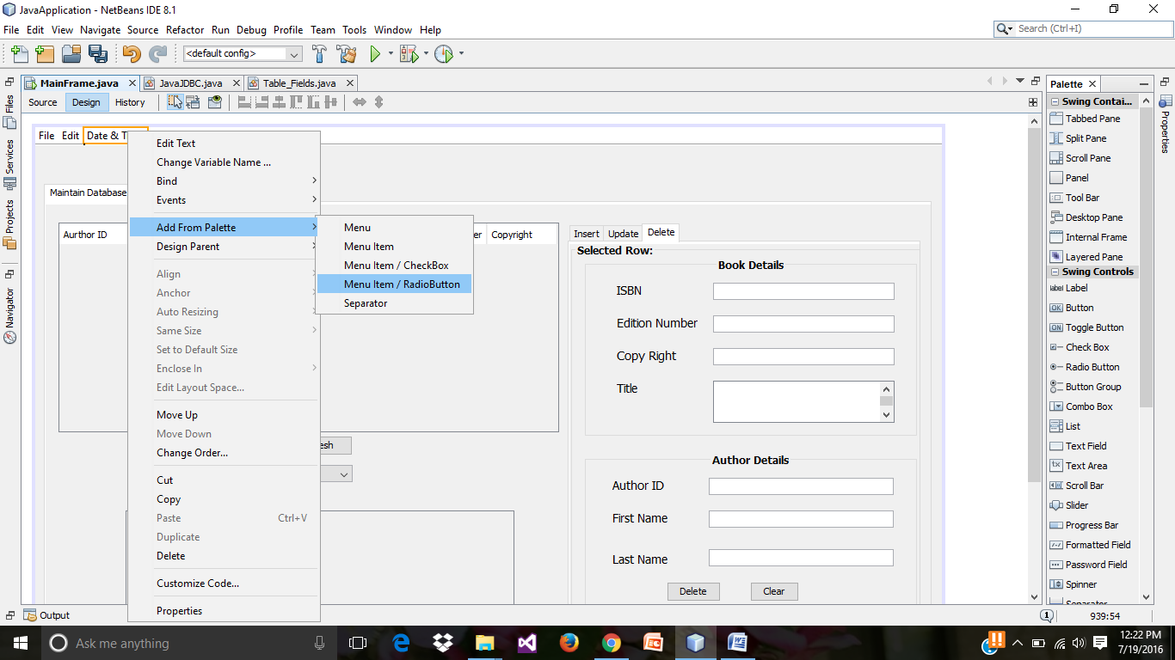

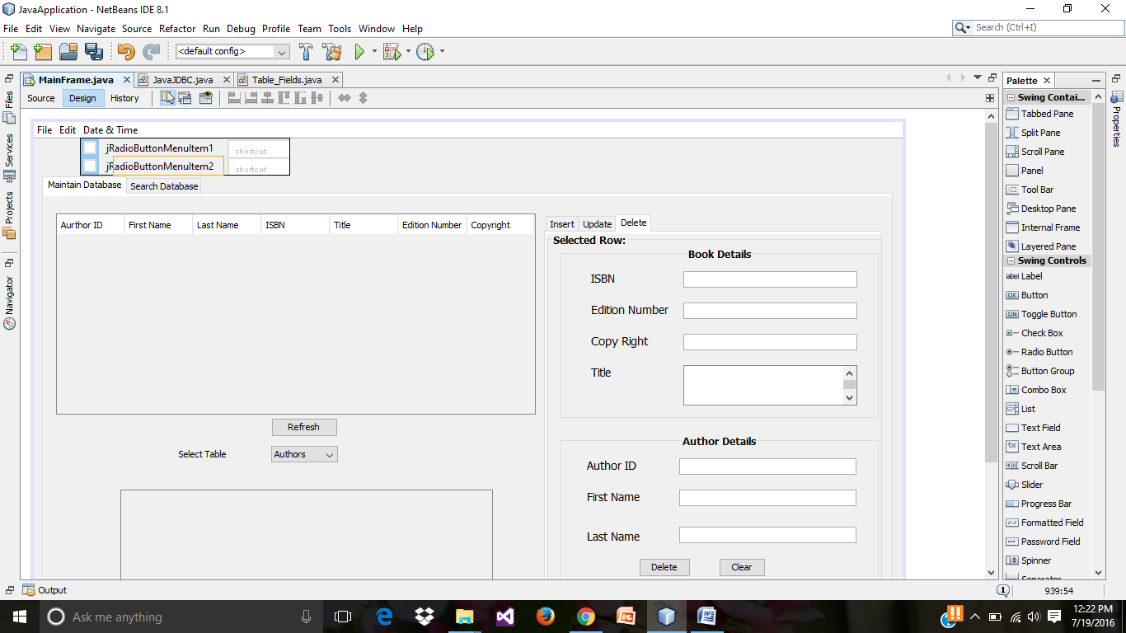

* Creating the action performed event for jRadioButtonMenuItem.

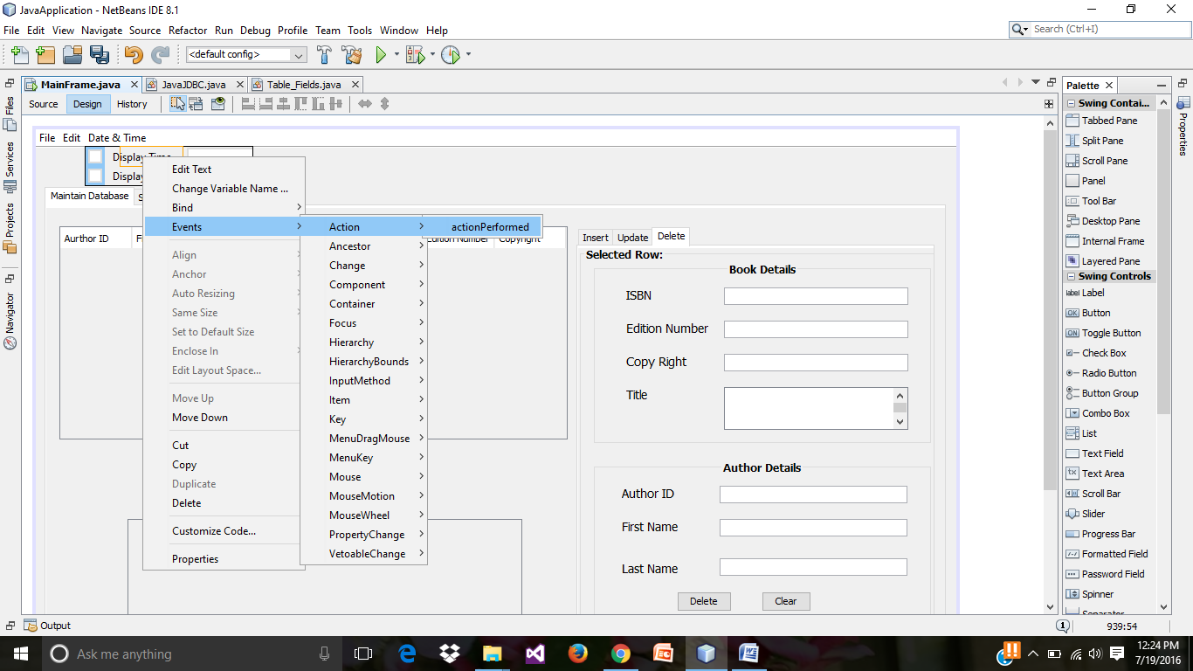

* Code for displaying the date and time in the **jRadioButtonMenuItems**.

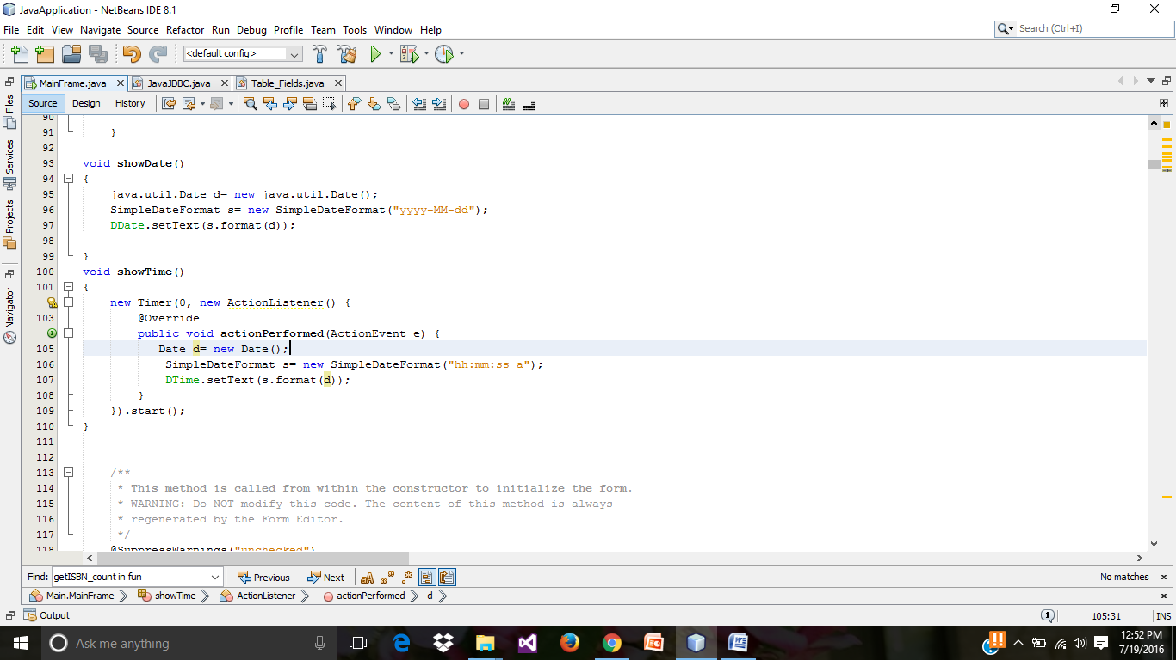

* Preview of run results displaying the date.

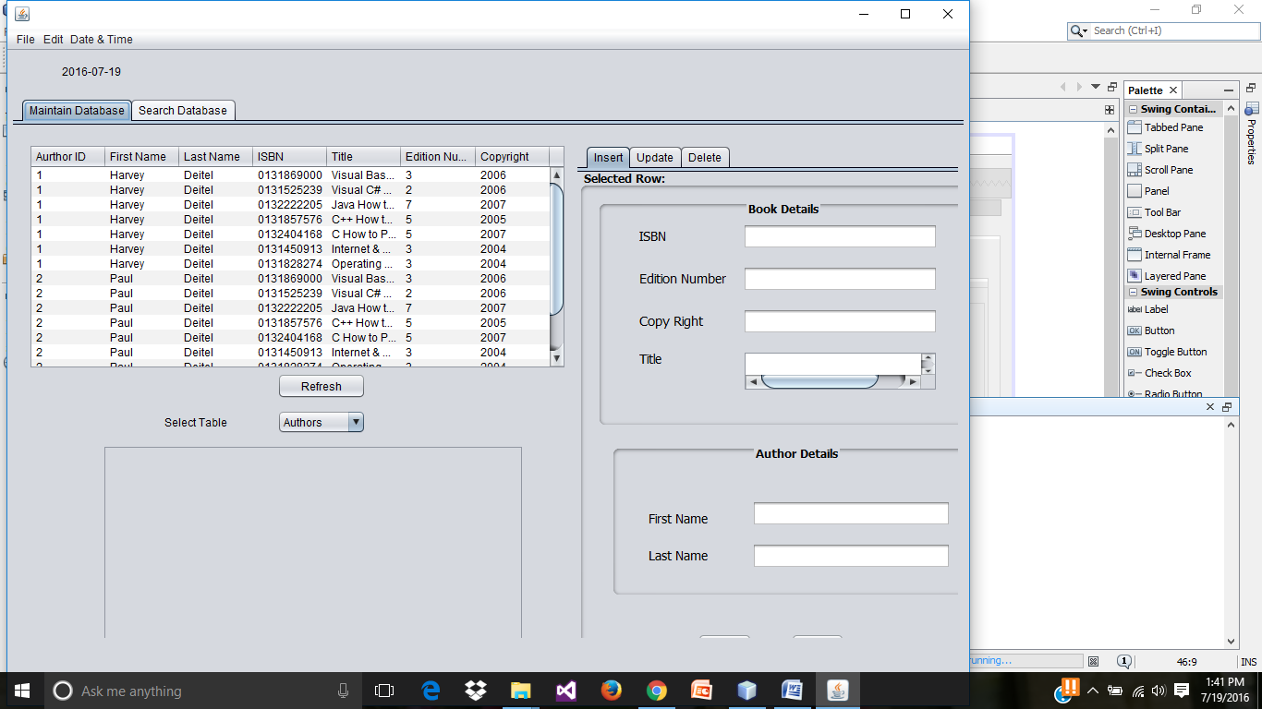

* Preview of run results displaying the **jradiobuttonmenuItem** selection for displaying time and date.

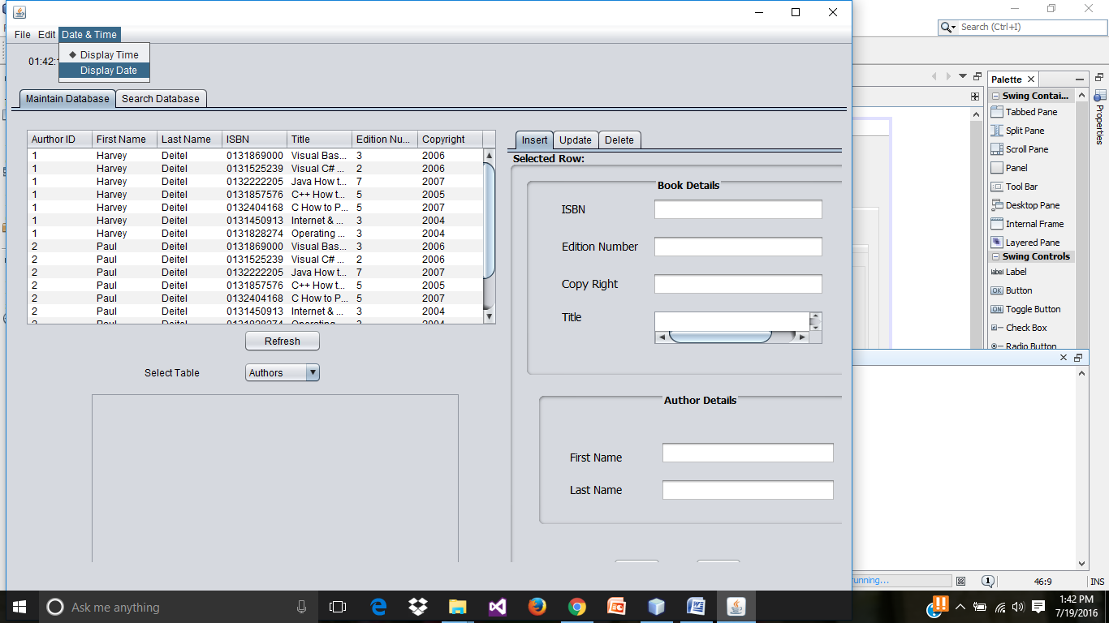

* Select a **jRadiobutton** from the palette on the **Search Database** Tab.

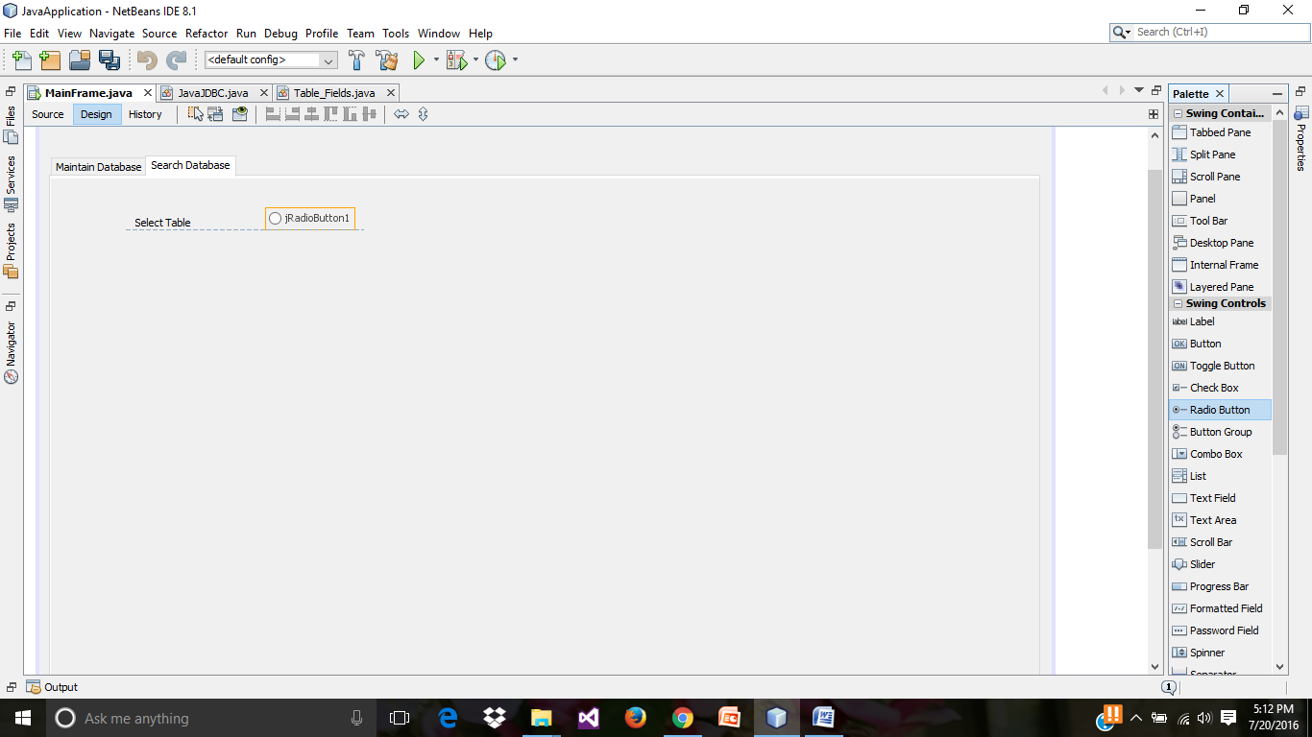

* Selecting the **jlist** .

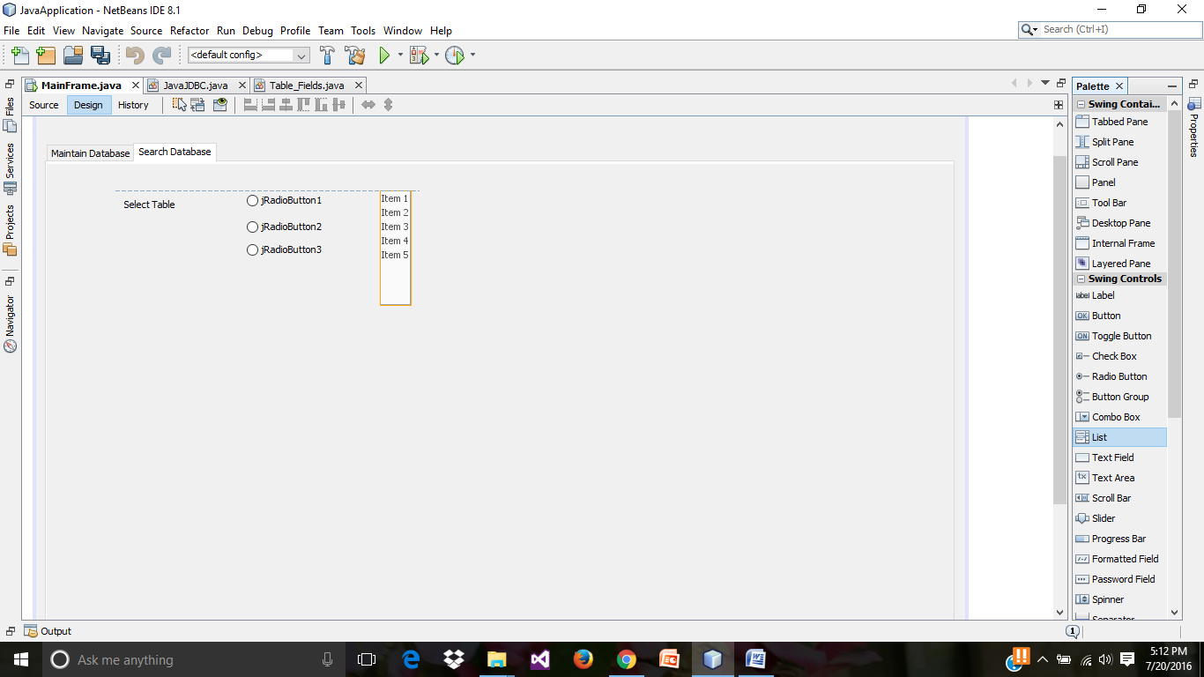

* Selecting a **jcheckbox**.

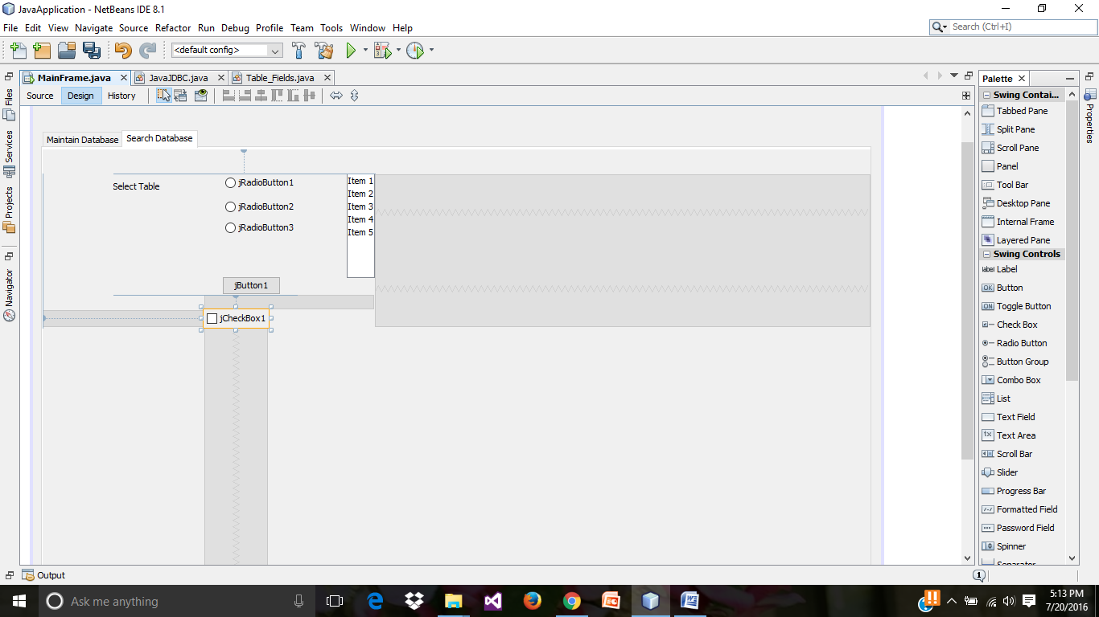

* Change the items in the **jList**.

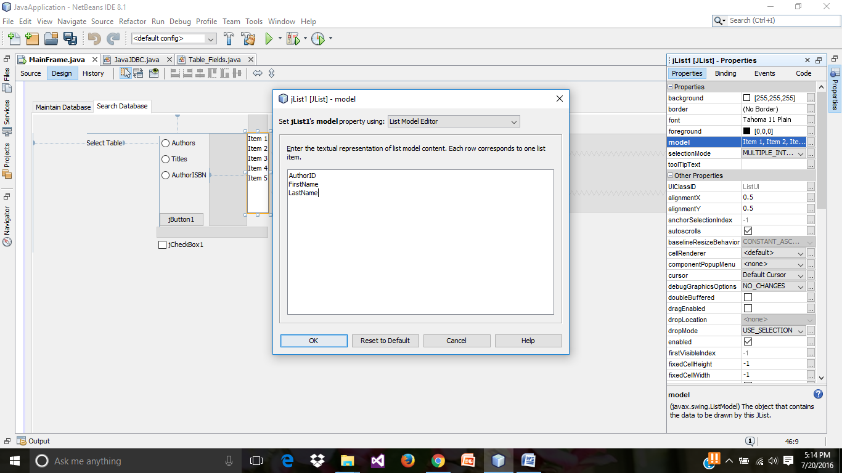

* Enclosing the **jlist** in the Panel.

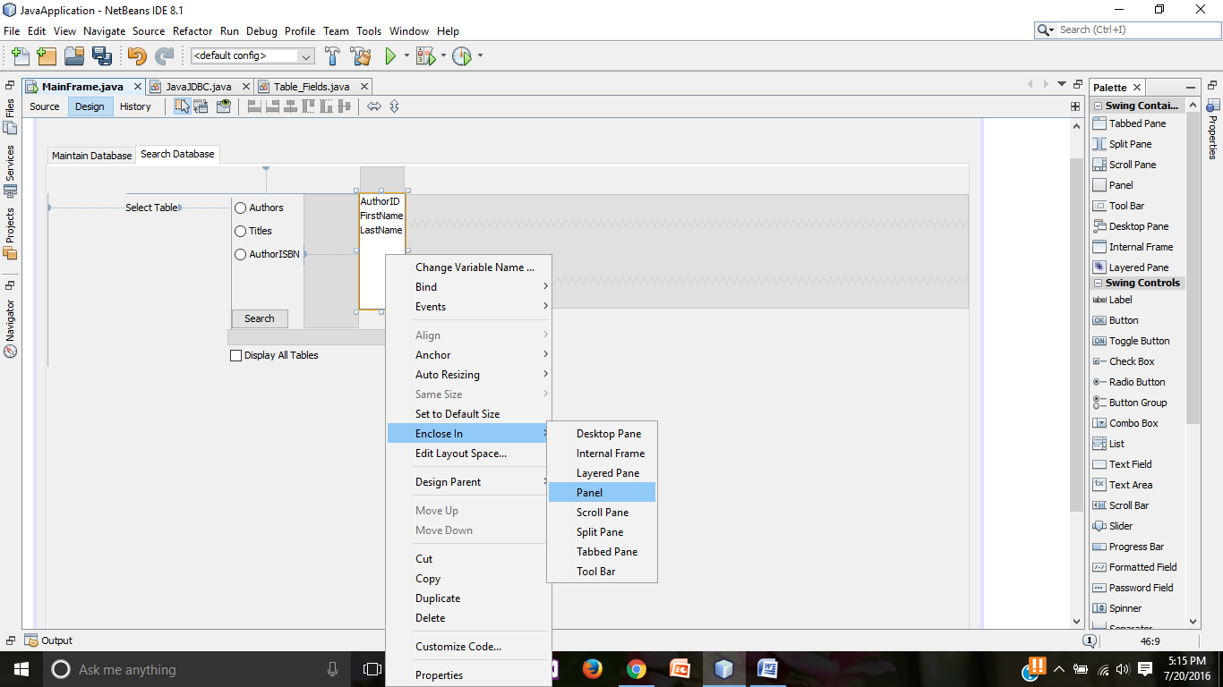

* Selecting a jtable.

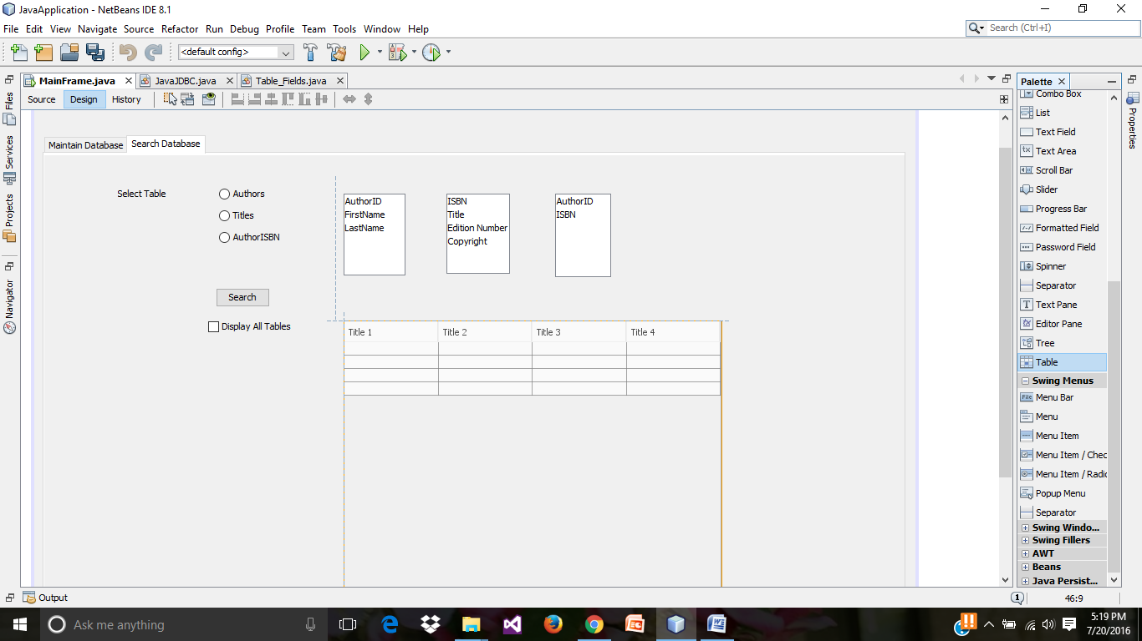

* Remove the columns from table properties and set the rows to 0.

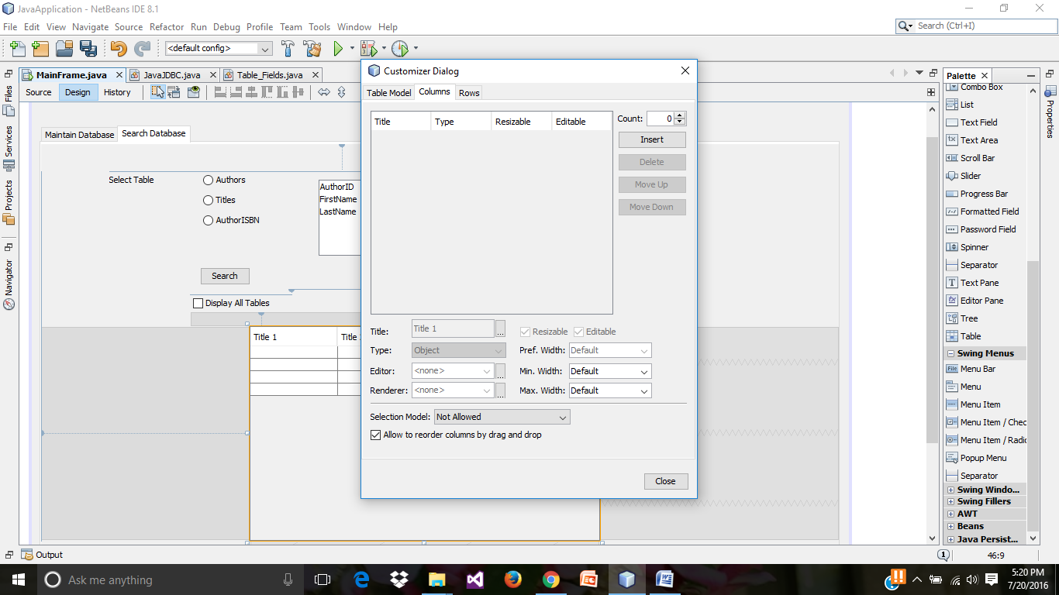

* Preview of Search Database tab, run results till now.

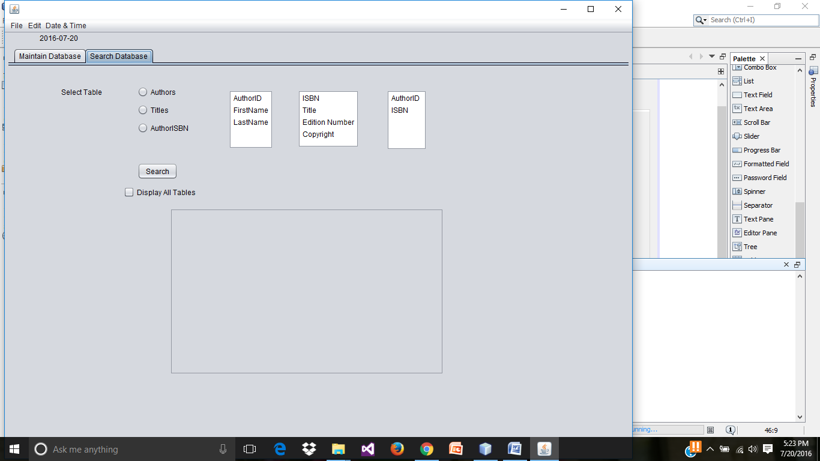

* Creating an action performed for the Authors radio button.

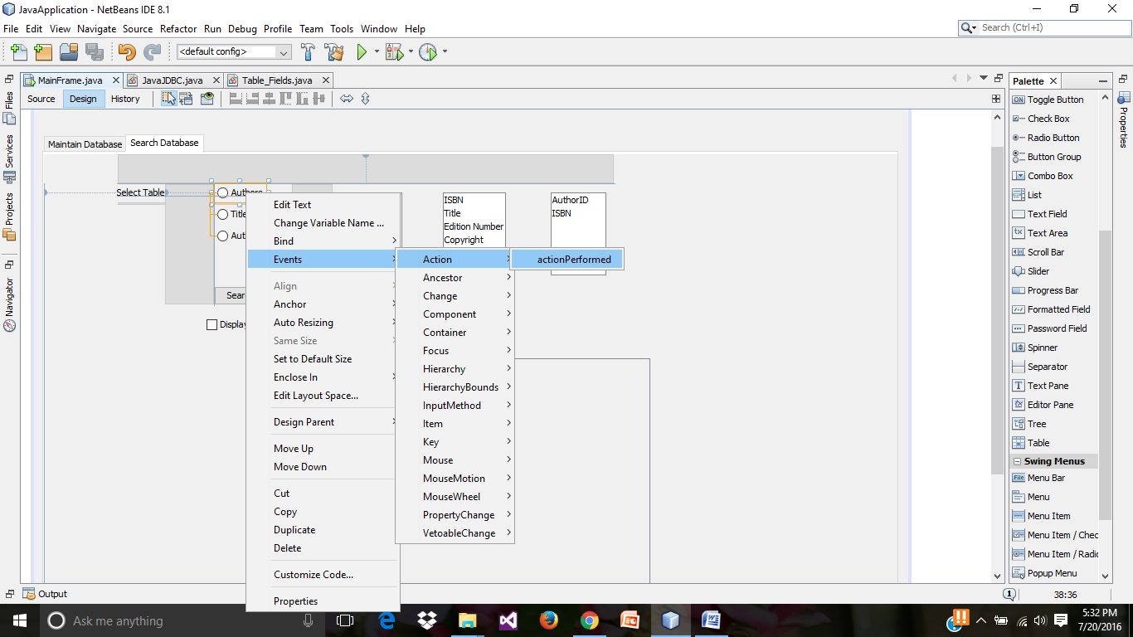

* Source code for Authors **jradiobutton** action performed. This code hides the **jlist** of tables which are not selected.

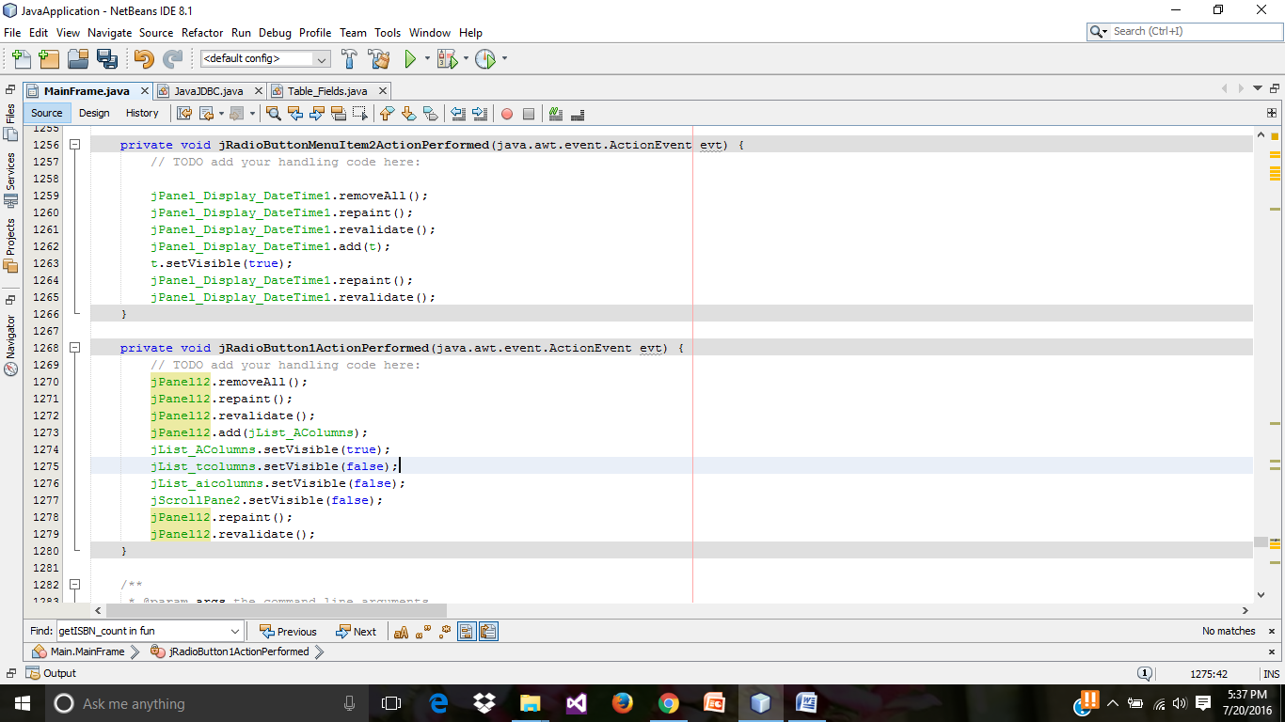

* Preview of run result on click on Authors, displays the fields in Authors Table in jlist.

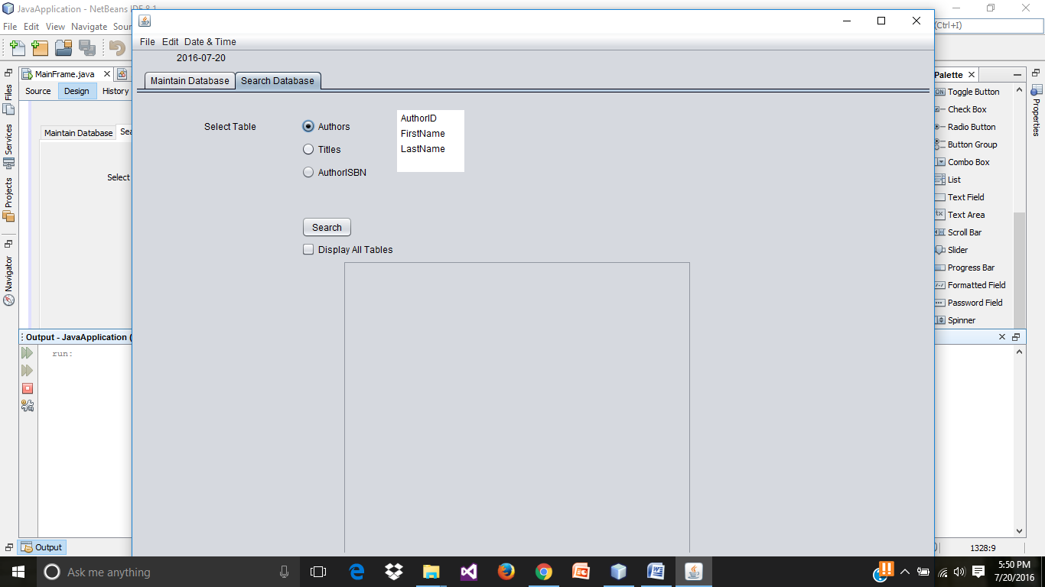

* Preview of run result on click on Titles, displays the fields in Titles Table in the **jlist**.

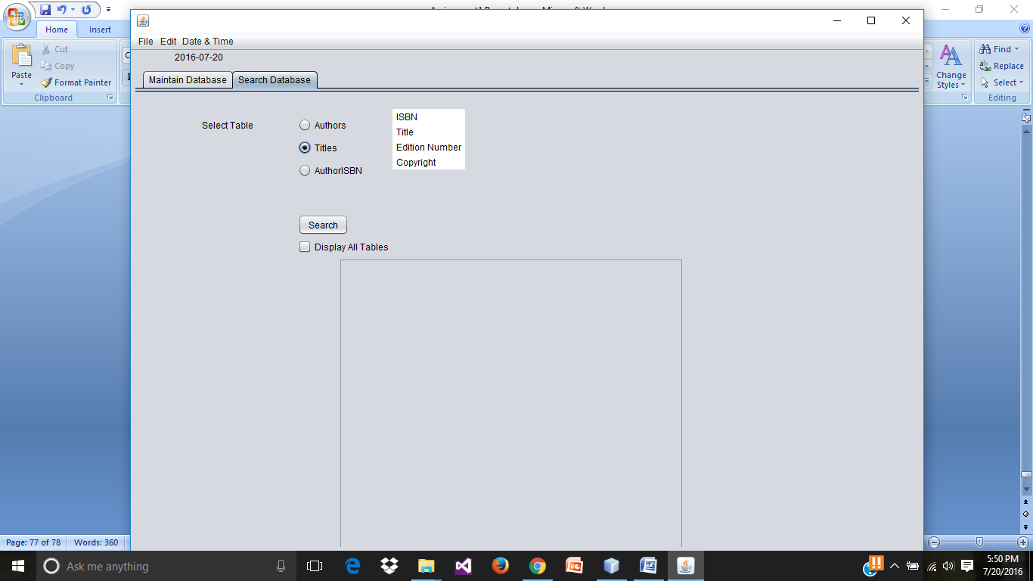

* Creating an action performed for **jCheckbox**.

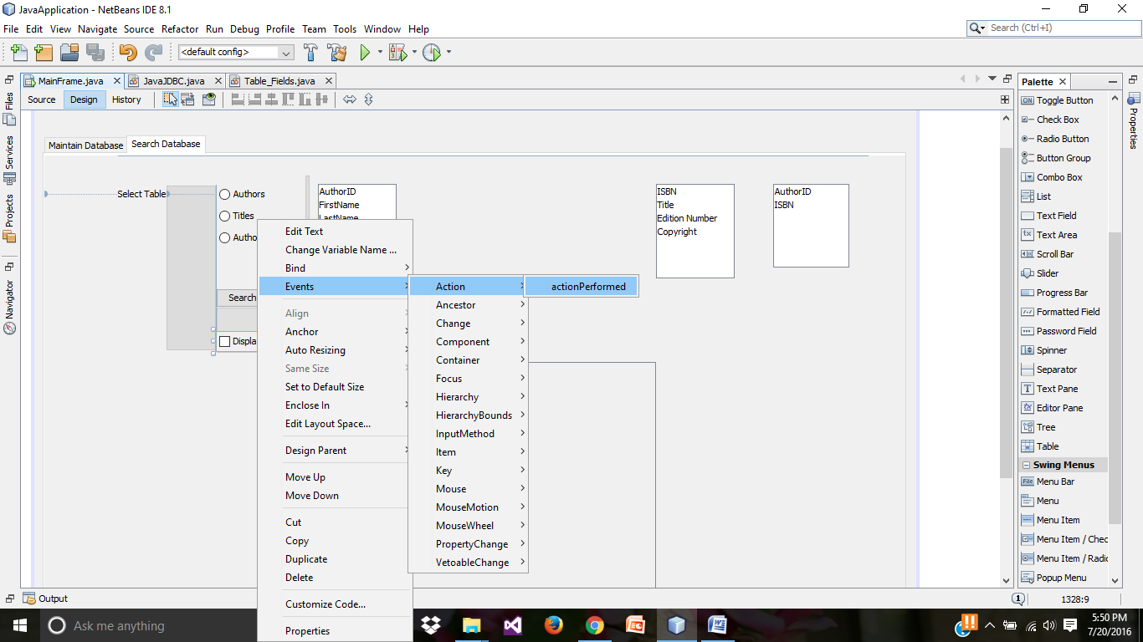

* Source code for jCheckbox action performed .

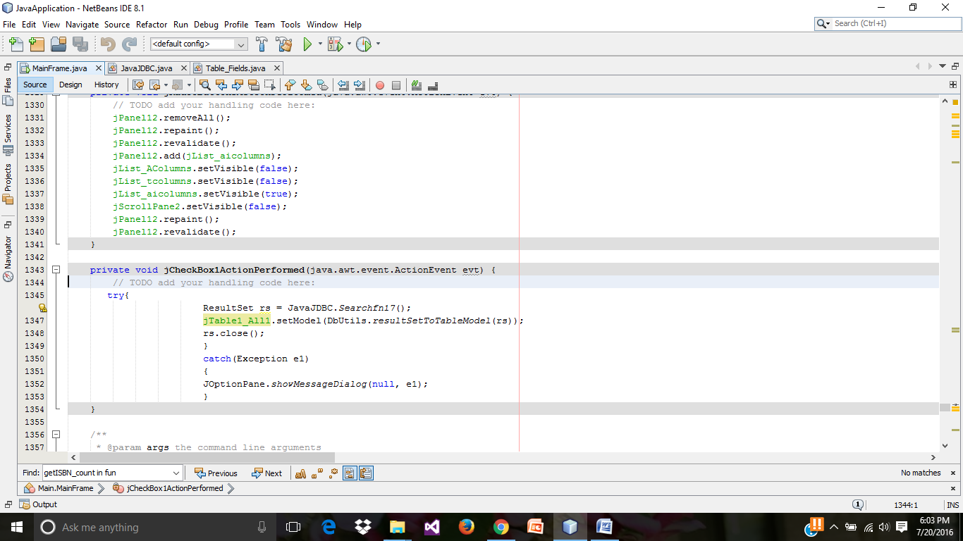

* Source code in **JavaJDBC.java** for displaying all the fields in all tables.

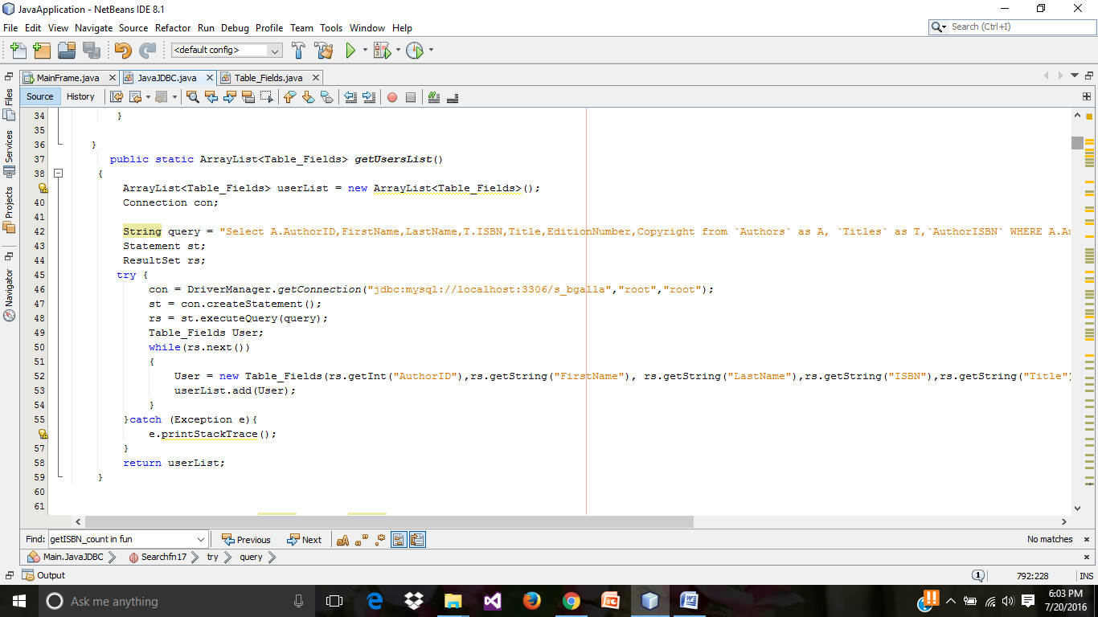

* Creating an action performed event for search button.

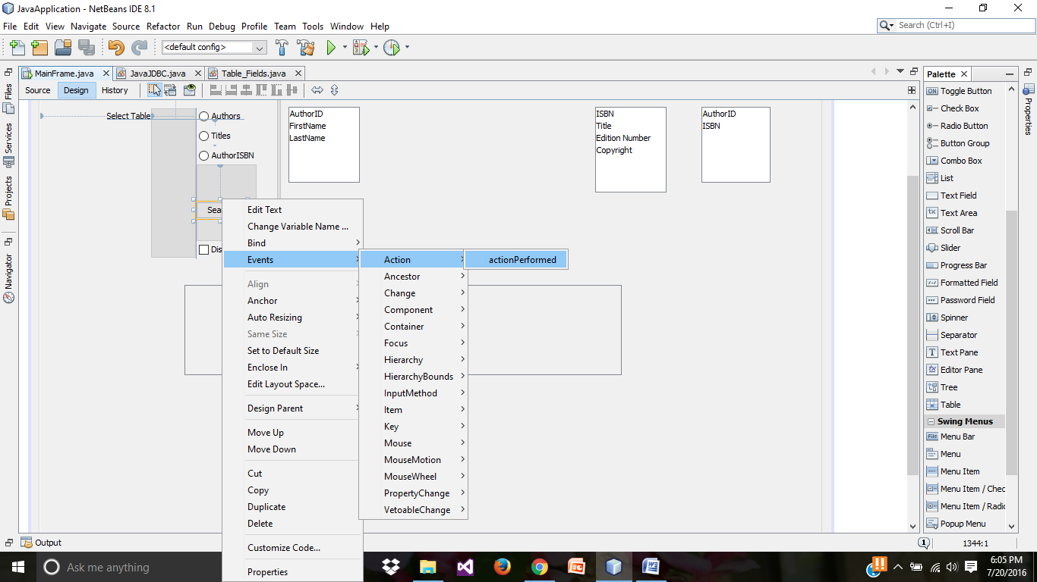

* Source code for the search button action performed.

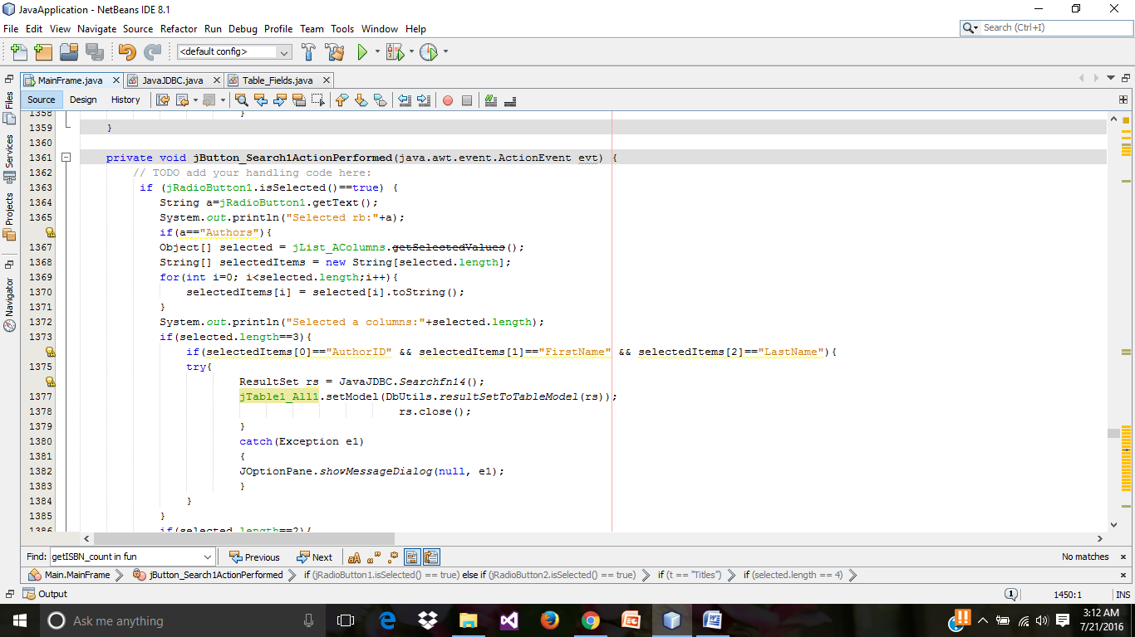

* Preview of run result by selecting the fields of ISBN, Title, EditonNumber in Titles table

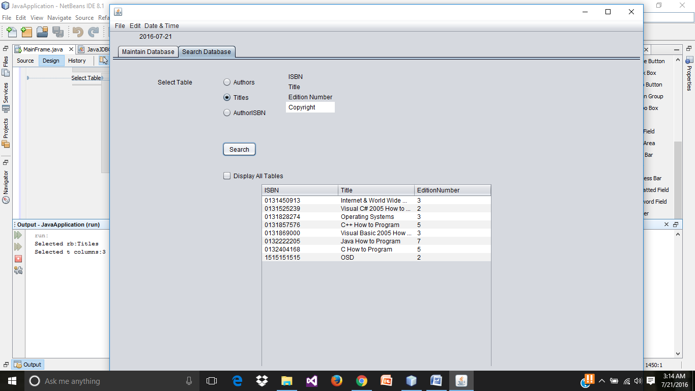

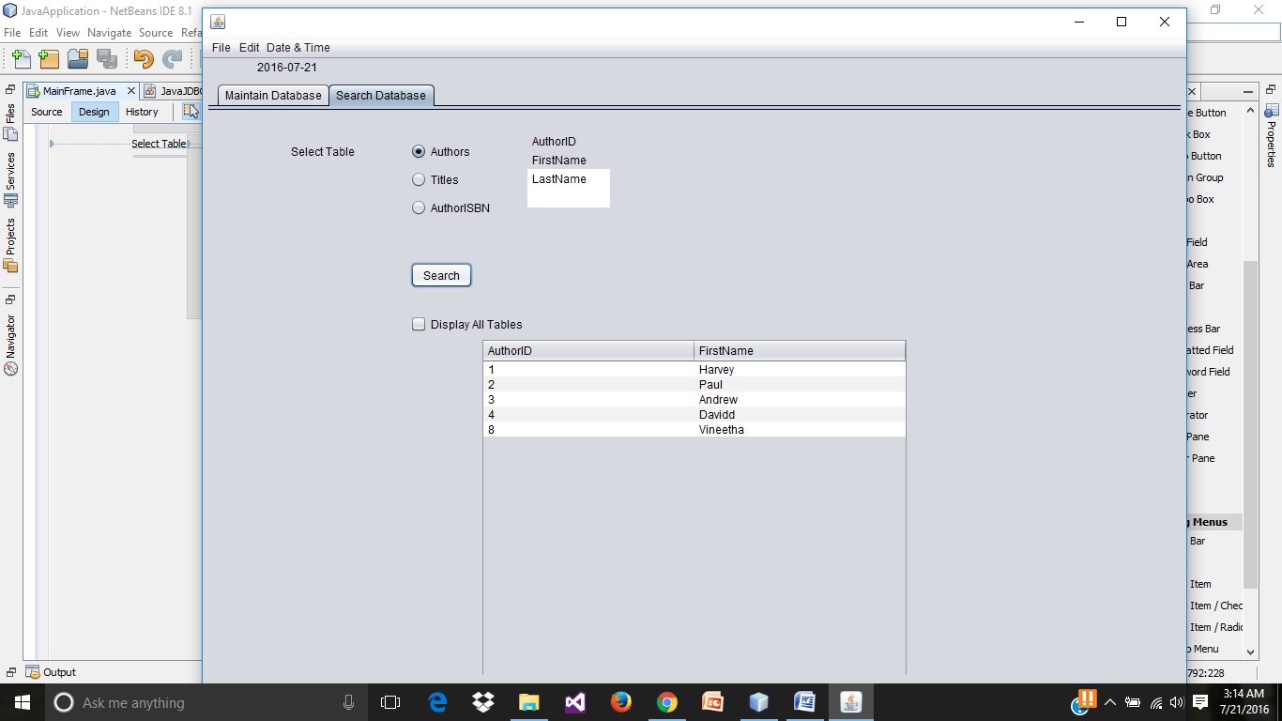

**Final Preview of Run Results**

* **Inserting a new record.**

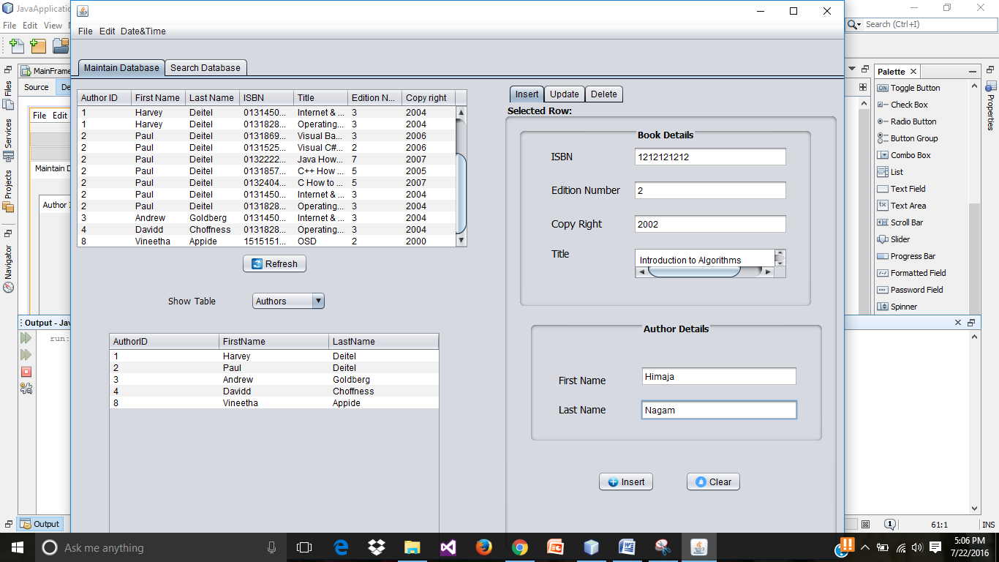

* **Preview of successful record insertion.**

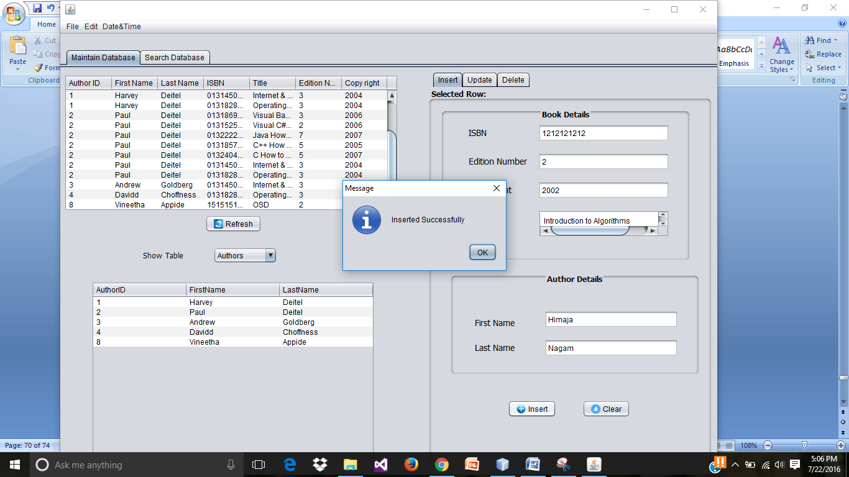

* **Preview of inserted record in data tables on click on refresh button.**

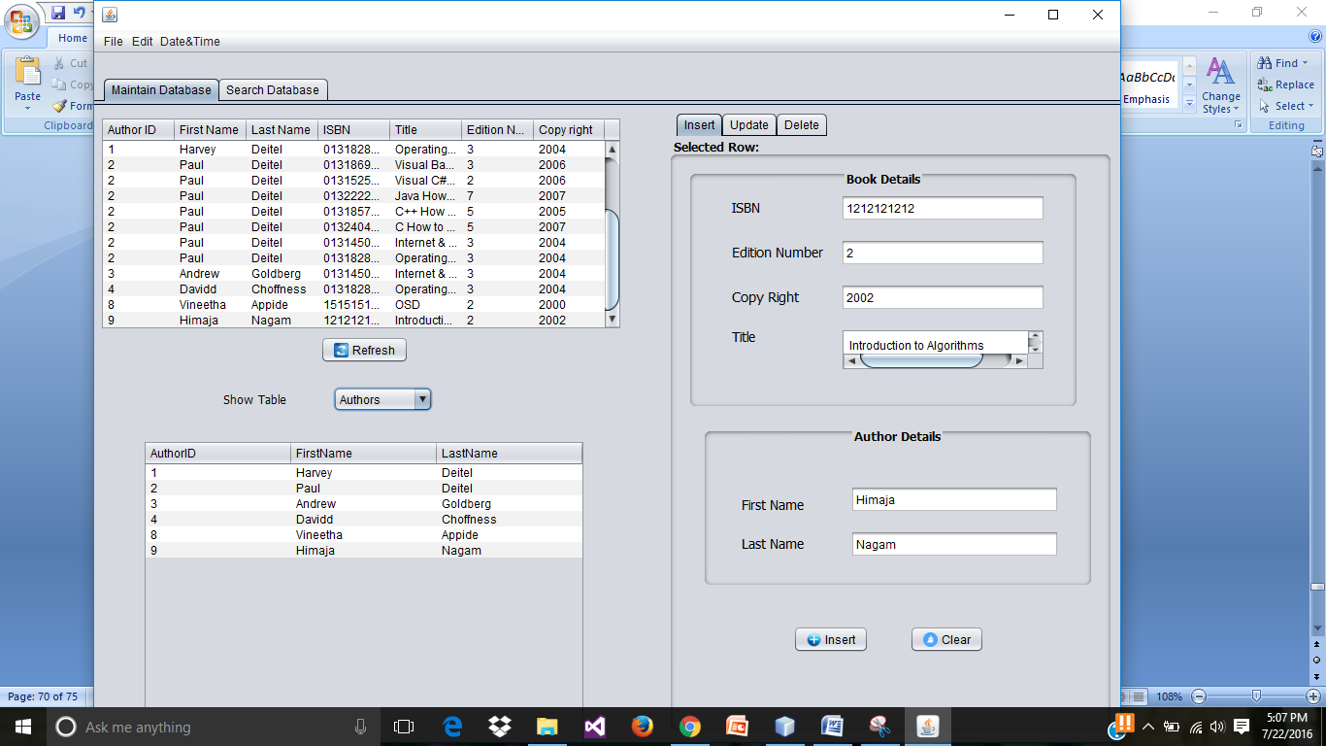

* **Updating the recently inserted record.**

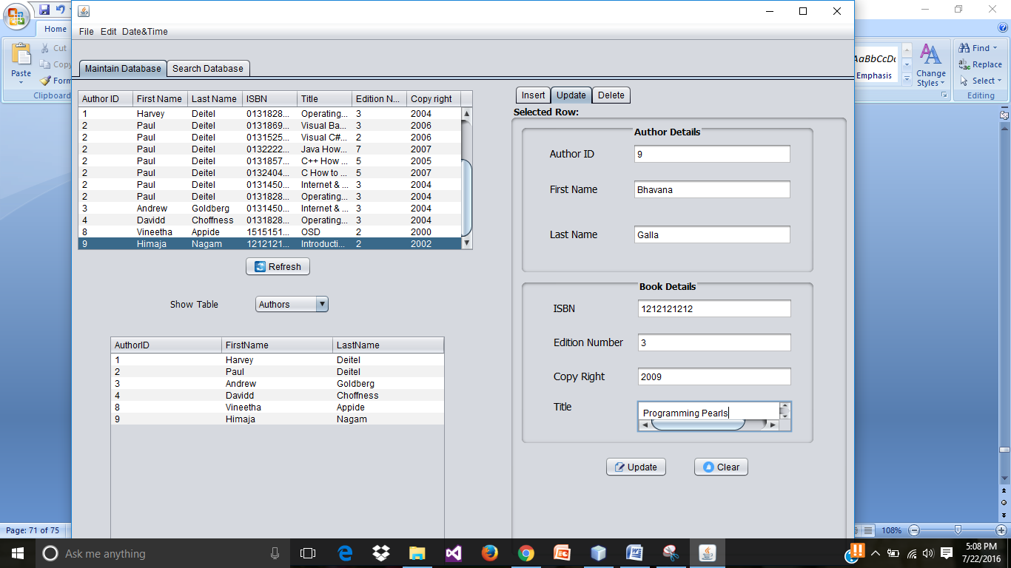

* **Preview of successful record updating.**

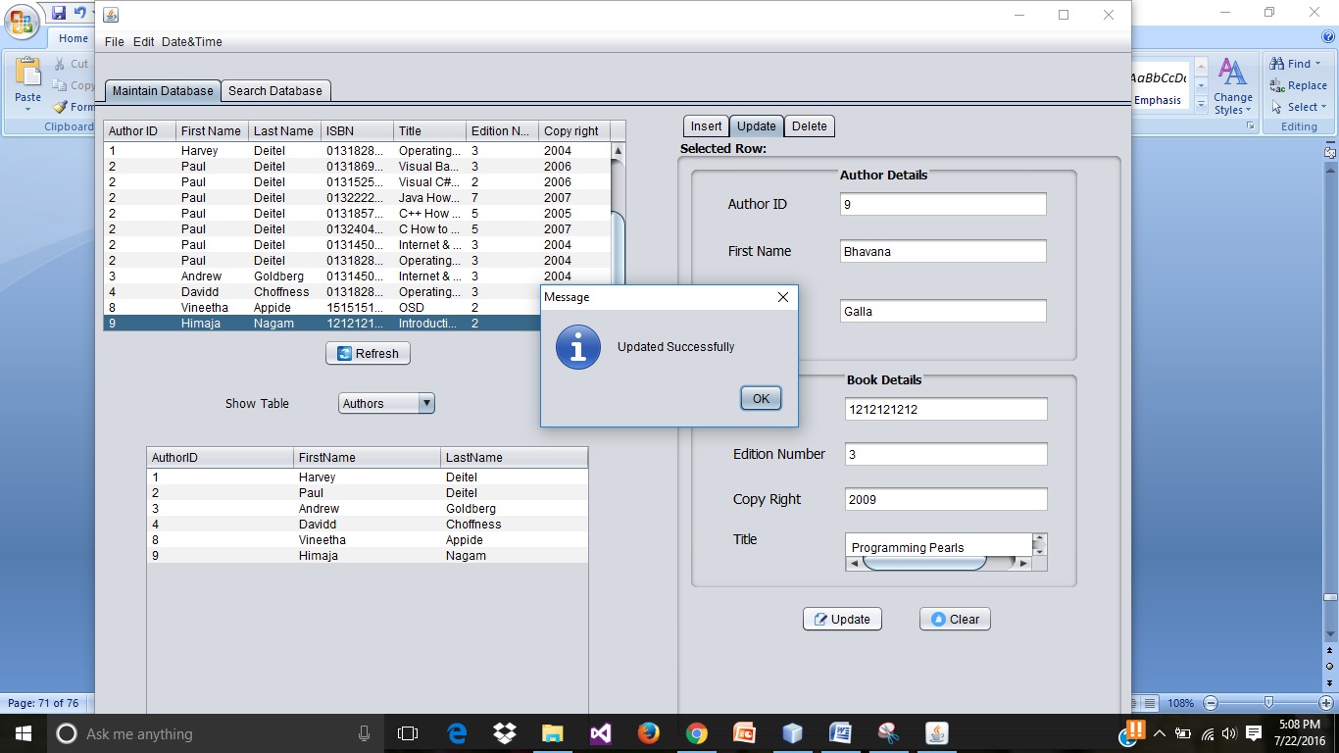

* **Checking the updated record in the tables.**

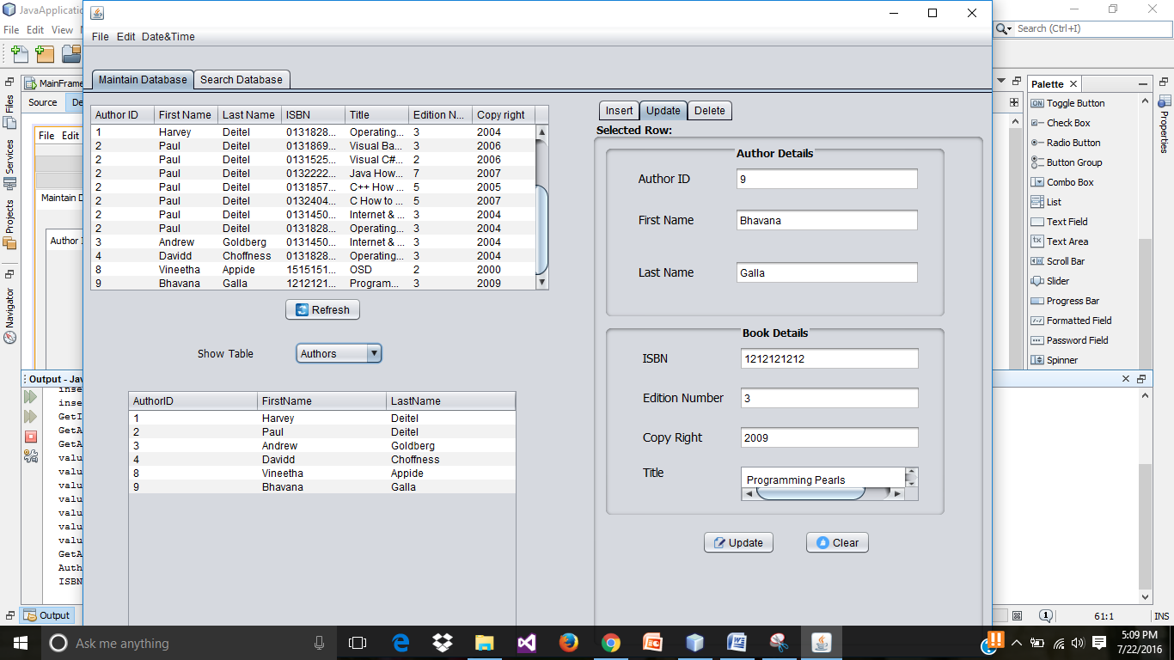

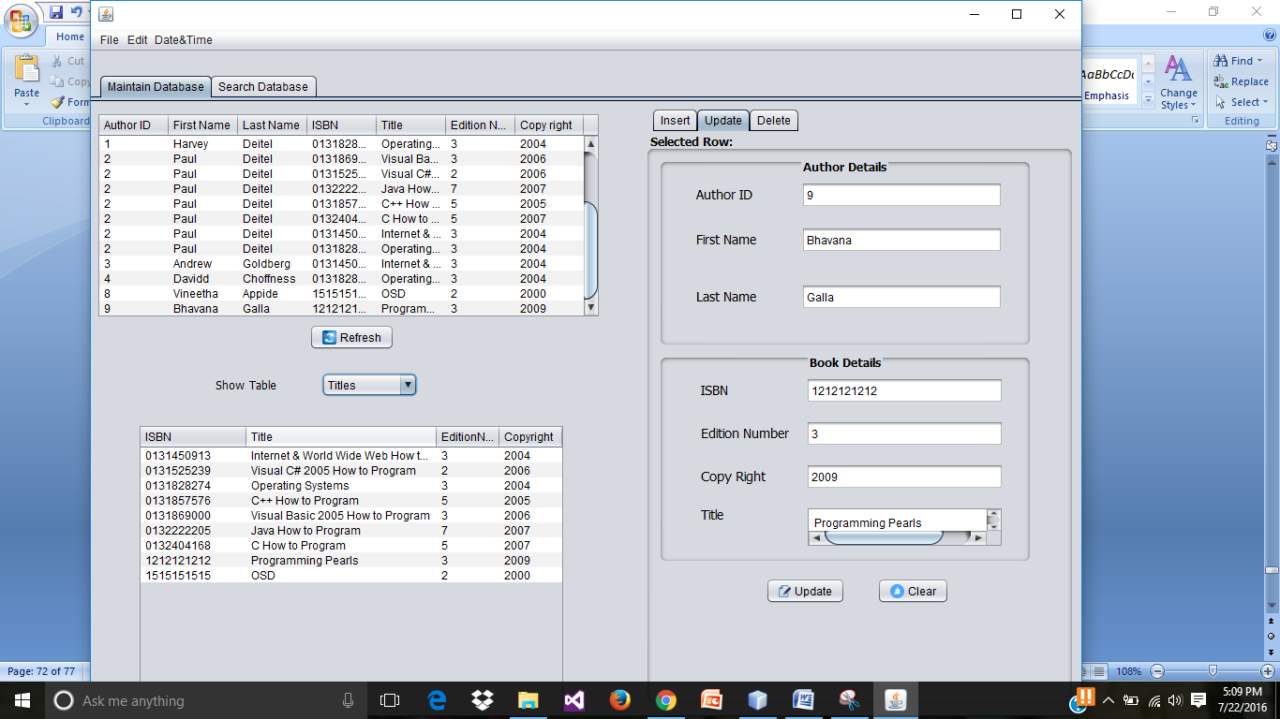

* **Deleting a record.**

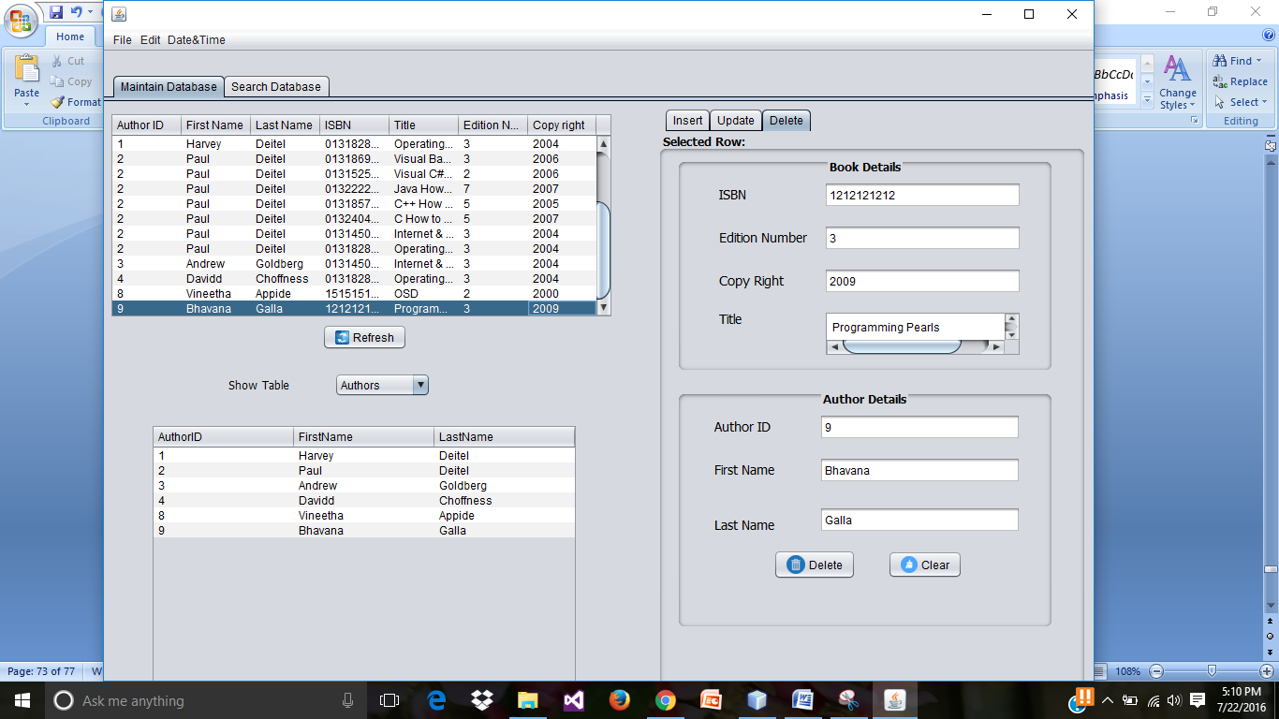

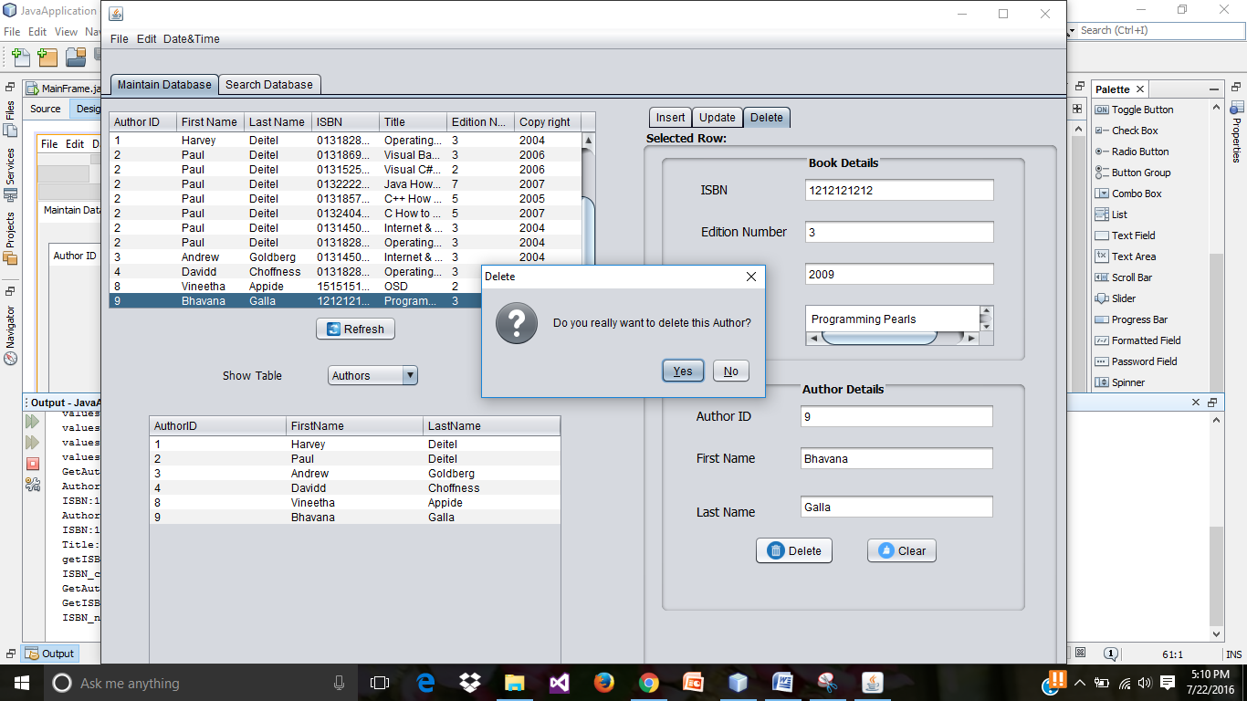

* **Checking the deleted record in the tables.**

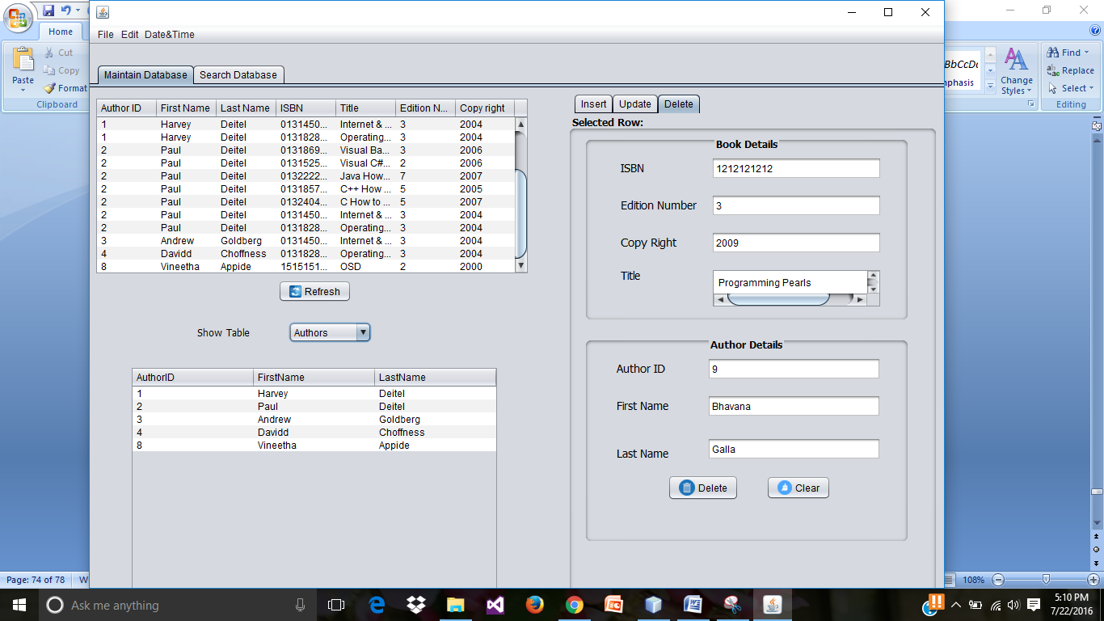

* **Checking on the Display all tables**

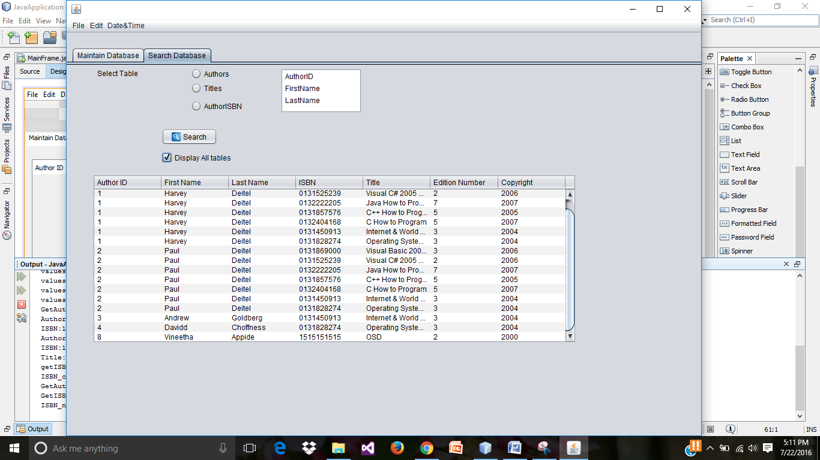

* **Displaying the data of the selected table and its fields in jlist.**

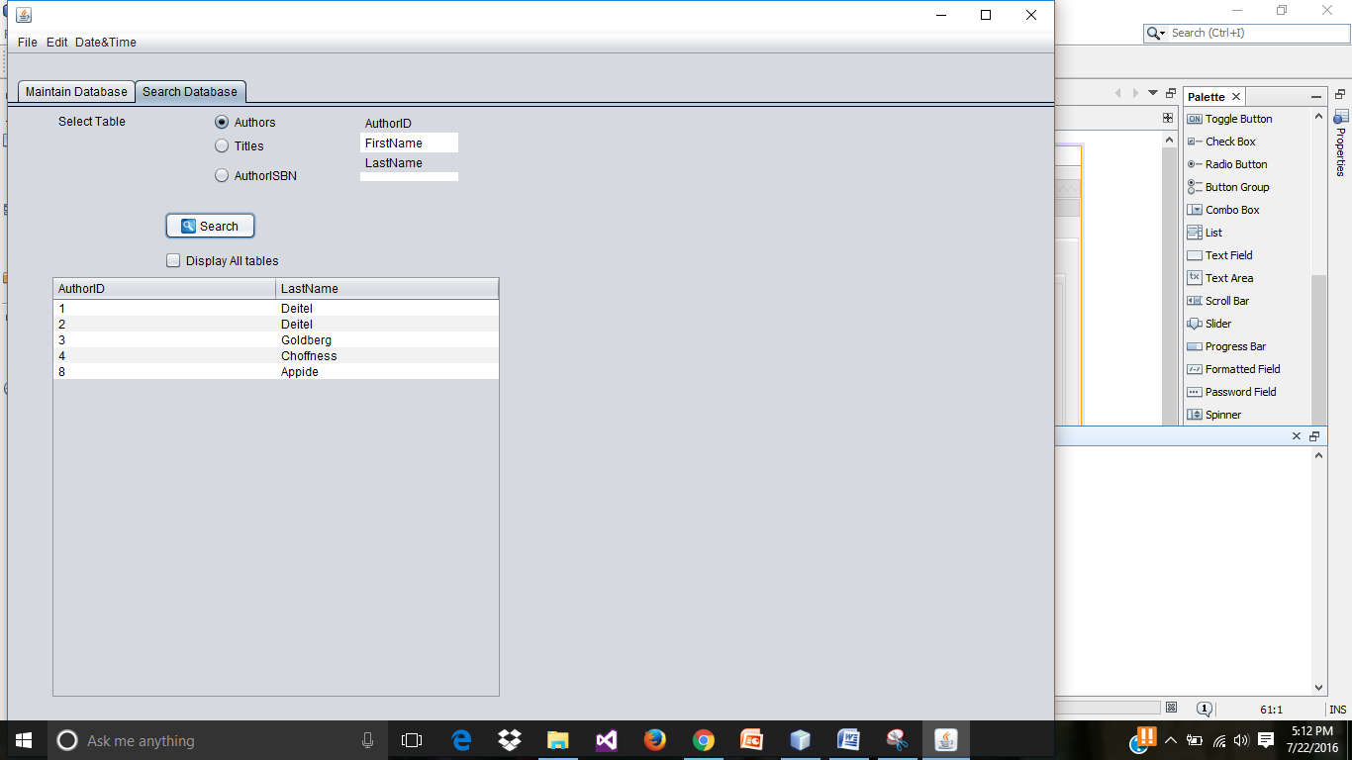

* **Displaying the data of the selected table and its fields in jlist.**

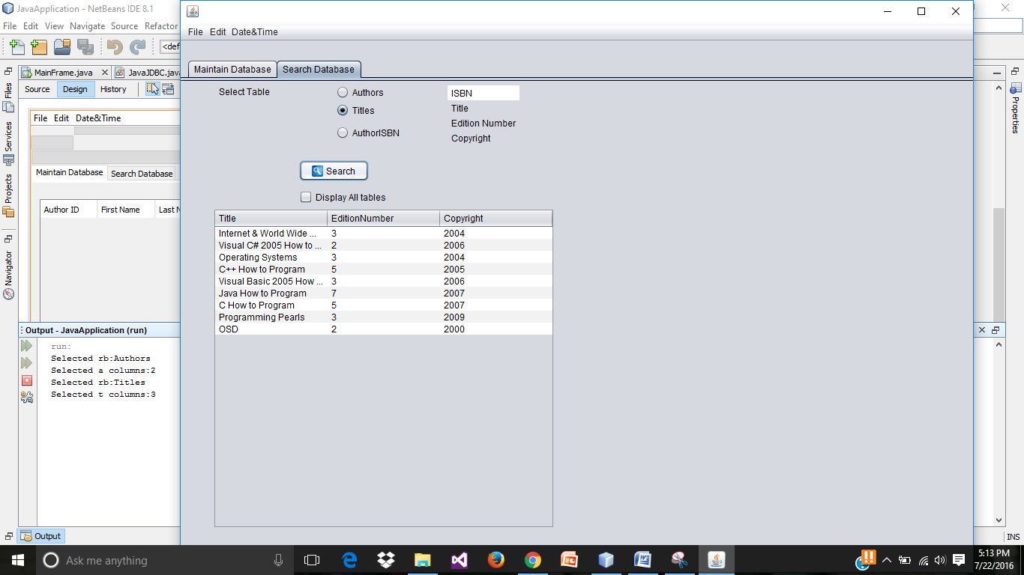

* **jRadiobuttonMenuItems dispalying time and date**

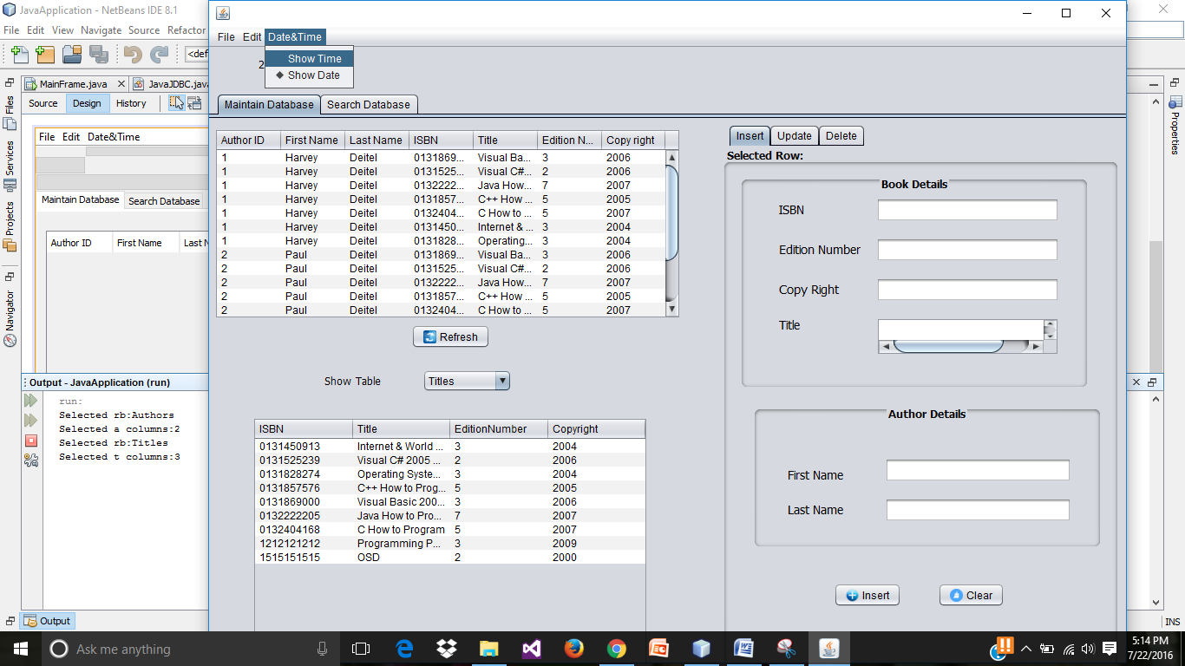

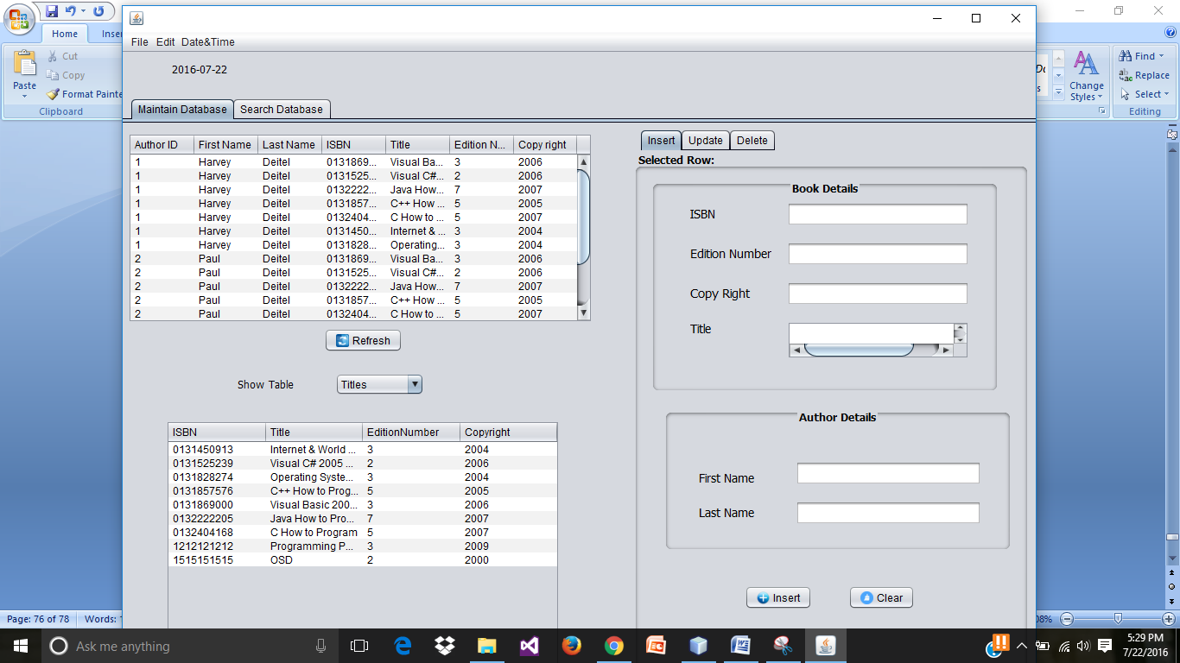

* **jCheckBoxMenuItem for the terminating the run result.**



